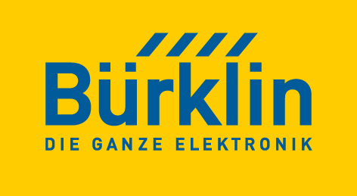PRESS RELEASE

Würth Elektronik and Bürklin Elektronik forge strategic partnership
Together for Sustainable Electronics
Waldenburg (Germany), October 27, 2023 – Würth Elektronik and Bürklin Elektronik have signed a distribution agreement. The strategic partnership combines the common strengths of both companies. Bürklin Elektronik will carry a wide range of Würth Elektronik products in the future, including passive components, connectors, sensors, and more.
Bürklin Elektronik – a leading supplier of electronic components and accessories – has gained an excellent reputation for high-quality products and outstanding customer service over its nearly 70-year history. Würth Elektronik, part of the internationally operating Würth Group, is a renowned manufacturer of electronic and electromechanical components and sees itself as a service-oriented technology enabler for cutting-edge electronic solutions. The decision to collaborate aims to guarantee customers with the best possible service and short distances in procuring components in the future. This makes Bürklin Elektronik one of the few authorized partners to exclusively represent the WE brand.
Available from stock without a minimum order quantity
The mix of technologically advanced products, such as wireless modules and DC/DC converters with integrated components offered by Würth Elektronik, is a perfect match in Bürklin Elektronik's portfolio, allowing Bürklin Elektronik to significantly expand its range and make an even broader spectrum of products and services available to its customers. At the same time, the strong partnership offers Würth Elektronik customers in the DACH region an additional attractive procurement channel, enabling 24-hour product availability. Bürklin Elektronik customers can find 7,500 products at the online shop available from stock without a minimum order quantity. Both companies also attach great importance to sustainability and environmental compatibility. Together, they will focus on developing environmentally-friendly solutions and promoting resource efficiency.
“The partnership with Würth Elektronik marks a major milestone in our company history. We are extremely confident that the combined expertise and resources of both companies will help us to deliver first-rate solutions to our customers,” says Jürgen Lampert, CEO of Bürklin Elektronik.
Lars Fahrbach, Vice President Global Distributions and New Markets of Würth Elektronik, is also excited about the strategic partnership with Bürklin Elektronik: “We’re convinced we can open up even shorter and simpler channels to our product technologies for our customers in Central Europe and we’re proud to now have Bürklin Elektronik - a unique and enduring brand in the electronics industry - as our partner.”

Available images
The following images can be downloaded from the Internet in printable quality: https://kk.htcm.de/press-releases/wuerth/
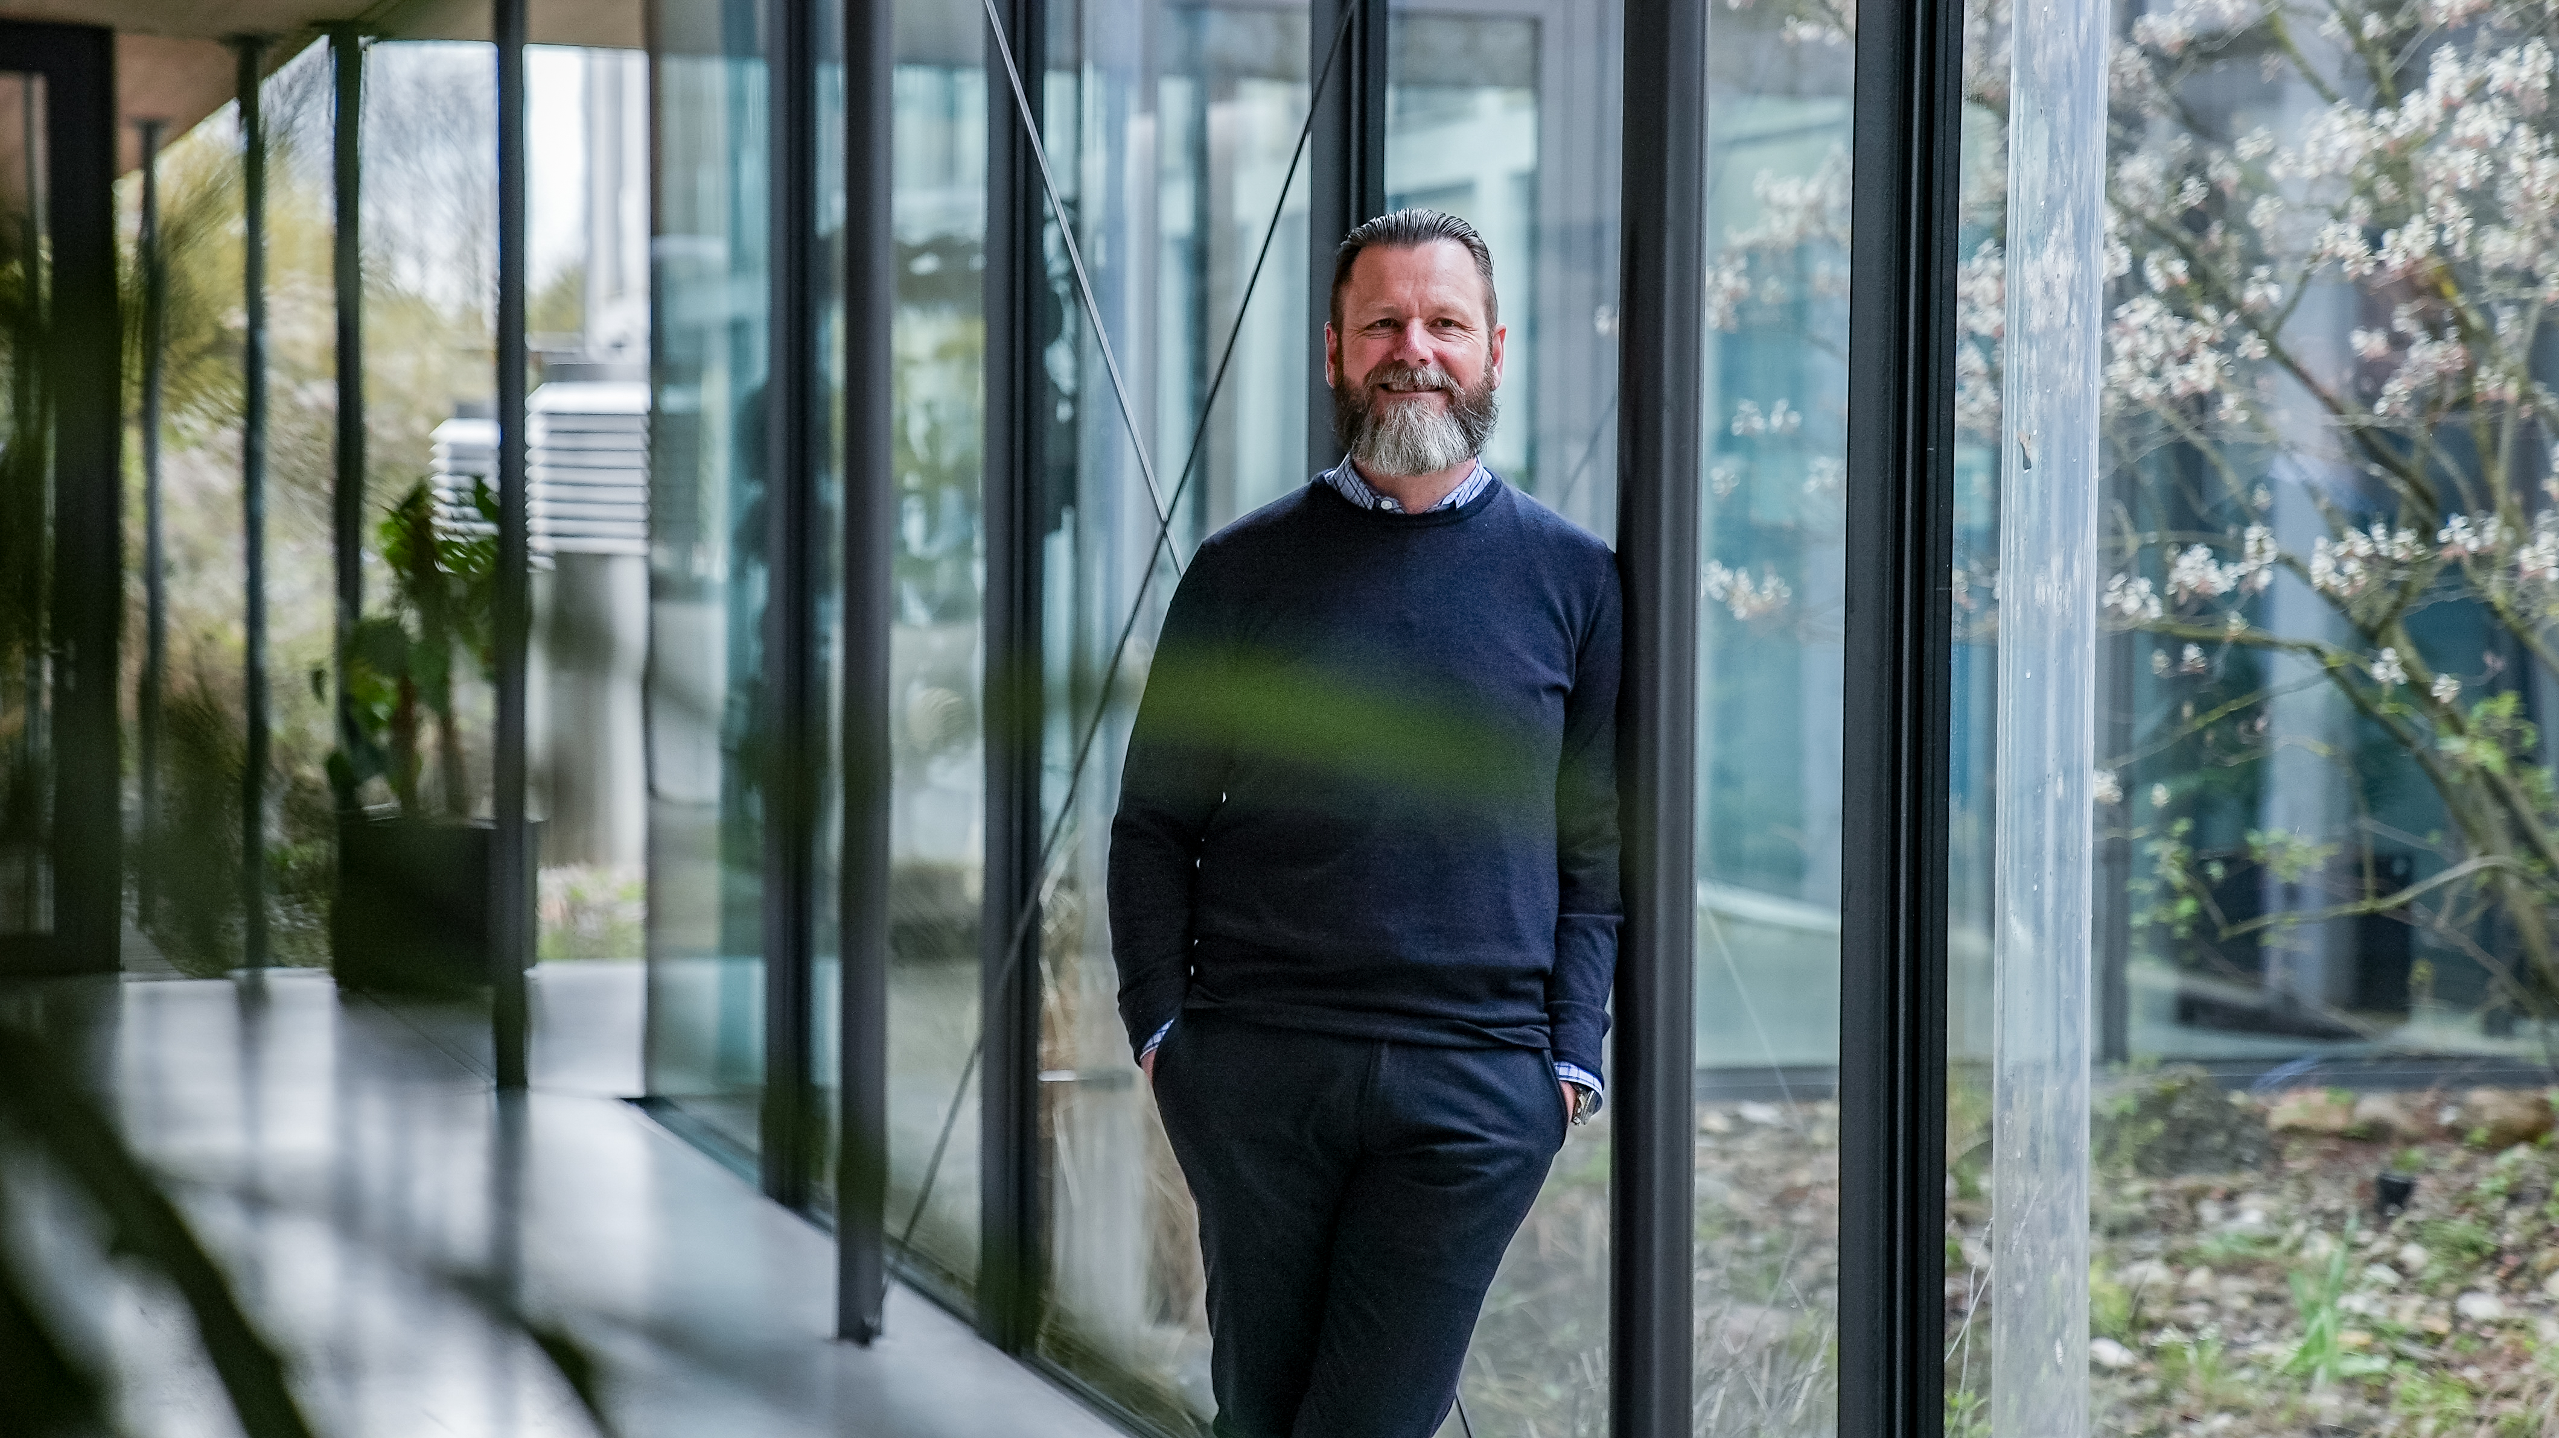Image source: Bürklin Elektronik  Jürgen Lampert, CEO of Bürklin Elektronik | Image source: Bürklin Elektronik  Lars Fahrbach, Vice President Global Distributions and New Markets of Würth Elektronik

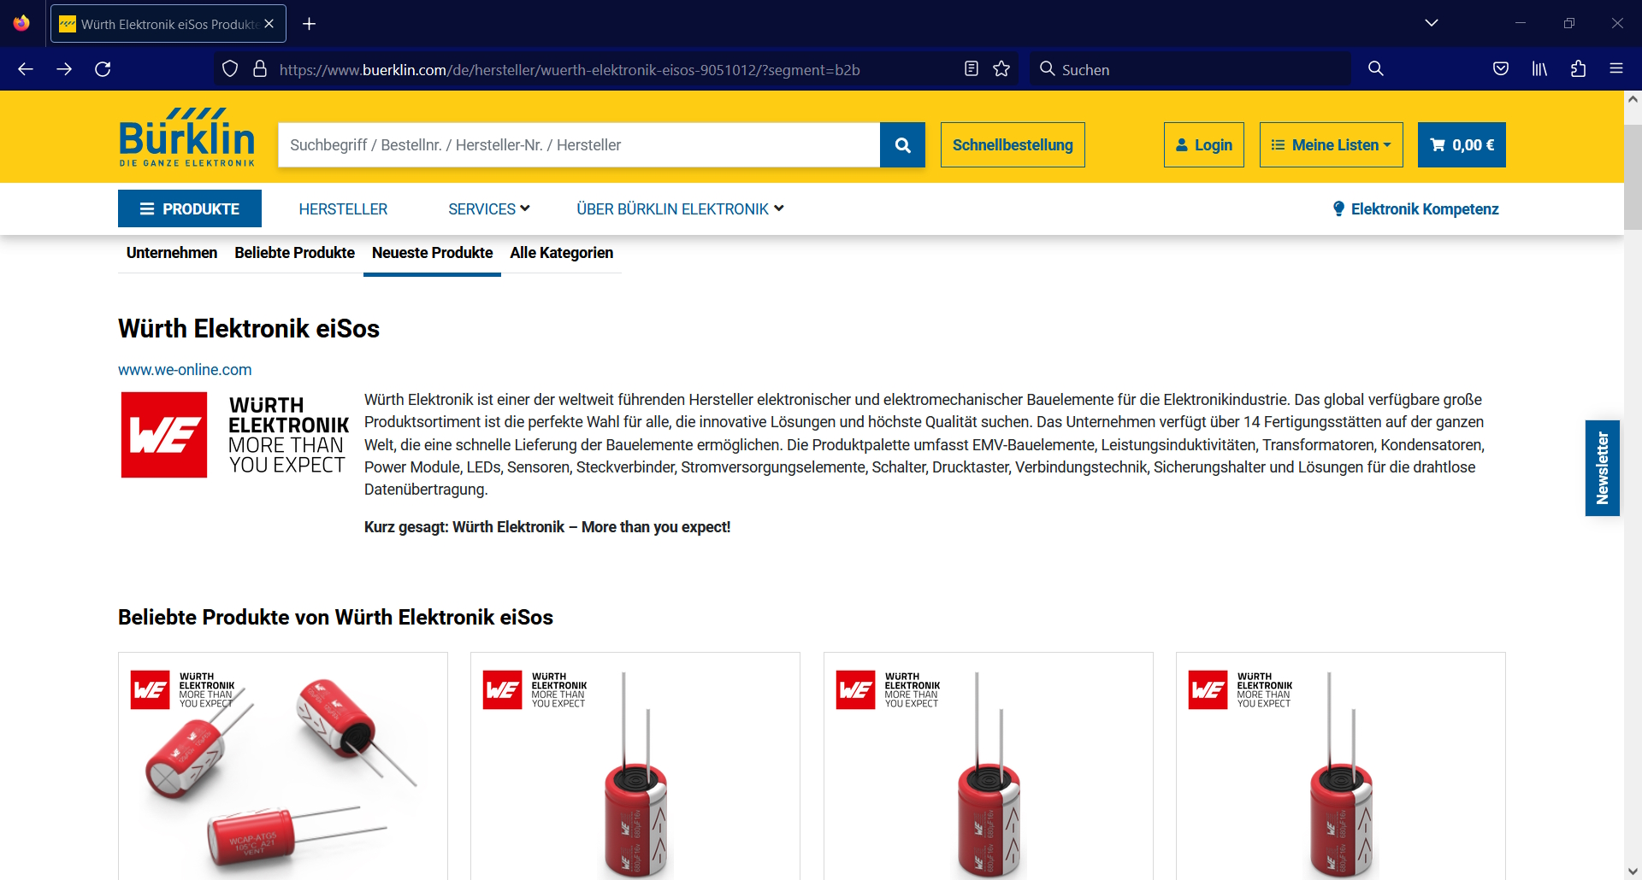
Image source: Bürklin Elektronik

Components from Würth Elektronik such as capacitors can now be found at Bürklin's online shop.

About Bürklin Elektronik
Bürklin Elektronik is an independent German distributor specializing in high-quality electronic components. The company headquartered in Oberhaching near Munich has more than 70,000 products from more than 500 leading manufacturers available immediately from stock. Bürklin Elektronik distributes its products worldwide via its online shop (www.buerklin.com) and in its store.

Orders for products in stock received by 6.00 pm Monday through Friday are usually delivered within Germany the next workday.
More information at www.buerklin.com

About the Würth Elektronik eiSos Group
Würth Elektronik eiSos Group is a manufacturer of electronic and electromechanical components for the electronics industry and a technology company that spearheads pioneering electronic solutions. Würth Elektronik eiSos is one of the largest European manufacturers of passive components and is active in 50 countries. Production sites in Europe, Asia and North America supply a growing number of customers worldwide.
The product range includes EMC components, inductors, transformers, RF components, varistors, capacitors, resistors, quartz crystals, oscillators, power modules, Wireless Power Transfer, LEDs, sensors, radio modules, connectors, power supply elements, switches, push-buttons, connection technology, fuse holders and solutions for wireless data transmission.
The unrivaled service orientation of the company is characterized by the availability of all catalog components from stock without minimum order quantity, free samples and extensive support through technical sales staff and selection tools.
Würth Elektronik is part of the Würth Group, the global market leader in the development, production, and sale of fastening and assembly materials, and employs 8,200 people. In 2022, the Würth Elektronik Group generated sales of 1.33 Billion Euro.
Würth Elektronik: more than you expect!
Further information at www.we-online.com

Further information:  Würth Elektronik eiSos GmbH & Co. KG  Sarah Hurst  Clarita-Bernhard-Strasse 9  81249 Munich  Germany  Phone: +49 7942 945-5186  E-mail: sarah.hurst@we-online.de  www.we-online.com | Press contact:  HighTech communications GmbH  Brigitte Basilio  Brunhamstrasse 21  81249 Munich  Germany  Phone: +49 89 500778-20  E-mail: b.basilio@htcm.de  www.htcm.de

