PRESS RELEASE

Würth Elektronik eiSos GmbH & Co. KG in the “Stern” poll “Companies fit for the future”
The way an employer should be fit for the future
Waldenburg (Germany), November 9, 2023 – Würth Elektronik eiSos GmbH & Co. KG, a manufacturer of electronic and electromechanical components, has won a top-ranking place in a survey into the way that work environments are shaped, achieving five out of five stars. The editorial board of “Stern” magazine worked together with the HR marketing agency, Territory Embrace, to organize the poll “Unternehmen mit Zukunft” (Companies fit for the future). Three hundred fifty-six companies with a total of almost 2 million employees took the time to answer nearly 90 questions. Right up there, among the listed companies with good to excellent results in the category of medium-sized companies with 500 to 2,500 employees, is Würth Elektronik eiSos GmbH & Co. KG.
The Stern editors drew up the survey in collaboration with the advisory board and experts of the HR marketing agency Territory Embrace. Professor Jutta Rump, director of the Institut für Beschäftigung und Employability IBE (Institute for Jobs and Employability) at the Ludwigshafen University of Business and Society, acting as scientific advisor.
Also involved was the entrepreneur Michael Trautmann, host of the podcast “On the Way to New Work.” The questions revolved around the aspects of mobile work, organizing working times, structural organization, empowerment, and digitization and innovation. Among the topics on the questionnaire were the freedom to choose where to work, the work tools provided by the employer, the design of the workplaces in the office, and measures for hybrid working, as well as ones concerning the space and budget for new ideas, advanced training opportunities, and measures to promote sustainability.
“For us, this five-out-of-five-star rating is clear confirmation that we really are fully on track in matters of ‘New Work,’ and even a trend-setter in the field", says Arnt Stumpf, Head of Human Resources at Würth Elektronik eiSos GmbH & Co. KG. “Anyone speaking with the employees at Würth Elektronik swiftly realizes that there’s a special spirit within our company, a motivating sense of cooperation at the eye-to-eye level. We’re delighted that accolades, like the one awarded to us by ‘Stern,’ help to put us on the map for potential job candidates; showing them that the work environment here is designed exactly as it should be for a company fit for the future.”

Available images
The following images can be downloaded from the Internet in printable quality: https://kk.htcm.de/press-releases/wuerth/
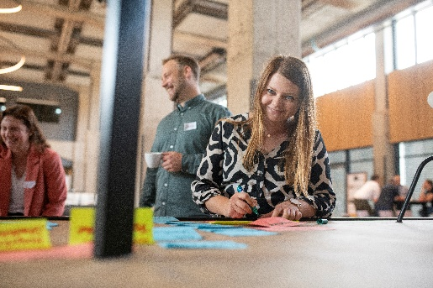
Image source: Würth Elektronik
Satisfied employees at Würth Elektronik - Stern study confirms future viability.

About the Würth Elektronik eiSos Group
Würth Elektronik eiSos Group is a manufacturer of electronic and electromechanical components for the electronics industry and a technology company that spearheads pioneering electronic solutions. Würth Elektronik eiSos is one of the largest European manufacturers of passive components and is active in 50 countries. Production sites in Europe, Asia and North America supply a growing number of customers worldwide.
The product range includes EMC components, inductors, transformers, RF components, varistors, capacitors, resistors, quartz crystals, oscillators, power modules, Wireless Power Transfer, LEDs, sensors, radio modules, connectors, power supply elements, switches, push-buttons, connection technology, fuse holders and solutions for wireless data transmission.
The unrivaled service orientation of the company is characterized by the availability of all catalog components from stock without minimum order quantity, free samples and extensive support through technical sales staff and selection tools.
Würth Elektronik is part of the Würth Group, the global market leader in the development, production, and sale of fastening and assembly materials, and employs 8,200 people. In 2022, the Würth Elektronik Group generated sales of 1.33 Billion Euro.

Würth Elektronik: more than you expect!
Further information at www.we-online.com

Further information:  Würth Elektronik eiSos GmbH & Co. KG  Sarah Hurst  Clarita-Bernhard-Strasse 9  81249 Munich  Germany  Phone: +49 7942 945-5186  E-mail: sarah.hurst@we-online.de  www.we-online.com | Press contact:  HighTech communications GmbH  Brigitte Basilio  Brunhamstrasse 21  81249 Munich  Germany  Phone: +49 89 500778-20  E-mail: b.basilio@htcm.de  www.htcm.de

