PRESS RELEASE
Würth Elektronik extends its MagI³C-FISM family
Isolated Power Module with High Efficiency, Highly Protected
Waldenburg (Germany), February 7, 2024 – The MagI³C-FISM power modules from Würth Elektronik have a new arrival: WPME-FISM ‘Fixed Isolated SIP/SMT Module’ SMT-8 with 3.3 V to 5 V, rated for 1 W P_{OUT}. The DC/DC voltage converter with fixed output voltage and integrated switching power stage, transformer, as well as input and output capacitance, is 100% pin-to-pin compatible with the previous MagI³C-FISM. It has improved properties: the efficiency goes up to 84 percent, the ambient temperature range has been increased to 105°C and the isolation voltage is 3 kV (for 60 seconds). Like some of its predecessors, this power module has continuous short-circuit protection.
The MagI³C FISM power modules have the advantage that no external components are required for operation and the effort required for circuit design is therefore minimal. Applications for the module include supplying voltages for interfaces and microcontrollers in test and measurement technology or industrial electronics. Thanks to its properties, it serves as simple functional isolation for overvoltage protection. For example, it prevents ground loops and shifts as well as interference in the signal path or sensor systems.
The entire product range is UL 62368-1 recognized. The low level of conducted and radiated electromagnetic interference complies with the EN55032 Class B / CISPR-32 standard.
Würth Elektronik supplies free samples on request. The new FISM module with 5 V output voltage is now available from stock without a minimum order quantity.

Available images
The following images can be downloaded from the Internet in printable quality: https://kk.htcm.de/press-releases/wuerth/

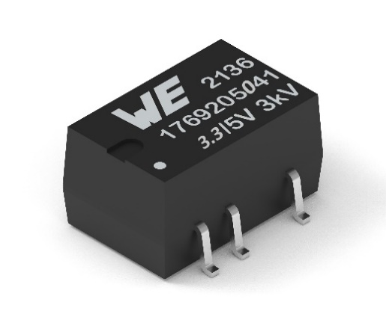Image source: Würth Elektronik
WPME-FISM SMT-8, 3.3 V to 5 V functionally isolated power module

About the Würth Elektronik eiSos Group
Würth Elektronik eiSos Group is a manufacturer of electronic and electromechanical components for the electronics industry and a technology company that spearheads pioneering electronic solutions. Würth Elektronik eiSos is one of the largest European manufacturers of passive components and is active in 50 countries. Production sites in Europe, Asia and North America supply a growing number of customers worldwide.
The product range includes EMC components, inductors, transformers, RF components, varistors, capacitors, resistors, quartz crystals, oscillators, power modules, Wireless Power Transfer, LEDs, sensors, radio modules, connectors, power supply elements, switches, push-buttons, connection technology, fuse holders and solutions for wireless data transmission. The portfolio is complemented by customized solutions.
The unrivaled service orientation of the company is characterized by the availability of all catalog components from stock without minimum order quantity, free samples and extensive support through technical sales staff and selection tools.
Würth Elektronik is part of the Würth Group, the global market leader in the development, production, and sale of fastening and assembly materials, and employs 7,900 people. In 2023, the Würth Elektronik Group generated sales of 1.24 Billion Euro.
Würth Elektronik: more than you expect!
Further information at www.we-online.com

Further information:  Würth Elektronik eiSos GmbH & Co. KG  Sarah Hurst  Clarita-Bernhard-Strasse 9  81249 Munich  Germany  Phone: +49 7942 945-5186  E-mail: sarah.hurst@we-online.de  www.we-online.com | Press contact:  HighTech communications GmbH  Brigitte Basilio  Brunhamstrasse 21  81249 Munich  Germany  Phone: +49 89 500778-20  E-mail: b.basilio@htcm.de  www.htcm.de

