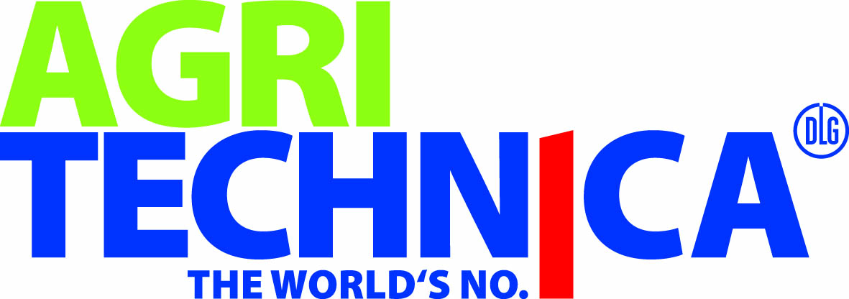PRESS RELEASE
Würth Elektronik to appear at Agritechnica
Light for indoor farming
12–18 November 2023
Hall 24, Booth E34
Waldenburg (Germany), October 31, 2023 – Würth Elektronik and Agile Solutions will be exhibiting together at Stand 24 in Hall E34 at the Hanover Trade Fair from November 12 to 18, 2023. The booth is part of the "Inhouse Farming - Feed & Food Show" at Agritechnica 2023, where the manufacturer of electronic and electromechanical components and the development service provider will present the result of their cooperation, a multichannel luminaire with Würth Elektronik's Horticulture LEDs, used in an algae reactor. Würth Elektronik is also contributing a presentation to the program of the leading German agricultural technology trade fair.
Würth Elektronik not only offers LEDs specially designed for the requirements of plant lighting, but also gives research into the control of plant growth via light recipes. On the motivation for getting involved in this area, Alexander Gerfer, CTO at Würth Elektronik eiSos GmbH & Co. KG says "Vertical farming with horticulture LEDs makes a significant contribution to producing food sustainably and locally. It should be seen as part of the solution when it comes to feeding the world's growing population in the future. It complements traditional agriculture in a meaningful way, providing increased yields and a secure food supply."
"Different wavelengths of light elicit different responses in plants. The possibilities for influencing nutrient content, for example, are fascinating. We are involved in researching these relationships and are happy to share our findings with developers of in-house farming solutions," adds Johann Waldherr, Electronic Power & Lighting Solutions Business Development Manager at Würth Elektronik eiSos.

Available images
The following images can be downloaded from the Internet in printable quality: https://kk.htcm.de/press-releases/wuerth/

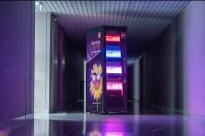
Image source: Würth Elektronik
Connected Vertical Farm prototype from Würth Elektronik: demonstration plant for plant-optimized LED lighting, sensor technology and wireless communication.

About the Würth Elektronik eiSos Group
Würth Elektronik eiSos Group is a manufacturer of electronic and electromechanical components for the electronics industry and a technology company that spearheads pioneering electronic solutions. Würth Elektronik eiSos is one of the largest European manufacturers of passive components and is active in 50 countries. Production sites in Europe, Asia and North America supply a growing number of customers worldwide.
The product range includes EMC components, inductors, transformers, RF components, varistors, capacitors, resistors, quartz crystals, oscillators, power modules, Wireless Power Transfer, LEDs, sensors, radio modules, connectors, power supply elements, switches, push-buttons, connection technology, fuse holders and solutions for wireless data transmission.
The unrivaled service orientation of the company is characterized by the availability of all catalog components from stock without minimum order quantity, free samples and extensive support through technical sales staff and selection tools.
Würth Elektronik is part of the Würth Group, the global market leader in the development, production, and sale of fastening and assembly materials, and employs 8,200 people. In 2022, the Würth Elektronik Group generated sales of 1.33 Billion Euro.
Würth Elektronik: more than you expect!
Further information at www.we-online.com

Further information:  Würth Elektronik eiSos GmbH & Co. KG  Sarah Hurst  Clarita-Bernhard-Strasse 9  81249 Munich  Germany  Phone: +49 7942 945-5186  E-mail: sarah.hurst@we-online.de  www.we-online.com | Press contact:  HighTech communications GmbH  Brigitte Basilio  Brunhamstrasse 21  81249 Munich  Germany  Phone: +49 89 500778-20  E-mail: b.basilio@htcm.de  www.htcm.de

