PRESS RELEASE

Würth Elektronik establishes Danish subsidiary
Strengthening the Scandinavian Presence
Waldenburg (Germany), December 13, 2023 – With the establishment of Würth Elektronik Danmark A/S, customers from Denmark, Greenland and the Faroe Islands now have a direct point of contact for their electronic and electromechanical component needs. Previously, these markets were also served by the Swedish subsidiary.
Würth Elektronik Danmark A/S is based in the north of Aarhus. A team headed by CEO Ole Sanggaard Knudsen, Finance Manager Gunhild Nors and Office Manager Claire Boelstoft is being set up there to provide even better support for the Danish electronics industry.
“We would like to thank our colleagues in Germany and Sweden for their support in establishing our company,” says Knudsen. “The fact that we can take this step comes from the trust our Danish customers have placed in us. Würth Elektronik is established here as a brand and now also as a company.”
The address of the new subsidiary in Denmark:

Würth Elektronik Danmark A/S
Agro Food Park 26
8200 Aarhus N

Available images
The following images can be downloaded from the Internet in printable quality: https://kk.htcm.de/press-releases/wuerth/

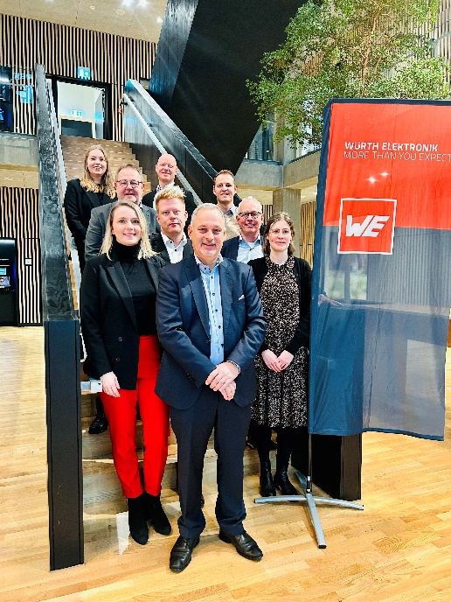
New subsidiary serves Denmark, Greenland and the Faroe Islands.
CEO Ole Sanggaard Knudsen (front center) with his team (from top left):
Marie Klausen, IDM, Jesper Ankerstjerne Boje, Area Sales Manager, Hans-Christian Elgaard, Area Sales Manager, Marius Bauer, IDM, Kenn Marcussen, Area Sales Manager, Bo Christensen, Sales Manager, Claire Boelstoft, Office Manager, Ole Sanggaard Knudsen, CEO, Gunhild Nors, Finance Manager.
Image source: Würth Elektronik

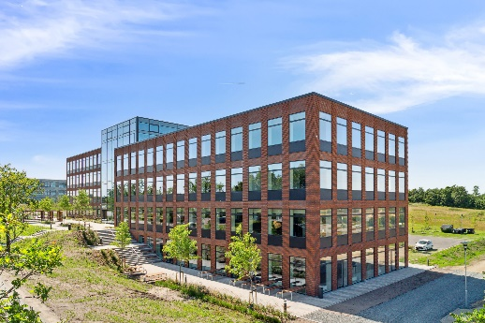
Würth Elektronik Danmark A/S is based in the north of Aarhus.
Image source: Würth Elektronik

About the Würth Elektronik eiSos Group
Würth Elektronik eiSos Group is a manufacturer of electronic and electromechanical components for the electronics industry and a technology company that spearheads pioneering electronic solutions. Würth Elektronik eiSos is one of the largest European manufacturers of passive components and is active in 50 countries. Production sites in Europe, Asia and North America supply a growing number of customers worldwide.
The product range includes EMC components, inductors, transformers, RF components, varistors, capacitors, resistors, quartz crystals, oscillators, power modules, Wireless Power Transfer, LEDs, sensors, radio modules, connectors, power supply elements, switches, push-buttons, connection technology, fuse holders and solutions for wireless data transmission.

The unrivaled service orientation of the company is characterized by the availability of all catalog components from stock without minimum order quantity, free samples and extensive support through technical sales staff and selection tools.
Würth Elektronik is part of the Würth Group, the global market leader in the development, production, and sale of fastening and assembly materials, and employs 8,200 people. In 2022, the Würth Elektronik Group generated sales of 1.33 Billion Euro.
Würth Elektronik: more than you expect!
Further information at www.we-online.com

Further information:  Würth Elektronik eiSos GmbH & Co. KG  Sarah Hurst  Clarita-Bernhard-Strasse 9  81249 Munich  Germany  Phone: +49 7942 945-5186  E-mail: sarah.hurst@we-online.de  www.we-online.com | Press contact:  HighTech communications GmbH  Brigitte Basilio  Brunhamstrasse 21  81249 Munich  Germany  Phone: +49 89 500778-20  E-mail: b.basilio@htcm.de  www.htcm.de

