PRESS RELEASE

Würth Elektronik renews partnership with student-run, fighting robot team
Technical prowess and innovation
Watertown (USA), October 30, 2023 – Würth Elektronik is thrilled to announce its ongoing collaboration with Team Uairrior, the formidable student-led combat robot squad. The global manufacturer of electronic and electromechanical components is proud to once again step into the role of a primary Patron for the team‘s awe-inspiring creation, Black Dragon, as they gear up to compete in the highly anticipated BattleBots World Championship VIII Tournament, set to air on The Discovery Channel.
Würth Elektronik eagerly returns to the electrifying arena where the true core of robotics education and expertise is put to the ultimate test. With robots becoming more prevalent in everyday living, this involvement provides an invaluable gateway to the heart of the industry.
Melissa Hansen, a Customer Outreach Specialist in Würth Elektronik's Marketing Department, expressed the significance of this ongoing partnership: "Our support last year laid the groundwork for what's possible when supporting a team as technically proficient as Uairrior. To discontinue this partnership would mean missing out on the full scale of benefits."
Black Dragon, the 250 pound fighting robot with an egg beater spinner as a weapon, made it’s televised debut in 2019; taking home the championship trophy of the competition. The BattleBot will also compete in the Golden Bolt Tournament; debuting in October 2023.
But Wait, There’s More!
This year, Team Uairrior has channeled a significant portion of their efforts towards the development of their impressive array of autonomous robots. Their dedication and innovation bore fruit in July 2023 at the Robocore Experience, where Team Uairrior clinched the prestigious Team Spirit award. In addition to this honor, they triumphed in eight other categories spanning autonomous and fighting robot competitions.
The 2023/2024 season lineup boasts an impressive roster of fighting robots, each proudly adorned with the Würth Elektronik logo. The lineup includes Kowalski, competing in the 150-gram (0.3 lbs.) division; Bacon, a contender in the 454-gram (1 lbs.) division; Federal, an intimidating force in the Lightweight (27.7 kilos or 60 lbs.) division; and General, reigning as the world champion in the Middleweight (54.4 kilos or 120 lbs.) division.
Beyond Patronage, Würth Elektronik extends its support to Team Uairrior, providing access to their expert engineering staff and delivering free samples upon request, thus bolstering the team's technical prowess and innovation.

Available images
The following images can be downloaded from the Internet in printable quality: https://kk.htcm.de/press-releases/wuerth/
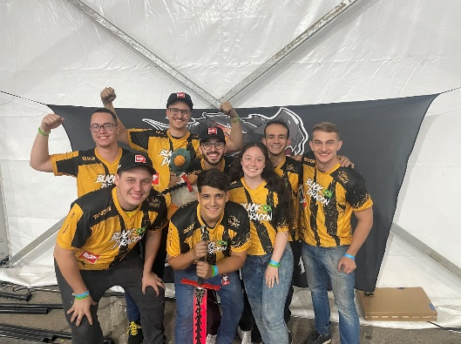  Image source: Wurth Electronics  The Team of Fighting Robot Black Dragon supported by Würth Elektronik: This year, Team Uairrior also developed impressive array of autonomous robots. | 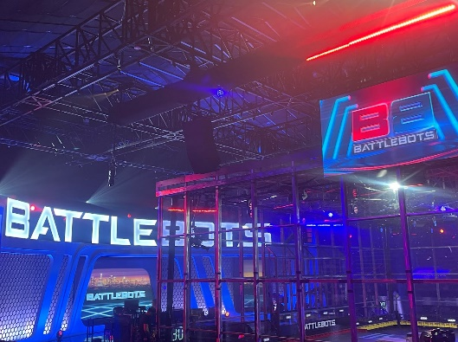  Image source: Wurth Electronics  The electrifying arena where the true core of robotics education and expertise is put to the ultimate test: WE will be back!

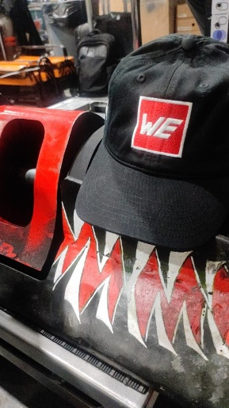

Patronage, access to expert engineering, free samples: Würth Elektronik offers all under one hat.
Image source: Wurth Electronics

About the Würth Elektronik eiSos Group
Würth Elektronik eiSos Group is a manufacturer of electronic and electromechanical components for the electronics industry and a technology company that spearheads pioneering electronic solutions. Würth Elektronik eiSos is one of the largest European manufacturers of passive components and is active in 50 countries. Production sites in Europe, Asia and North America supply a growing number of customers worldwide.
The product range includes EMC components, inductors, transformers, RF components, varistors, capacitors, resistors, quartz crystals, oscillators, power modules, Wireless Power Transfer, LEDs, sensors, radio modules, connectors, power supply elements, switches, push-buttons, connection technology, fuse holders and solutions for wireless data transmission.
The unrivaled service orientation of the company is characterized by the availability of all catalog components from stock without minimum order quantity, free samples and extensive support through technical sales staff and selection tools.
Würth Elektronik is part of the Würth Group, the global market leader in the development, production, and sale of fastening and assembly materials, and employs 8,200 people. In 2022, the Würth Elektronik Group generated sales of 1.33 Billion Euro.
Würth Elektronik: more than you expect!
Further information at www.we-online.com

Further information:  Wurth Electronics Midcom, Inc.  Amelia Thompson  121 Airport Drive  PO Box 1330  Watertown, SD 57201 USA  Phone: +1 605 886 4385  Toll-free (in the U.S.):  Phone: +1 800 643 2661  E-mail: amelia.thompson@we-online.com  www.we-online.com | Press contact:  HighTech communications GmbH  Brigitte Basilio  Brunhamstrasse 21  81249 Munich  Germany  Phone: +49 89 500778-20  E-mail: b.basilio@htcm.de  www.htcm.de

