PRESS RELEASE

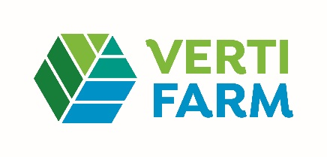
Würth Elektronik at the VertiFarm 2023
Present and future in vertical farming
September 26-28, 2023
Hall 4, Booth 4.D24
Waldenburg, September 19, 2023 – Coming soon to VertiFarm, the international trade fair for Next Level Farming and New Food Systems, Würth Elektronik will be showing how modern electronic components and expertise in food production can make innovations possible. At booth 4.D24, the manufacturer of electronic and electromechanical components, together with lighting specialist ENGEL LIGHTING, will present concepts and technologies for vertical farming.
From September 26 to 28, 2023, experts and decision-makers from all over the world will come to Dortmund to find innovative ideas, high-tech innovations, and products and services for a sustainable food supply. The focus of the exhibition is on controlled cultivation systems for plants, along with solutions for fish, algae, and insect farming, and the production of mushrooms and cell-based or cell-cultured meat.
Connected Vertical Farming
At the trade fair, Würth Elektronik will demonstrate how vertical farming with LEDs, or smart farming with control via IoT, works. The focus will be on plant-optimized lighting with horticulture LEDs, as well as real-time monitoring and remote control of sensors and actuators via wireless connectivity.
Vertical Farming in Practice
The economic aspects of vertical farming will be the subject of a presentation, “Vertical Farming: profitable or not? – It all depends on the application,” by Johann Waldherr, Business Development Manager Electronic Power & Lightning Solutions at Würth Elektronik eiSos GmbH & Co. KG, on September 27 at 3:05 p.m. on the VertiFarm Stage in Hall 4. Waldherr will present various use cases, as well as research projects for increasing efficiency.
Show what works
"In view of the growing population, advancing climate change and rising transport costs, we need to make our food production more effective, environmentally friendly and closer to the consumer, both now and in the future. In this context, vertical farming is a sensible and necessary complement to traditional agriculture," explains Alexander Gerfer, CTO at Würth Elektronik eiSos GmbH & Co. KG. "Here at VertiFarm, we are showing what is possible, what can already be implemented today - with concepts that we helped develop, with components that we can deliver immediately from stock, even in large quantities. We support our customers with free laboratory samples and know-how. The result is mature products like those presented by lighting specialist ENGEL LIGHTING at our joint booth."

Available images
The following images can be downloaded from the Internet in printable quality: https://kk.htcm.de/press-releases/wuerth/
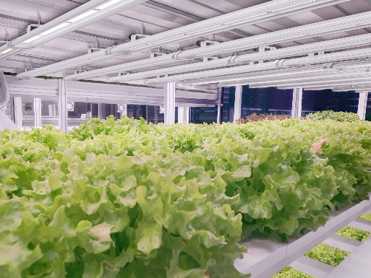
Image source: Engel Lighting
Plant lighting "Line", made with Würth Elektronik LEDs, designed for indoor vertical farming.

Available videos
You can find a video on this topic on our YouTube channel:
https://www.youtube.com/watch?v=U_OoyHLR7lQ
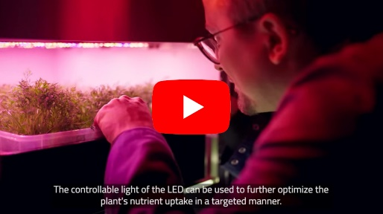
Image source: Würth Elektronik
„The future of food production!“

About the Würth Elektronik eiSos Group
Würth Elektronik eiSos Group is a manufacturer of electronic and electromechanical components for the electronics industry and a technology company that spearheads pioneering electronic solutions. Würth Elektronik eiSos is one of the largest European manufacturers of passive components and is active in 50 countries. Production sites in Europe, Asia and North America supply a growing number of customers worldwide.
The product range includes EMC components, inductors, transformers, RF components, varistors, capacitors, resistors, quartz crystals, oscillators, power modules, Wireless Power Transfer, LEDs, sensors, radio modules, connectors, power supply elements, switches, push-buttons, connection technology, fuse holders and solutions for wireless data transmission.
The unrivaled service orientation of the company is characterized by the availability of all catalog components from stock without minimum order quantity, free samples and extensive support through technical sales staff and selection tools.
Würth Elektronik is part of the Würth Group, the global market leader in the development, production, and sale of fastening and assembly materials, and employs 8,200 people. In 2022, the Würth Elektronik Group generated sales of 1.33 Billion Euro.
Würth Elektronik: more than you expect!
Further information at www.we-online.com

Further information:  Wurth Electronics Midcom, Inc.  Amelia Thompson  121 Airport Drive  PO Box 1330  Watertown, SD 57201 USA  Phone: +1 605 886 4385  Toll-free (in the U.S.):  Phone: +1 800 643 2661  E-mail: amelia.thompson@we-online.com  www.we-online.com | Press contact:  HighTech communications GmbH  Brigitte Basilio  Brunhamstrasse 21  81249 Munich  Germany  Phone: +49 89 500778-20  E-mail: b.basilio@htcm.de  www.htcm.de

