PRESS RELEASE

Würth Elektronik expands its program of differential pressure sensors
High-precision MEMS Pressure Sensors Now Also for 3.3 V Supply
Waldenburg (Germany), December 14, 2023 – The family of WSEN-PDUS differential pressure sensors from Würth Elektronik has grown: The two new models work with an operating voltage of 3.3 V and are therefore compatible with most microcontrollers that support this supply voltage. The other models in the series require 5 V. What all sensors have in common is their high robustness and accuracy of up to ±0.25 percent FSS tolerance. Another innovation: A sensor version is now also available with horizontal nozzles.
The new packaging design with horizontal-barbed nozzles enables pneumatic hoses to be connected directly to the sensor nozzles. This eliminates the need for an additional adapter and simplifies the installation process. Equipped with digital I²C and analog output interfaces, the sensors deliver fully calibrated pressure data as well as optional temperature data. Different transfer functions from ±1 mbar to +15 bar (±0.0145 PSI to +0.218 PSI) may be selected. Würth Elektronik’s robust differential pressure sensors with an operating temperature range of -25°C to +85°C can be used in a variety of applications: from HVAC technology to monitoring filter status and detecting gas leaks, through to inhalers.
All sensor components in the product range and evaluation boards are available from stock with no minimum order quantities. Würth Elektronik can also design individual application-specific sensor variants on request, with customer-specific pressure ranges.

Available images
The following images can be downloaded from the Internet in printable quality: https://kk.htcm.de/press-releases/wuerth/

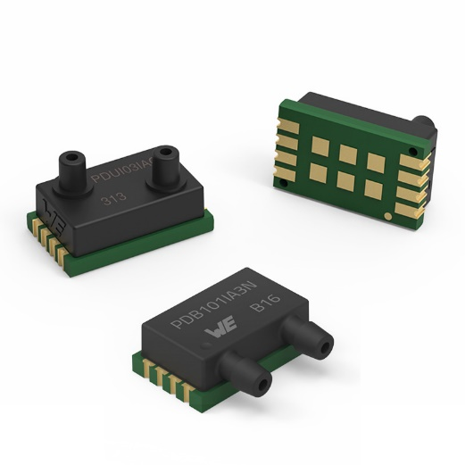 Image source: Würth Elektronik
The WSEN-PDUS differential pressure sensors from Würth Elektronik – now available with 3.3 V operating voltage and side nozzles.

About the Würth Elektronik eiSos Group
Würth Elektronik eiSos Group is a manufacturer of electronic and electromechanical components for the electronics industry and a technology company that spearheads pioneering electronic solutions. Würth Elektronik eiSos is one of the largest European manufacturers of passive components and is active in 50 countries. Production sites in Europe, Asia and North America supply a growing number of customers worldwide.
The product range includes EMC components, inductors, transformers, RF components, varistors, capacitors, resistors, quartz crystals, oscillators, power modules, Wireless Power Transfer, LEDs, sensors, radio modules, connectors, power supply elements, switches, push-buttons, connection technology, fuse holders and solutions for wireless data transmission.
The unrivaled service orientation of the company is characterized by the availability of all catalog components from stock without minimum order quantity, free samples and extensive support through technical sales staff and selection tools.
Würth Elektronik is part of the Würth Group, the global market leader in the development, production, and sale of fastening and assembly materials, and employs 8,200 people. In 2022, the Würth Elektronik Group generated sales of 1.33 Billion Euro.
Würth Elektronik: more than you expect!
Further information at www.we-online.com

Further information:  Würth Elektronik eiSos GmbH & Co. KG  Sarah Hurst  Clarita-Bernhard-Strasse 9  81249 Munich  Germany  Phone: +49 7942 945-5186  E-mail: sarah.hurst@we-online.de  www.we-online.com | Press contact:  HighTech communications GmbH  Brigitte Basilio  Brunhamstrasse 21  81249 Munich  Germany  Phone: +49 89 500778-20  E-mail: b.basilio@htcm.de  www.htcm.de

