PRESS RELEASE

Zephyr OS with drivers for Würth Elektronik sensors
Easy Sensor Integration for IoT Projects
Waldenburg (Germany), November 21, 2023 – Würth Elektronik is also focusing on IoT applications with its portfolio of MEMS sensors. Zephyr OS – the microcontroller operating system from the Linux Foundation now includes the corresponding drivers. The new application note ANR034 (www.we-online.com/ANR034) from Würth Elektronik provides instructions on how to integrate a sensor into the terminal device software in just a few steps.
Würth Elektronik offers a product portfolio of compact sensors, which includes humidity and temperature sensors, a 6-axis gyroscope with accelerometer, as well as absolute and differential pressure sensors. Their selectable measuring ranges and data rates make all sensors extremely versatile. They provide pre-calibrated and aligned data for easy integration into any application. Thanks to the drivers written into the Zephyr source code and the practical guidance now published, integration into a terminal device is near effortless.
Flexible hardware usage
The vendor-independent Zephyr operating system has the major advantage that the firmware developed with it operates on different hardware platforms without modifications. In view of the sometimes limited availability of semiconductors, this represents a significant strategic advantage. A large number of IC manufacturers have already entered their hardware descriptions into Zephyr. What’s more, the open source community is involved in maintaining the software along with companies like NXP, Nordic Semiconductor, ST Micro Electronics, and Intel to name a few. Zephyr not only includes operating system functions like multithreading and dynamic memory allocation, but also offers many functions for operating external electronic components such as sensors, displays and radio modules. Besides sensor drivers, the information needed to develop firmware for the Würth Elektronik wireless modules is also included in Zephyr OS. As communication solutions are an important part of IoT projects, Würth Elektronik offers a firmware development service and support in certifying customer-specific wireless technology.

Available images
The following images can be downloaded from the Internet in printable quality: https://kk.htcm.de/press-releases/wuerth/
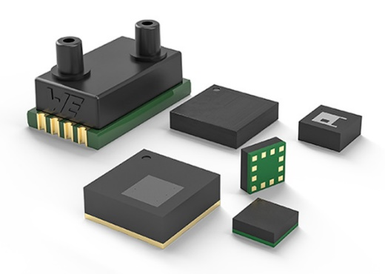
Image source: Würth Elektronik
Firmware for IoT devices: Zephyr OS now includes the drivers for the Würth Elektronik sensor modules. An application note guides you step by step through the integration process.

About the Würth Elektronik eiSos Group
Würth Elektronik eiSos Group is a manufacturer of electronic and electromechanical components for the electronics industry and a technology company that spearheads pioneering electronic solutions. Würth Elektronik eiSos is one of the largest European manufacturers of passive components and is active in 50 countries. Production sites in Europe, Asia and North America supply a growing number of customers worldwide.
The product range includes EMC components, inductors, transformers, RF components, varistors, capacitors, resistors, quartz crystals, oscillators, power modules, Wireless Power Transfer, LEDs, sensors, radio modules, connectors, power supply elements, switches, push-buttons, connection technology, fuse holders and solutions for wireless data transmission.
The unrivaled service orientation of the company is characterized by the availability of all catalog components from stock without minimum order quantity, free samples and extensive support through technical sales staff and selection tools.

Würth Elektronik is part of the Würth Group, the global market leader in the development, production, and sale of fastening and assembly materials, and employs 8,200 people. In 2022, the Würth Elektronik Group generated sales of 1.33 Billion Euro.
Würth Elektronik: more than you expect!
Further information at www.we-online.com

Further information:  Würth Elektronik eiSos GmbH & Co. KG  Sarah Hurst  Clarita-Bernhard-Strasse 9  81249 Munich  Germany  Phone: +49 7942 945-5186  E-mail: sarah.hurst@we-online.de  www.we-online.com | Press contact:  HighTech communications GmbH  Brigitte Basilio  Brunhamstrasse 21  81249 Munich  Germany  Phone: +49 89 500778-20  E-mail: b.basilio@htcm.de  www.htcm.de

