PRESS RELEASE

Application Note for using Würth Elektronik optocouplers in flyback converters
Design of the Compensation Circuit for a Flyback Converter
Waldenburg (Germany), February 13, 2024 – Würth Elektronik has published its new Application Note “Compensating the feedback loop of a current-controlled flyback converter with optocoupler” (http://www.we-online.com/ANP113). The guide is aimed at developers looking to use a DC/DC flyback converter to achieve greater stability and reliability in power supply design. It might also be useful for those who use optocouplers for galvanic isolation of the feedback path. Applications include primary and auxiliary power supplies for home appliances, battery chargers for smartphones and tablets, as well as LED lighting. This Application Note also provides valuable assistance with power supplies for desktop and laptop computers, industrial power supplies and auxiliary supplies in motor drives, or for Power-over-Ethernet (PoE).
AppNote ANP113 explains in detail how the feedback loop can be compensated using a current-controlled flyback converter with optocoupler, and which aspects require special attention. The CTR (current transfer ratio) influences the control loop of the compensation circuit and therefore must be carefully considered in the design stage. ANP113 places particular emphasis on design constraints imposed by the optocoupler parameters and on the related solutions. The validation results of a 30-W flyback converter prototype are also included in the AppNote.

Available images
The following images can be downloaded from the Internet in printable quality: https://kk.htcm.de/press-releases/wuerth/

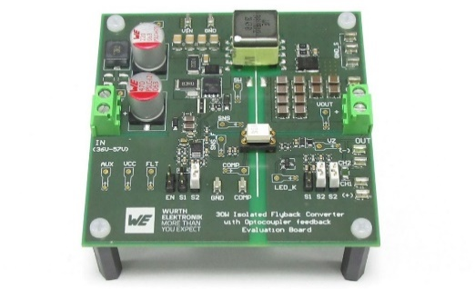
Image source: Würth Elektronik
Current-controlled flyback converter with optocoupler feedback loop – Application Note ANP113 from Würth Elektronik explains what needs to be considered in design.

About the Würth Elektronik eiSos Group
Würth Elektronik eiSos Group is a manufacturer of electronic and electromechanical components for the electronics industry and a technology company that spearheads pioneering electronic solutions. Würth Elektronik eiSos is one of the largest European manufacturers of passive components and is active in 50 countries. Production sites in Europe, Asia and North America supply a growing number of customers worldwide.
The product range includes EMC components, inductors, transformers, RF components, varistors, capacitors, resistors, quartz crystals, oscillators, power modules, Wireless Power Transfer, LEDs, sensors, radio modules, connectors, power supply elements, switches, push-buttons, connection technology, fuse holders and solutions for wireless data transmission. The portfolio is complemented by customized solutions.
The unrivaled service orientation of the company is characterized by the availability of all catalog components from stock without minimum order quantity, free samples and extensive support through technical sales staff and selection tools.
Würth Elektronik is part of the Würth Group, the global market leader in the development, production, and sale of fastening and assembly materials, and employs 7,900 people. In 2023, the Würth Elektronik Group generated sales of 1.24 Billion Euro.
Würth Elektronik: more than you expect!
Further information at www.we-online.com

Further information:  Würth Elektronik eiSos GmbH & Co. KG  Sarah Hurst  Clarita-Bernhard-Strasse 9  81249 Munich  Germany  Phone: +49 7942 945-5186  E-mail: sarah.hurst@we-online.de  www.we-online.com | Press contact:  HighTech communications GmbH  Brigitte Basilio  Brunhamstrasse 21  81249 Munich  Germany  Phone: +49 89 500778-20  E-mail: b.basilio@htcm.de  www.htcm.de

