PRESS RELEASE

Würth Elektronik introduces its series of MEMS humidity sensor capacitors
Small, Economical and Very Precise
Waldenburg (Germany), January 24, 2024 – Würth Elektronik is launching a very compact, cost-effective digital humidity sensor in the WSEN-HIDS series. The MEMS (Micro-Electro-Mechanical System) sensor measures with a precision of ±1.8% RH in the 20 - 80 percent relative humidity range. The DFN (Dual Flat No Leads) package for SMT assembly measures just 1.5 x 1.5 x 0.5 mm. The sensor works with a current of only 0.4 µA and can be operated with a power supply between 1.08 and 3.6 V. So it is ideally suited for distributed IoT sensor networks, such as those in smart farming applications.
The humidity sensor from Würth Elektronik uses a dielectric polymer that interacts with water molecules to adjust the permeability of the capacitor structure depending on the relative humidity of the surroundings. A temperature sensor is also included. Using the integrated analog-digital converter, the momentary temperature as well as the humidity information can be transmitted as 16-bit measurement data directly to conventional microcontrollers via an I²C interface. The heater (also included) with three selectable heating levels can be switched on temporarily as required, so the sensor works effectively even under demanding ambient conditions and the measurement is not falsified by condensation.
The Würth Elektronik humidity sensor is extremely versatile – from air conditioning equipment to data loggers in the food industry, to smart buildings, vertical farming, and other applications that require precise environmental control. It is now available from stock in any quantities. To support rapid prototyping, the sensor is part of the FeatherWing sensor and the IoT Development Kit from Würth Elektronik.

Available images
The following images can be downloaded from the Internet in printable quality: https://kk.htcm.de/press-releases/wuerth/

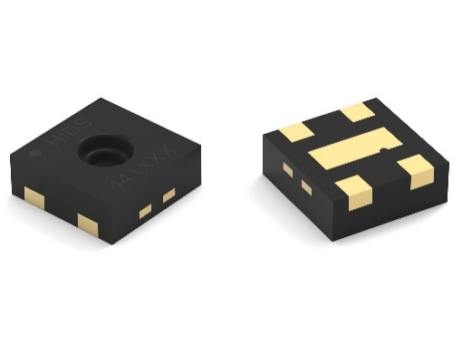
Image source: Würth Elektronik

WSEN-HIDS Humidity Sensor with integrated Temperature Sensor

About the Würth Elektronik eiSos Group
Würth Elektronik eiSos Group is a manufacturer of electronic and electromechanical components for the electronics industry and a technology company that spearheads pioneering electronic solutions. Würth Elektronik eiSos is one of the largest European manufacturers of passive components and is active in 50 countries. Production sites in Europe, Asia and North America supply a growing number of customers worldwide.
The product range includes EMC components, inductors, transformers, RF components, varistors, capacitors, resistors, quartz crystals, oscillators, power modules, Wireless Power Transfer, LEDs, sensors, radio modules, connectors, power supply elements, switches, push-buttons, connection technology, fuse holders and solutions for wireless data transmission. The portfolio is complemented by customized solutions.
The unrivaled service orientation of the company is characterized by the availability of all catalog components from stock without minimum order quantity, free samples and extensive support through technical sales staff and selection tools.
Würth Elektronik is part of the Würth Group, the global market leader in the development, production, and sale of fastening and assembly materials, and employs 8,200 people. In 2022, the Würth Elektronik Group generated sales of 1.33 Billion Euro.
Würth Elektronik: more than you expect!
Further information at www.we-online.com

Further information:  Würth Elektronik eiSos GmbH & Co. KG  Sarah Hurst  Clarita-Bernhard-Strasse 9  81249 Munich  Germany  Phone: +49 7942 945-5186  E-mail: sarah.hurst@we-online.de  www.we-online.com | Press contact:  HighTech communications GmbH  Brigitte Basilio  Brunhamstrasse 21  81249 Munich  Germany  Phone: +49 89 500778-20  E-mail: b.basilio@htcm.de  www.htcm.de

