PRESS RELEASE

Würth Elektronik publishes Application Note on optocouplers
Principles for the use of phototransistor optocouplers
Waldenburg (Germany), October 19, 2023 – Würth Elektronik has expanded its collection of practical information to support electronics developers with the new AppNote ANO007 “Understanding Phototransistor Optocouplers” (www.we-online.com/ANO007). Optocouplers, also known as photocouplers or optoisolators, are components that send an electrical signal by means of optical coupling between two galvanically separated circuits. An essential aspect for the development of robust applications involving optocouplers is not only to understand and integrate their main parameters, but also to take the potential effects of their parasitic elements into consideration. A profound understanding of these aspects and the precise consideration of tolerances, deviations, and interdependences are indispensable. The new Application Note starts by explaining the principles and goes on to present comprehensive experimental results gained with the WL-OCPT optocouplers made by Würth Elektronik.
Optocouplers offer high isolation voltage (5 kV) in connection with a very compact form factor. In contrast to transformers and capacitors, which are only capable of transmitting AC signals, the optocouplers send both AC and DC signals. This makes them particularly attractive for applications such as isolated communication interfaces, high-voltage motor drives, AC grid monitoring, control circuits for power-supply stations, industrial I/O modules, or sensor systems. The AppNote provides instructions on the characterization of parameters and on important aspects that must be considered from the design aspect.
Contents:
- Design and function of optocouplers
- DC and AC CTR: Calculating the CTR scope
- Parasitic Capacitance and cut-off frequency
- Switching behaviour and DC biasing
- Parameter measurement and characterization
- Experimental results for the WL-OCPT 817-816 series

Available images
The following images can be downloaded from the Internet in printable quality: https://kk.htcm.de/press-releases/wuerth/
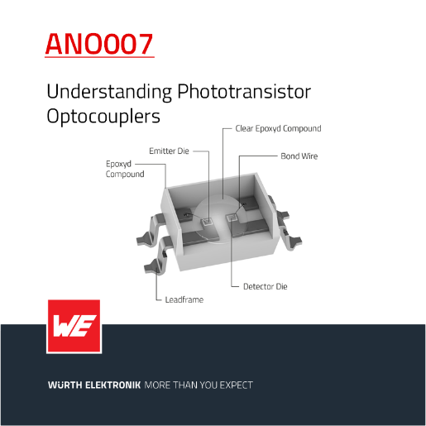  Image source: Würth Elektronik  Würth Elektronik publishes a new Application Note on optocouplers. | 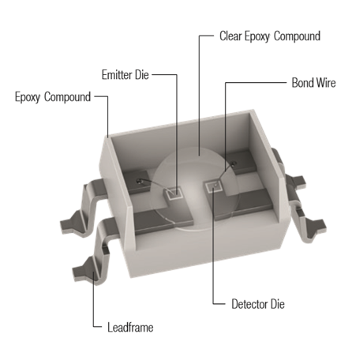  Image source: Würth Elektronik  Optocouplers made by Würth Elektronik offer a stable CTR over the entire operating-temperature range.

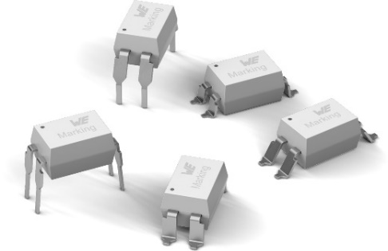
Image source: Würth Elektronik
Optocouplers from Würth Elektronik – the new Application Note shows how robust applications can be developed.

About the Würth Elektronik eiSos Group
Würth Elektronik eiSos Group is a manufacturer of electronic and electromechanical components for the electronics industry and a technology company that spearheads pioneering electronic solutions. Würth Elektronik eiSos is one of the largest European manufacturers of passive components and is active in 50 countries. Production sites in Europe, Asia and North America supply a growing number of customers worldwide.
The product range includes EMC components, inductors, transformers, RF components, varistors, capacitors, resistors, quartz crystals, oscillators, power modules, Wireless Power Transfer, LEDs, sensors, radio modules, connectors, power supply elements, switches, push-buttons, connection technology, fuse holders and solutions for wireless data transmission.
The unrivaled service orientation of the company is characterized by the availability of all catalog components from stock without minimum order quantity, free samples and extensive support through technical sales staff and selection tools.
Würth Elektronik is part of the Würth Group, the global market leader in the development, production, and sale of fastening and assembly materials, and employs 8,200 people. In 2022, the Würth Elektronik Group generated sales of 1.33 Billion Euro.
Würth Elektronik: more than you expect!
Further information at www.we-online.com

Further information:  Würth Elektronik eiSos GmbH & Co. KG  Sarah Hurst  Clarita-Bernhard-Strasse 9  81249 Munich  Germany  Phone: +49 7942 945-5186  E-mail: sarah.hurst@we-online.de  www.we-online.com | Press contact:  HighTech communications GmbH  Brigitte Basilio  Brunhamstrasse 21  81249 Munich  Germany  Phone: +49 89 500778-20  E-mail: b.basilio@htcm.de  www.htcm.de

