PRESS RELEASE

Würth Elektronik publishes Application Note on MLCC
Ferroelectricity and voltage-capacitance behaviour
Waldenburg (Germany), December 6, 2023 – Würth Elektronik has implemented the voltage-capacitance behaviour of ferroelectric multilayer ceramic capacitors (MLCCs) in the LTspice files of its products, which significantly improves the accuracy of simulations. The Application Note "ANP114" published by the supplier of electronic and electromechanical components describes the model development for ferroelectric class-2 multilayer ceramic capacitors, explaining their dependence on voltage and frequency. The use of MLCCs, e.g. in filtering circuits, is thus significantly simplified for the developer.
Ferroelectric multilayer ceramic capacitors (MLCCs) are electronic components that exhibit the property of ferroelectricity. They can maintain stable electric polarization even in the absence of an external electric field and therefore have a voltage-dependent capacitance. The Application Note gives an in-depth explanation of the voltage and frequency dependence of ferroelectric MLCCs. The AppNote starts with an introduction into the world of ferroelectricity, before going on to derive a mathematic model for the capacitance-voltage behaviour of ceramic MLCCs from a dipole polarization model, in which the parameters of the model are reduced to two fitting parameters.
Model tested by measurements
To demonstrate the practical applicability, the model was tested by comprehensive measurements on a selection of MLCCs from Würth Elektronik's portfolio. Since the integral of the capacitance-voltage model mathematically contains only basic trigonometric expressions, it can be easily implemented in software that requires functions of charge instead of capacitance, such as the simulation software LTspice. Furthermore, it is shown that the model is extremely useful in describing the capacitance spectra of MLCCs at different DC voltages.
Contents:
• Introduction to the ferroelectricity of capacitors
• Interpretation of capacitance-voltage measurements
• Mathematical model of ferroelectric polarization
• Experimental measurements and boundary conditions
• Implementation of a frequency- and voltage-dependent model
The AppNote is part of a comprehensive collection of publications on the complex of issues regarding multilayer ceramic capacitors and can be directly downloaded from the internet at: www.we-online.com/ANP114

Available images
The following images can be downloaded from the Internet in printable quality: https://kk.htcm.de/press-releases/wuerth/
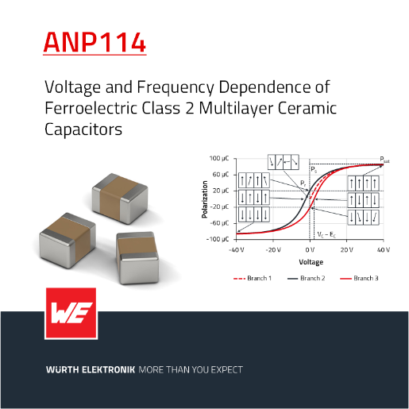Image source: Würth Elektronik  The AppNote explains the background details of LTspice files | 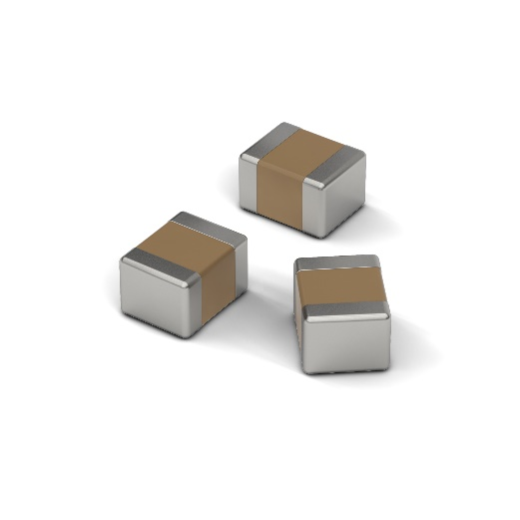Image source: Würth Elektronik  Würth Elektronik offers a broad portfolio of multilayer ceramic chip capacitors (MLCCs)

About the Würth Elektronik eiSos Group
Würth Elektronik eiSos Group is a manufacturer of electronic and electromechanical components for the electronics industry and a technology company that spearheads pioneering electronic solutions. Würth Elektronik eiSos is one of the largest European manufacturers of passive components and is active in 50 countries. Production sites in Europe, Asia and North America supply a growing number of customers worldwide.
The product range includes EMC components, inductors, transformers, RF components, varistors, capacitors, resistors, quartz crystals, oscillators, power modules, Wireless Power Transfer, LEDs, sensors, radio modules, connectors, power supply elements, switches, push-buttons, connection technology, fuse holders and solutions for wireless data transmission.

The unrivaled service orientation of the company is characterized by the availability of all catalog components from stock without minimum order quantity, free samples and extensive support through technical sales staff and selection tools.
Würth Elektronik is part of the Würth Group, the global market leader in the development, production, and sale of fastening and assembly materials, and employs 8,200 people. In 2022, the Würth Elektronik Group generated sales of 1.33 Billion Euro.
Würth Elektronik: more than you expect!
Further information at www.we-online.com

Further information:  Würth Elektronik eiSos GmbH & Co. KG  Sarah Hurst  Clarita-Bernhard-Strasse 9  81249 Munich  Germany  Phone: +49 7942 945-5186  E-mail: sarah.hurst@we-online.de  www.we-online.com | Press contact:  HighTech communications GmbH  Brigitte Basilio  Brunhamstrasse 21  81249 Munich  Germany  Phone: +49 89 500778-20  E-mail: b.basilio@htcm.de  www.htcm.de

