PRESS RELEASE

Würth Elektronik Application Note on Gigabit Power over Ethernet
Understanding a PoE Interface from an EMC Perspective
Waldenburg (Germany), November 14, 2023 – Würth Elektronik has published another Application Note on a special challenge in EMC. App Note ANP122 “Understanding a PoE Interface from an EMC Perspective” clarifies which electromagnetic interference must be taken into account for an Ethernet interface also used as a power supply. The application example is the RD022 reference design, in which Würth Elektronik has developed an industrial GB Ethernet USB adapter with integrated PoE functionality.
Devices with low power consumption (below 100W) networked via Ethernet can be supplied via ‘Power-over-Ethernet’ (PoE). Data transmission and power supply are realized with a network cable. With the RD022 reference design, Würth Elektronik presents a GB Ethernet USB adapter with integrated PoE functionality up to 25W. App Note ANP122, which is now available, takes an in-depth look at its electromagnetic behavior and provides design tips.
Getting a grip on interference
The Application Note explains the emission measurements from the reference design and compares them with the standard limit values. If the subsequently used device with PoE interface takes on larger dimensions or the secondary side is earthed, additional filtering is needed for the conducted emission. It can be seen that both conducted and radiated emissions are dominated by the isolated converter, while the emission from the digital circuit is negligibly small.
The App Note proposes an island concept to reduce emissions from the converter, whereby the interference from the isolated switching regulator is controlled better.
Besides describing the reference design, the paper also outlines the underlying EMC considerations of PoE: the EMC test setup, operating parameters, the influence of output voltage, output filter, the influence of different load resistors, input filters, optimization of conducted emission and interference immunity.

Available images
The following images can be downloaded from the Internet in printable quality: https://kk.htcm.de/press-releases/wuerth/
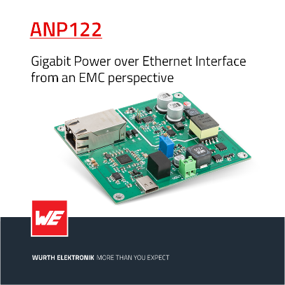Image source: Würth Elektronik  Würth Elektronik’s publishes the Application Note “Understanding a PoE Interface from an EMC Perspective”. | 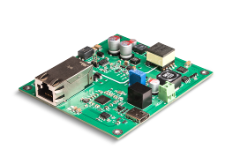  Image source: Würth Elektronik  Application Note ANP122 relates to the RD022 reference design from Würth Elektronik.

About the Würth Elektronik eiSos Group
Würth Elektronik eiSos Group is a manufacturer of electronic and electromechanical components for the electronics industry and a technology company that spearheads pioneering electronic solutions. Würth Elektronik eiSos is one of the largest European manufacturers of passive components and is active in 50 countries. Production sites in Europe, Asia and North America supply a growing number of customers worldwide.
The product range includes EMC components, inductors, transformers, RF components, varistors, capacitors, resistors, quartz crystals, oscillators, power modules, Wireless Power Transfer, LEDs, sensors, radio modules, connectors, power supply elements, switches, push-buttons, connection technology, fuse holders and solutions for wireless data transmission.
The unrivaled service orientation of the company is characterized by the availability of all catalog components from stock without minimum order quantity, free samples and extensive support through technical sales staff and selection tools.

Würth Elektronik is part of the Würth Group, the global market leader in the development, production, and sale of fastening and assembly materials, and employs 8,200 people. In 2022, the Würth Elektronik Group generated sales of 1.33 Billion Euro.
Würth Elektronik: more than you expect!
Further information at www.we-online.com

Further information:  Würth Elektronik eiSos GmbH & Co. KG  Sarah Hurst  Clarita-Bernhard-Strasse 9  81249 Munich  Germany  Phone: +49 7942 945-5186  E-mail: sarah.hurst@we-online.de  www.we-online.com | Press contact:  HighTech communications GmbH  Brigitte Basilio  Brunhamstrasse 21  81249 Munich  Germany  Phone: +49 89 500778-20  E-mail: b.basilio@htcm.de  www.htcm.de

