PRESS RELEASE

Würth Elektronik presents its reference design for PoE adapter
Supplying Terminal Devices via the EMC-compliant Network Connection
Waldenburg (Germany), October 5, 2023 – Würth Elektronik is proud to present its RD022 reference design “GB-PoE+ Ethernet USB adapter,” freely available at www.we-online.de/RD022. Devices networked via Ethernet usually depend on a separate power supply, however, if these terminal devices get by with low power consumption, then Power over Ethernet (PoE) is an alternative where data transmission and power supply are achieved via a network cable.
Devices with low power consumption, like IP cameras, VoIP phones, WiFi routers, network switches, LED lighting or access systems, are suitable for power supply through the Ethernet line. Würth Elektronik’s new RD022 reference design, which can provide up to 25W of power, shows how this can work while still maintaining EMC compliance. The ‘GB-PoE+ Ethernet USB adapter’ is based on the reference design of a 1 Gbps Ethernet USB adapter without PoE functionality, as described in detail under RD016 (www.we-online.de/RD016).
The ‘GB-PoE+ Ethernet USB Adapter provides three interfaces: a USB Type-C interface (USB 3.1), an RJ45 1 Gbps Ethernet interface with integrated PoE functionality, and a connection for a DC/DC converter with an adjustable output voltage of 6V to 18V and a maximum output power of 25W. The board makes it easier for customers to get started with PoE technology. The reference design familiarizes users with the technology, signals, interface structure, power-up and PoE detection of a Gigabit PoE interface. It provides the hardware design for Power Sourcing Equipment (PSE) and the Powered Device (PD) and explains the conception and construction of the adapter board: current flow, USB controller and interface, Ethernet interface as well as power supply (PoE). Special importance placed on the EMC-compliant design highlights its significance.

Available images
The following images can be downloaded from the Internet in printable quality: https://kk.htcm.de/press-releases/wuerth/

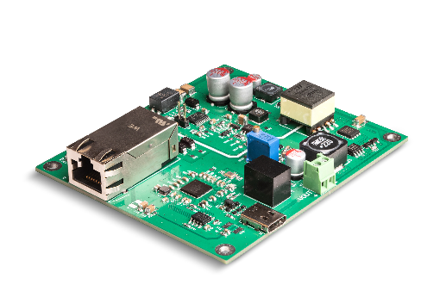
Image source: Würth Elektronik
With the RD022 reference design ‘GB-PoE+ Ethernet USB adapter’, Würth Elektronik offers the possibility of realizing an alternative power supply for networked devices with Power-over-Ethernet.

About the Würth Elektronik eiSos Group
Würth Elektronik eiSos Group is a manufacturer of electronic and electromechanical components for the electronics industry and a technology company that spearheads pioneering electronic solutions. Würth Elektronik eiSos is one of the largest European manufacturers of passive components and is active in 50 countries. Production sites in Europe, Asia and North America supply a growing number of customers worldwide.
The product range includes EMC components, inductors, transformers, RF components, varistors, capacitors, resistors, quartz crystals, oscillators, power modules, Wireless Power Transfer, LEDs, sensors, radio modules, connectors, power supply elements, switches, push-buttons, connection technology, fuse holders and solutions for wireless data transmission.
The unrivaled service orientation of the company is characterized by the availability of all catalog components from stock without minimum order quantity, free samples and extensive support through technical sales staff and selection tools.
Würth Elektronik is part of the Würth Group, the global market leader in the development, production, and sale of fastening and assembly materials, and employs 8,200 people. In 2022, the Würth Elektronik Group generated sales of 1.33 Billion Euro.
Würth Elektronik: more than you expect!
Further information at www.we-online.com

Further information:  Würth Elektronik eiSos GmbH & Co. KG  Sarah Hurst  Clarita-Bernhard-Strasse 9  81249 Munich  Germany  Phone: +49 7942 945-5186  E-mail: sarah.hurst@we-online.de  www.we-online.com | Press contact:  HighTech communications GmbH  Brigitte Basilio  Brunhamstrasse 21  81249 Munich  Germany  Phone: +49 89 500778-20  E-mail: b.basilio@htcm.de  www.htcm.de

