PRESS RELEASE

Würth Elektronik Introduces PFC Inductor Family
Robust PFC Chokes
Waldenburg (Germany), August 17, 2023 – The expansion of the WE-TORPFC inductor series, with 17 new parts, is now available from Würth Elektronik. These toroidal inductors are suitable for continuous-conduction mode (CCM) Boost converters and are capable of producing up to several kW of power. Unlike traditional bobbin-wound power factor correction (PFC) inductors, this new series uses flat wire windings, resulting in lower winding losses and better cooling.
The series is designed for elevated temperatures, up to 155°C, and is capable of handling operating voltages up to 1000VDC. With multiple sizes available, inductances ranging from 118-720µH, and rated currents up to 48A, this new series is a fit for active power factor correction, industrial AC/DC, solar inverters, and a variety of other applications. In addition, this series includes a robust mounting system that is evaluated through AEC-Q200 reliability testing.
All parts are in stock and free samples available upon request.

Available images
The following images can be downloaded from the Internet in printable quality: https://kk.htcm.de/press-releases/wuerth/
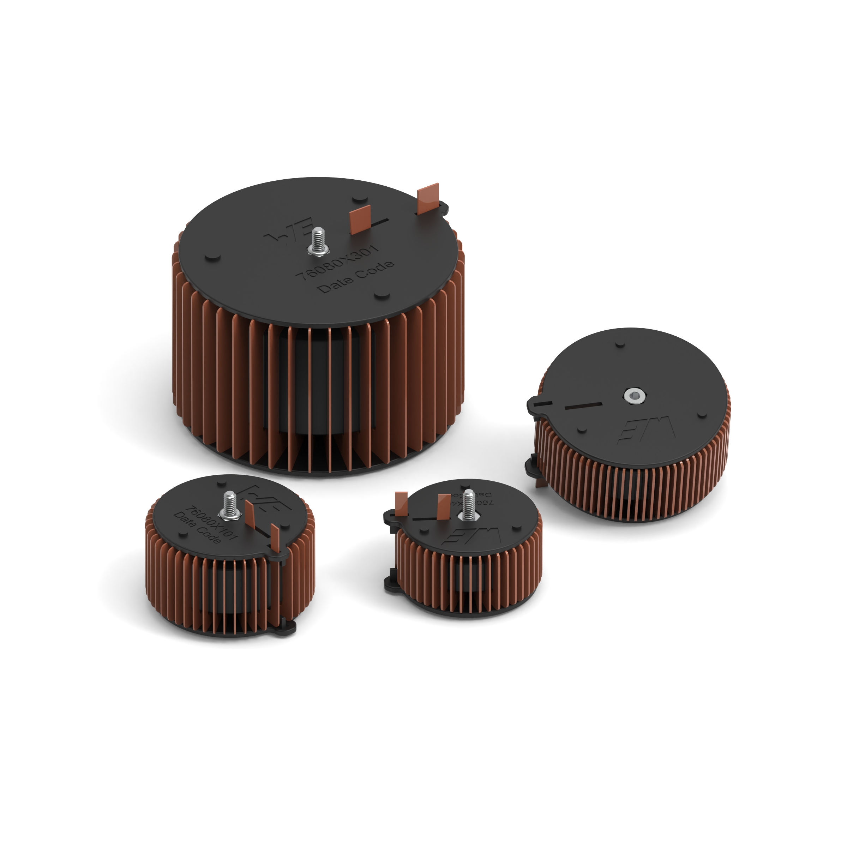
A new family of PFC chokes from Würth Elektronik
Image source: Würth Elektronik

About the Würth Elektronik eiSos Group
Würth Elektronik eiSos Group is a manufacturer of electronic and electromechanical components for the electronics industry and a technology company that spearheads pioneering electronic solutions. Würth Elektronik eiSos is one of the largest European manufacturers of passive components and is active in 50 countries. Production sites in Europe, Asia and North America supply a growing number of customers worldwide.
The product range includes EMC components, inductors, transformers, RF components, varistors, capacitors, resistors, quartz crystals, oscillators, power modules, Wireless Power Transfer, LEDs, sensors, radio modules, connectors, power supply elements, switches, push-buttons, connection technology, fuse holders and solutions for wireless data transmission.
The unrivaled service orientation of the company is characterized by the availability of all catalog components from stock without minimum order quantity, free samples and extensive support through technical sales staff and selection tools.
Würth Elektronik is part of the Würth Group, the global market leader in the development, production, and sale of fastening and assembly materials, and employs 8,200 people. In 2022, the Würth Elektronik Group generated sales of 1.33 Billion Euro.
Würth Elektronik: more than you expect!
Further information at www.we-online.com

Further information:  Würth Elektronik eiSos GmbH & Co. KG  Sarah Hurst  Max-Eyth-Strasse 1  74638 Waldenburg  Germany  Phone: +49 7942 945-5186  E-mail: sarah.hurst@we-online.de  www.we-online.com | Press contact:  HighTech communications GmbH  Brigitte Basilio  Brunhamstrasse 21  81249 Munich  Germany  Phone: +49 89 500778-20  E-mail: b.basilio@htcm.de  www.htcm.de

