PRESS RELEASE

Würth Elektronik component libraries on GitHub
Service offer speeds up design process
Waldenburg (Germany), July 25, 2023 – Würth Elektronik now offers a comprehensive library of components for Altium designers on GitHub. The ready-for-use component models and detailed data spare designers the effort of having to compile models of components themselves for use in circuit-board layout software.
The Würth Elektronik Altium database is now being constantly expanded with new components, presenting not only symbols and footprints but also detailed 3D models and spice models. The libraries have been created in the dblib format to enable their easy integration. We recommend the use of a Git tool to keep the database details up to date, thus making the cloning of the library files a simple matter.
The Würth Elektronik Altium libraries can be found in the following GitHub repository: https://github.com/WurthElektronik/Altium-Library.git
A user guide provides instructions on how to use the models.

Available images
The following images can be downloaded from the Internet in printable quality: https://kk.htcm.de/press-releases/wuerth/
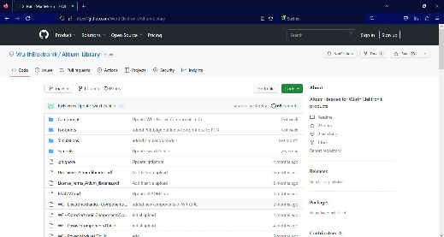
Image source: Würth Elektronik
The WE Altium database on GitHub presents ready-for-use models of individual components.

About the Würth Elektronik eiSos Group
Würth Elektronik eiSos Group is a manufacturer of electronic and electromechanical components for the electronics industry and a technology company that spearheads pioneering electronic solutions. Würth Elektronik eiSos is one of the largest European manufacturers of passive components and is active in 50 countries. Production sites in Europe, Asia and North America supply a growing number of customers worldwide.
The product range includes EMC components, inductors, transformers, RF components, varistors, capacitors, resistors, quartz crystals, oscillators, power modules, Wireless Power Transfer, LEDs, sensors, radio modules, connectors, power supply elements, switches, push-buttons, connection technology, fuse holders and solutions for wireless data transmission.
The unrivaled service orientation of the company is characterized by the availability of all catalog components from stock without minimum order quantity, free samples and extensive support through technical sales staff and selection tools.
Würth Elektronik is part of the Würth Group, the global market leader in the development, production, and sale of fastening and assembly materials, and employs 8,200 people. In 2022, the Würth Elektronik Group generated sales of 1.33 Billion Euro.
Würth Elektronik: more than you expect!
Further information at www.we-online.com

Further information:  Würth Elektronik eiSos GmbH & Co. KG  Sarah Hurst  Max-Eyth-Strasse 1  74638 Waldenburg  Germany  Phone: +49 7942 945-5186  E-mail: sarah.hurst@we-online.de  www.we-online.com | Press contact:  HighTech communications GmbH  Brigitte Basilio  Brunhamstrasse 21  81249 Munich  Germany  Phone: +49 89 500778-20  E-mail: b.basilio@htcm.de  www.htcm.de

