PRESS RELEASE
Würth Elektronik extends its terminal block connector series
Screwless alternatives and THR versions
Waldenburg (Germany), November 28, 2023 – Würth Elektronik is extending its WR-TBL series by screwless push-in connectors in the 3.5mm and 3.81mm pitches. The new 4101, 8101, 4093, and 8093 series come close to matching the specifications of the screw-fixed connectors and can replace them. Another important feature for customers with SMT-dominated production lines: The THR series 8101 and 8093 are designed for soldering in the reflow oven.
The housing of the connectors in the THR series is made of a high-temperature plastic, the pins are shorter in length, and the connectors are supplied in automatically processable belt format. The 4101 (THT) and 8101 (THR) series in the 3.5mm pitch are available with horizontal, vertical, and 45° cable entries. The 4093 (THT) and 8093 (THR) series in the 3.81mm pitch have a 45° cable entry.
The terminal blocks are available from stock with two to twelve pins. 13- to 24-pin connectors can be supplied on request as per customer specifications.
All the series named above have both cULus and VDE certification.

Available images
The following images can be downloaded from the Internet in printable quality: https://kk.htcm.de/press-releases/wuerth/

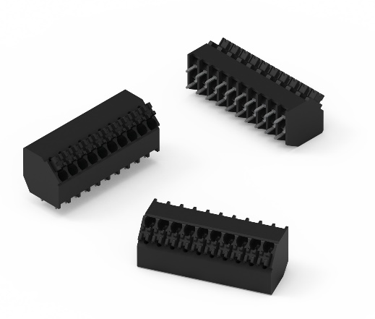Image source: Würth Elektronik
Series 8101, 3.5mm pitch, 45° cable entry, THR – robust terminal blocks for line assembly in the reflow oven.

About the Würth Elektronik eiSos Group
Würth Elektronik eiSos Group is a manufacturer of electronic and electromechanical components for the electronics industry and a technology company that spearheads pioneering electronic solutions. Würth Elektronik eiSos is one of the largest European manufacturers of passive components and is active in 50 countries. Production sites in Europe, Asia and North America supply a growing number of customers worldwide.
The product range includes EMC components, inductors, transformers, RF components, varistors, capacitors, resistors, quartz crystals, oscillators, power modules, Wireless Power Transfer, LEDs, sensors, radio modules, connectors, power supply elements, switches, push-buttons, connection technology, fuse holders and solutions for wireless data transmission.
The unrivaled service orientation of the company is characterized by the availability of all catalog components from stock without minimum order quantity, free samples and extensive support through technical sales staff and selection tools.
Würth Elektronik is part of the Würth Group, the global market leader in the development, production, and sale of fastening and assembly materials, and employs 8,200 people. In 2022, the Würth Elektronik Group generated sales of 1.33 Billion Euro.
Würth Elektronik: more than you expect!
Further information at www.we-online.com

Further information:  Würth Elektronik eiSos GmbH & Co. KG  Sarah Hurst  Clarita-Bernhard-Strasse 9  81249 Munich  Germany  Phone: +49 7942 945-5186  E-mail: sarah.hurst@we-online.de  www.we-online.com | Press contact:  HighTech communications GmbH  Brigitte Basilio  Brunhamstrasse 21  81249 Munich  Germany  Phone: +49 89 500778-20  E-mail: b.basilio@htcm.de  www.htcm.de

