PRESS RELEASE

Würth Elektronik introduces its WR-CRD micro SIM card interface with card detection
Cost-effective and Convenient Acceptance of Wireless Chip Cards
Waldenburg (Germany), August 31, 2023 – Faced with a rising demand for wireless connections for IoT devices, innovative designers will need to integrate SIM card interfaces into their products. In response, Würth Elektronik is expanding its range of card interfaces. The first representative of the new generation of connectors is the WR-CRD Micro SIM Card Connector with “Push & Push” insert & eject mechanism.
In designing the SIM card receptacle, special attention was paid to kink resistance, high durability and easy card detection. The brass contacts are gold plated and the package is made of tin-plated steel. The contact resistance is around 100 mΩ. The operating temperature range is -20 to +70°C. The WR-CRD Micro SIM Card Connector is now available from stock and there are free samples for developers.

Available images
The following images can be downloaded from the Internet in printable quality: https://kk.htcm.de/press-releases/wuerth/
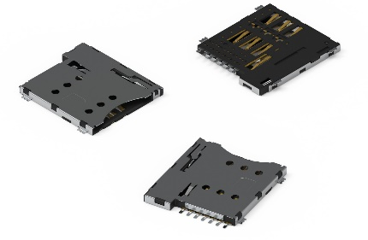
Image source: Würth Elektronik
WR-CRD can be used to equip IoT devices that require a SIM card.

About the Würth Elektronik eiSos Group
Würth Elektronik eiSos Group is a manufacturer of electronic and electromechanical components for the electronics industry and a technology company that spearheads pioneering electronic solutions. Würth Elektronik eiSos is one of the largest European manufacturers of passive components and is active in 50 countries. Production sites in Europe, Asia and North America supply a growing number of customers worldwide.
The product range includes EMC components, inductors, transformers, RF components, varistors, capacitors, resistors, quartz crystals, oscillators, power modules, Wireless Power Transfer, LEDs, sensors, radio modules, connectors, power supply elements, switches, push-buttons, connection technology, fuse holders and solutions for wireless data transmission.
The unrivaled service orientation of the company is characterized by the availability of all catalog components from stock without minimum order quantity, free samples and extensive support through technical sales staff and selection tools.
Würth Elektronik is part of the Würth Group, the global market leader in the development, production, and sale of fastening and assembly materials, and employs 8,200 people. In 2022, the Würth Elektronik Group generated sales of 1.33 Billion Euro.
Würth Elektronik: more than you expect!
Further information at www.we-online.com

Further information:  Würth Elektronik eiSos GmbH & Co. KG  Sarah Hurst  Clarita-Bernhard-Strasse 9  81249 Munich  Germany  Phone: +49 7942 945-5186  E-mail: sarah.hurst@we-online.de  www.we-online.com | Press contact:  HighTech communications GmbH  Brigitte Basilio  Brunhamstrasse 21  81249 Munich  Germany  Phone: +49 89 500778-20  E-mail: b.basilio@htcm.de  www.htcm.de

