PRESS RELEASE

STMicroelectronics and Würth Elektronik cooperate for a high-performance power tool
Motor Control Reference Design Project
Geneva (Switzerland), Waldenburg (Germany) – July 11, 2023 – Würth Elektronik and STMicroelectronics jointly developed a demo using a Würth power tool. The design, which efficiently drives a low-voltage Brushless DC motor, is ideal for handheld power-tool applications. Moreover, the design includes all the necessary user interfaces required to control the motor’s trigger, speed, and direction.
At the leading international tradeshow PCIM Europe, which took place from 9 to 11 May 2023 in Nuremberg, the power tool demo was exhibited at STMicroelectronics’ and Würth Elektronik’s booths and attracted a significant number of visitors.
The demo is based on the STDES-PTOOL3A reference design, in which the Gerber files, Bill of Materials, schematics and all other reference materials are downloadable from ST.com without charge. It showcases the capabilities of ST’s STM32G4 MCU and STDRIVE101 gate driver in powering six STL220N6F7 MOSFETs that all comply with Würth Elektronik’s Ferrite Bead (WE-CBF SMT EMI Suppression Ferrite Bead 74279271) and Power Inductor (WE-LHMI SMT Power Inductor 74437368330) and the benefits they bring to each application in performance, cost, quality, and ease of implementation. The software code embedded in the STM32G4 was developed using the STM32 Motor Control software development kit (X-CUBE-MCSDK). The design shows real-world usage scenarios in battery-operated handheld power tools.
Over the past few years, STMicroelectronics, a global semiconductor leader serving customers across the spectrum of electronics applications, and the passive components manufacturer Würth Elektronik, an STMicroelectronics Authorized Partner, have established a strong collaboration developing reference designs that leverage the best of each companies’ portfolios. By combining active components from STMicroelectronics with passive components from Würth Elektronik, the companies can offer ready-made turnkey or customizable solutions to customers. The synergies of the collaboration between STMicroelectronics and Würth Elektronik are reflected in the breadth and success of earlier joint projects, including the integration of Würth Elektronik components on a range of STMicroelectronics evaluation boards.
“Working with Würth Elektronik, STMicroelectronics has shown its capability to work with partners to extract the best performance from its product offer and to jointly develop system solutions addressing the most challenging and complex application needs,” said Ricardo De Sa Earp, Executive Vice President, General-Purpose Microcontroller Sub-Group, STMicroelectronics.
“The development of a cost-effective, high-quality reference design that forms the basis for outstanding power tools is another example of the fruitful collaboration we share with STMicroelectronics,” said Alexander Gerfer, CTO, Würth Elektronik eiSos Group.
The demo will be exhibited at other upcoming tradeshows, including the Smart Product Solutions (SPS) in Nuremberg and the SIDO in Lyon.

Available images
The following images can be downloaded from the Internet in printable quality: https://kk.htcm.de/press-releases/wuerth/
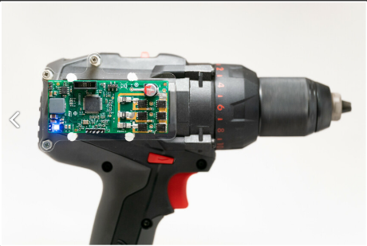
Image source: STMicroelectronics

STDES-PTOOL3 Demo with Würth Power Tool

Available videos
You can find a video on this topic on YouTube:
https://youtu.be/p74O6Fijb_8
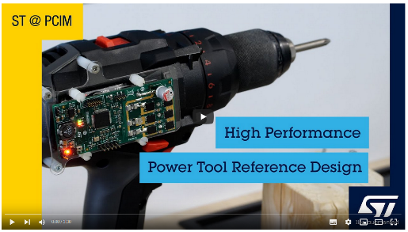
Quelle: STMicroelectronics
High Performance Power Tool Reference Design

About STMicroelectronics
At ST, we are over 50,000 creators and makers of semiconductor technologies mastering the semiconductor supply chain with state-of-the-art manufacturing facilities. An integrated device manufacturer, we work with more than 200,000 customers and thousands of partners to design and build products, solutions, and ecosystems that address their challenges and opportunities, and the need to support a more sustainable world. Our technologies enable smarter mobility, more efficient power and energy management, and the wide-scale deployment of the Internet of Things and connectivity. We are committed to achieving our goal of becoming carbon neutral by 2027.
Further information can be found at www.st.com

Further information:
STMicroelectronics
Michael Markowitz
Director Technical Media Relations
Tel: +1 781 591 0354
Email: michael.markowitz@st.com

About the Würth Elektronik eiSos Group
Würth Elektronik eiSos Group is a manufacturer of electronic and electromechanical components for the electronics industry and a technology company that spearheads pioneering electronic solutions. Würth Elektronik eiSos is one of the largest European manufacturers of passive components and is active in 50 countries. Production sites in Europe, Asia and North America supply a growing number of customers worldwide.
The product range includes EMC components, inductors, transformers, RF components, varistors, capacitors, resistors, quartz crystals, oscillators, power modules, Wireless Power Transfer, LEDs, sensors, connectors, power supply elements, switches, push-buttons, connection technology, fuse holders and solutions for wireless data transmission.
The unrivaled service orientation of the company is characterized by the availability of all catalog components from stock without minimum order quantity, free samples and extensive support through technical sales staff and selection tools.
Würth Elektronik is part of the Würth Group, the global market leader in the development, production, and sale of fastening and assembly materials, and employs 8,200 people. In 2022, the Würth Elektronik Group generated sales of 1.33 Billion Euro.
Würth Elektronik: more than you expect!
Further information at www.we-online.com

Further information:  Würth Elektronik eiSos GmbH & Co. KG  Sarah Hurst  Max-Eyth-Strasse 1  74638 Waldenburg  Germany  Phone: +49 7942 945-5186  E-mail: sarah.hurst@we-online.de  www.we-online.com | Press contact:  HighTech communications GmbH  Brigitte Basilio  Brunhamstrasse 21  81249 Munich  Germany  Phone: +49 89 500778-20  E-mail: b.basilio@htcm.de  www.htcm.de

