PRESS RELEASE
Würth Elektronik expands transformer series for SiC MOSFET gate drivers
Ultra Low Interwinding Capacitance
Waldenburg (Germany), October 26, 2023 – Würth Elektronik presents new additions to the WE-AGDT series, with interwinding capacitance lower than 1 picofarad, more topologies and higher output voltage options. All transformers use the same compact SMT EP7 package with 11.3 x 10.95 x 11.94mm dimensions.
The WE-AGDT series is an Auxiliary Gate Drive Transformer series for up to 6 W isolated auxiliary supplies targeting gate drivers systems for SiC-MOSFETs and IGBTs. In these designs, the most crucial aspect is the transformer interwinding capacitance due to the high dV/dt, which is common in designs utilizing Wide-Bandgap Devices. The new additions to this series feature interwinding capacitance is as low as 0.68 pF and output voltages as high as 30 V. Options now include LLC, Half-Bridge, or Flyback topologies and one or two outputs which can be used in either unipolar or bipolar applications.
WE-AGDT complies with the IEC62368-1/IEC61558-2-16 safety standard and is AEC-Q200 qualified. The transformers are suitable for use in industrial drives, AC motor inverters, HEV/EV charging stations, solar inverters, uninterruptible power supply devices and active power factor correction.
Like all products in the Electronic Components 2022/2023 catalog, WE-AGDT samples are available ex-stock without minimum order quantities (MOQ). Free samples are also provided.
Reference designs are available together with PCB fabrication and layout design files:
Example Flyback topology reference designs:
RD001: 6 W Bipolar isolated auxiliary supply for SiC-MOSFET and IGBT gate driver (PDF)
RD002: 6 W Unipolar isolated auxiliary supply for SiC-MOSFET and IGBT gate driver (PDF)

Example LLC topology reference design:
Bias Supply Design for Isolated Gate Driver Using UCC25800-Q1 Open-Loop LLC Transformer Driver

Available images
The following images can be downloaded from the Internet in printable quality: https://kk.htcm.de/press-releases/wuerth/
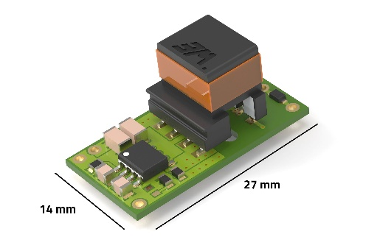
Image source: Würth Elektronik
Target applications HEV/EV charging stations and solar inverters: WE-AGDT is Würth Elektronik's contribution to the energy transition.

About the Würth Elektronik eiSos Group
Würth Elektronik eiSos Group is a manufacturer of electronic and electromechanical components for the electronics industry and a technology company that spearheads pioneering electronic solutions. Würth Elektronik eiSos is one of the largest European manufacturers of passive components and is active in 50 countries. Production sites in Europe, Asia and North America supply a growing number of customers worldwide.
The product range includes EMC components, inductors, transformers, RF components, varistors, capacitors, resistors, quartz crystals, oscillators, power modules, Wireless Power Transfer, LEDs, sensors, radio modules, connectors, power supply elements, switches, push-buttons, connection technology, fuse holders and solutions for wireless data transmission.
The unrivaled service orientation of the company is characterized by the availability of all catalog components from stock without minimum order quantity, free samples and extensive support through technical sales staff and selection tools.

Würth Elektronik is part of the Würth Group, the global market leader in the development, production, and sale of fastening and assembly materials, and employs 8,200 people. In 2022, the Würth Elektronik Group generated sales of 1.33 Billion Euro.
Würth Elektronik: more than you expect!
Further information at www.we-online.com

Further information:  Würth Elektronik eiSos GmbH & Co. KG  Sarah Hurst  Clarita-Bernhard-Strasse 9  81249 Munich  Germany  Phone: +49 7942 945-5186  E-mail: sarah.hurst@we-online.de  www.we-online.com | Press contact:  HighTech communications GmbH  Brigitte Basilio  Brunhamstrasse 21  81249 Munich  Germany  Phone: +49 89 500778-20  E-mail: b.basilio@htcm.de  www.htcm.de

