PRESS RELEASE

IQD extends Range of -40 to 125 °C crystals
Meet the Demands of new Product Designs
Waldenburg (Germany), May 4, 2023 – Components capable of withstanding high operating temperatures are increasingly in demand, and it is not just by engineers working on the traditional high temperature or extreme applications, for example downhole. This trend is partly driven by IC manufacturers, who often design one chipset suitable for both industrial and automotive applications, and by the increased use of electronic devices in more extreme environments. Additionally, the internal self-heating of electronic components close to the crystal on the board can be a motivation to select a crystal that is guaranteed to operate within the specification up to 125 °C.
Customers who are using the same frequencies in multiple projects with different temperature requirements, may also benefit from selecting one extended temperature part that is designed to work within all these applications rather than having to source and stock multiple parts.
IQD is therefore introducing a range of crystals housed in the popular 4-pad SMD ceramic packages 3.2 x 2.5 mm (CFPX-180) and 2.0 x 1.6 mm (IQXC-42) with the extended operating temperature range of -40 to 125 °C. The CFPX-180 is available in a range of frequencies from 12.0 MHz and the IQXC-42 from 16.0 MHz, with various load capacitances. The parts are offered with frequency stabilities down to +-30ppm over -40 to 125 °C and the ESR values are specified slightly lower than for the existing range of crystals in order to meet the demands of new microcontrollers, which often require lower ESR, for example for IoT applications. For engineers requiring AEC-Q200 qualification, IQD also has a range of automotive qualified crystals. For a full list of the available frequencies and specifications please visit our website www.iqdfrequencyproducts.com.
These parts are recommended for multiple applications, including Internet of Things (IoT and IIoT), e.g.:
- Ethernet
- Green and smart energy applications (Solar inverters)
- Industrial Control Systems
- RFID
- Test and Measurement Systems
- Telemetry systems
- Transportation systems
- WiFi modules

Available images
The following images can be downloaded from the Internet in printable quality: https://kk.htcm.de/press-releases/wuerth/
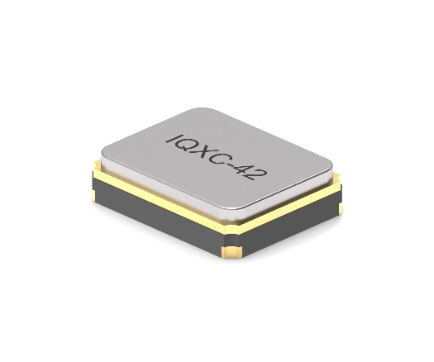  Image source: IQD  Crystal IQXC-42 | 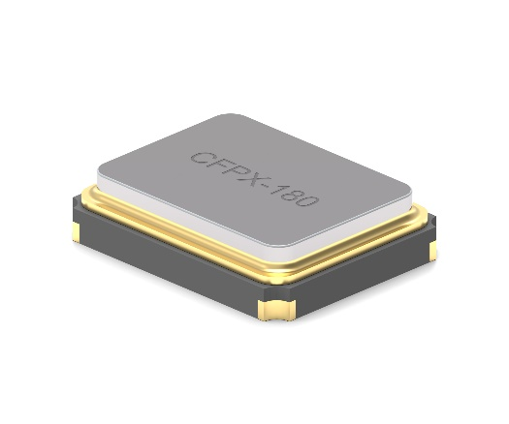  Image source: IQD  Crystal CFPX-180

About IQD
Backed by nearly 50 years’ experience in the manufacture of frequency products, IQD is a recognised market leader in the frequency control market and part of the Würth Elektronik eiSos Group, one of the leading European manufacturers of passive components. With active customers in over 80 countries, IQD offers one of the most comprehensive frequency product ranges available, from low cost commercial grade product to that used in high reliability industrial and automotive applications including: Quartz Crystals, Clock Oscillators, AEC-Q200 Crystals & Oscillators, VCXOs, TCXOs, OCVCSOs & OCXOs, GPS Disciplined OCXOs, and Rubidium Oscillators.
Further info at www.iqdfrequencyproducts.com

About the Würth Elektronik eiSos Group
Würth Elektronik eiSos Group is a manufacturer of electronic and electromechanical components for the electronics industry and a technology company that spearheads pioneering electronic solutions. Würth Elektronik eiSos is one of the largest European manufacturers of passive components and is active in 50 countries. Production sites in Europe, Asia and North America supply a growing number of customers worldwide.
The product range includes EMC components, inductors, transformers, RF components, varistors, capacitors, resistors, quartz crystals, oscillators, power modules, Wireless Power Transfer, LEDs, sensors, connectors, power supply elements, switches, push-buttons, connection technology, fuse holders and solutions for wireless data transmission.
The unrivaled service orientation of the company is characterized by the availability of all catalog components from stock without minimum order quantity, free samples and extensive support through technical sales staff and selection tools.
Würth Elektronik is part of the Würth Group, the global market leader in the development, production, and sale of fastening and assembly materials, and employs 8,200 people. In 2022, the Würth Elektronik Group generated sales of 1.33 Billion Euro.
Würth Elektronik: more than you expect!
Further information at www.we-online.com

Further information:  IQD Frequency Products Ltd  Liz Thompson  Station Road  Crewkerne  Somerset  TA18 8AR  United Kingdom  Phone: +44 1460 270270  E-mail: Liz.Thompson@iqdfrequencyproducts.com  www.we-online.com  www.iqdfrequencyproducts.com | Press contact:  HighTech communications GmbH  Brigitte Basilio  Brunhamstrasse 21  81249 Munich  Germany  Phone: +49 89 500778-20  E-mail:  b.basilio@htcm.de  www.htcm.de

