PRESS RELEASE

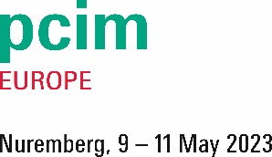
Würth Elektronik at the PCIM Europe 2023 in Nuremberg
Trade fair appearance focuses on electromagnetic compatibility
Hall 6, Booth 217
Waldenburg (Germany), April 27, 2023 – Würth Elektronik will be exhibiting at PCIM Europe from May 9 to 11, 2023, at booth 217 in hall 6. While at the Nuremberg trade fair, the manufacturer of electronic and electromechanical components will primarily present ferrites, inductors, transformers, and high-current connections for automotive applications. During a seminar, as well as several presentations, the company will show what is important in the selection and design-in of components.
Visitors to the Würth Elektronik booth will not only learn about the range of general components for power electronics and e-mobility, but also about the services offered, including advice provided by Würth Elektronik's component specialists, and simulation and selection in REDEXPERT and support during development.
Würth Elektronik sees itself as a partner to developers and supports its customers in their search for solutions to problems. Participants at the trade fair will learn from EMC specialist, Dr.-Ing. Heinz Zenkner, that there are a number of challenges, particularly in the field of e-mobility, and how they can be overcome. Zenkner is a publicly appointed and sworn expert for EMC, and a freelancer at Würth Elektronik. He will speak on Monday, May 8, 2023 from 9:00 a.m. to 12:30 p.m. on the topic "How to use ferrites on power distribution cable systems as an example in electric vehicles".
E-Mobility & Energy Storage Stage
Würth Elektronik is also involved in the program of the E-Mobility & Energy Storage Stage Hall 6-220. On May 9, 2023 at 4:00 p.m., Jose Rocamora, Division Manager Automotive, will present "EMC Cable Ferrite for the Field of E-Mobility." On May 9 at 10:45 a.m. and on May 10 and 11, both at 11:45 a.m., Jose Rocamora's presentations on Automotive Inductive Solutions will start at the Würth Elektronik booth.
The cooperations with IC manufacturers, which are so important for the development of reference designs, will also be included in Würth Elektronik's trade fair appearance. On May 9, 2023, STMicroelectronics will be at the booth with a reference design as a partner.

Available images
The following images can be downloaded from the Internet in printable quality: https://kk.htcm.de/press-releases/wuerth/
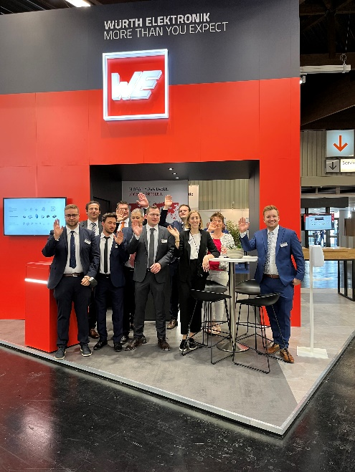
Image source: Würth Elektronik
Components for power electronics? You can get support at the PCIM booth of Würth Elektronik.

About the Würth Elektronik eiSos Group
Würth Elektronik eiSos Group is a manufacturer of electronic and electromechanical components for the electronics industry and a technology company that spearheads pioneering electronic solutions. Würth Elektronik eiSos is one of the largest European manufacturers of passive components and is active in 50 countries. Production sites in Europe, Asia and North America supply a growing number of customers worldwide.
The product range includes EMC components, inductors, transformers, RF components, varistors, capacitors, resistors, quartz crystals, oscillators, power modules, Wireless Power Transfer, LEDs, sensors, connectors, power supply elements, switches, push-buttons, connection technology, fuse holders and solutions for wireless data transmission.
The unrivaled service orientation of the company is characterized by the availability of all catalog components from stock without minimum order quantity, free samples and extensive support through technical sales staff and selection tools.
Würth Elektronik is part of the Würth Group, the global market leader in the development, production, and sale of fastening and assembly materials, and employs 8,200 people. In 2022, the Würth Elektronik Group generated sales of 1.33 Billion Euro.
Würth Elektronik: more than you expect!
Further information at www.we-online.com

Further information:  Würth Elektronik eiSos GmbH & Co. KG  Sarah Hurst  Max-Eyth-Strasse 1  74638 Waldenburg  Germany  Phone: +49 7942 945-5186  E-mail: sarah.hurst@we-online.de  www.we-online.com | Press contact:  HighTech communications GmbH  Brigitte Basilio  Brunhamstrasse 21  81249 Munich  Germany  Phone: +49 89 500778-20  E-mail: b.basilio@htcm.de  www.htcm.de

