PRESS RELEASE

Würth Elektronik Webinars Receive Exclusive Partnership with Digi-Key Electronics
World Wide Webinars See Growth
Watertown (USA), April 21, 2023 – For the fifth year in a row, Würth Elektronik is pleased to announce Digi-Key Electronics as the exclusive partner of their 2023 technical WEbinars.
„Our technical and educational webinars continue to see growth year after year. Though the world continues to hear the phrase ‘webinar fatigue,‘ we still see how successful and useful these online seminars are to so many people,“ says Amelia Thompson, Marketing & Communications Coordinator with Würth Elektronik. „The continued support from Digi-Key Electronics ensures the webinars remain free and on-demand for our entire audience, no matter their status or location.“
In 2022, the America’s webinar team welcomed their German counterparts to offer a wider, more multilingual set of presentations in conjunction with the help from Digi-Key Electronics.
„By creating this dynamic, global team, we are better able to reach a wider audience in English, German, Spanish, and Portuguese and we hope to include more languages in the future. Digi-Key’s worldwide presence also helps to reach those who might not know the immensity of what Würth Elektronik offers.“
In 2023, brand new topics will include Switch Mode Power Supplies (SMPS), automotive power, joint IC manufacturing topics, and others. Thompson is hopeful that the growing partnerships help to reach a variety of listeners, such as universities, incubators, start-ups, current customers, and more.
Registration for all 2023 WEbinars is available at www.we-online.com/webinars.

Available images
The following images can be downloaded from the Internet in printable quality: https://kk.htcm.de/press-releases/wuerth/
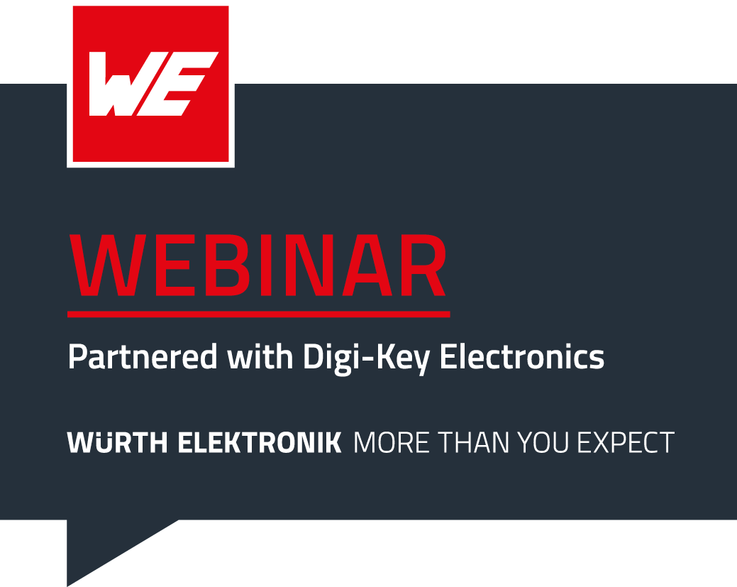
Image source: Wurth Electronics
A successful model is continued and expanded: Webinars from Würth Elektronik and Digi-Key Electronics.

About the Würth Elektronik eiSos Group
Würth Elektronik eiSos Group is a manufacturer of electronic and electromechanical components for the electronics industry and a technology company that spearheads pioneering electronic solutions. Würth Elektronik eiSos is one of the largest European manufacturers of passive components and is active in 50 countries. Production sites in Europe, Asia and North America supply a growing number of customers worldwide.
The product range includes EMC components, inductors, transformers, RF components, varistors, capacitors, resistors, quartz crystals, oscillators, power modules, Wireless Power Transfer, LEDs, sensors, connectors, power supply elements, switches, push-buttons, connection technology, fuse holders and solutions for wireless data transmission.
The unrivaled service orientation of the company is characterized by the availability of all catalog components from stock without minimum order quantity, free samples and extensive support through technical sales staff and selection tools.
Würth Elektronik is part of the Würth Group, the global market leader in the development, production, and sale of fastening and assembly materials, and employs 8,200 people. In 2022, the Würth Elektronik Group generated sales of 1.33 Billion Euro.
Würth Elektronik: more than you expect!
Further information at www.we-online.com

Further information:  Wurth Electronics Midcom, Inc.  Amelia Thompson  121 Airport Drive  PO Box 1330  Watertown, SD 57201 USA  Phone: +1 605 886 4385  Toll-free (in the U.S.):  Phone: +1 800 643 2661  E-mail: amelia.thompson@we-online.com  www.we-online.com | Press contact:  HighTech communications GmbH  Brigitte Basilio  Brunhamstrasse 21  81249 Munich  Germany  Phone: +49 89 500778-20  E-mail: b.basilio@htcm.de  www.htcm.de

