PRESS RELEASE
“Germany’s most innovative companies”: Five stars for the Würth Elektronik Group
Top Innovation Ranking
Waldenburg (Germany), April 13, 2023 – The Würth Elektronik Group maintains its upswing. And that also goes for its innovation ranking from the renowned German business magazine, Capital: The manufacturer of electronic and electromechanical components, PCBs and intelligent power and control systems received a five-star top rating for the first time in the ‘Electronics & Electrical Engineering, Automation and Measurement Technology’ category, and was also well ahead on patent relevance.
The Würth Elektronik Group even managed to pick up another star over last year’s rating. As it was also awarded two points for ‘patent relevance’ for the first time in 2023, the ranking can be regarded as a very special success in view of the oftentimes challenging business situation - and of course as a spur for striving to consistently realize its corporate goals: to drive technology forward, enable innovation, promote sustainability, together with customers, partners and selected start-ups.
Independent experts make their selection
For the fourth time, Capital and Statista - the online platform specialized in market and consumer data - have paid tribute to Germany's most innovative companies. Just 134 out of a total of 1,849 candidates received the maximum five-star rating and Würth Elektronik was among them. The selection is made across 20 sectors and industries, from the automotive industry and the chemical sector, to energy and the environment. The independent ranking is based on a survey of 3,700 innovation specialists (representatives of award-winning innovation companies who evaluate companies from their industries, as well as experts on the Statista panel).
The score is composed of the number of recommendations (60%) as well as the average value across the respective areas of innovation (30%) and the average value from the reasons for recommendation. The score determined is presented in the respective star category. The companies distinguished are classified by industry and company size: 233 very large companies (over 1,000 employees), 121 large companies (250 to 1,000 employees) and 112 SMEs (up to 250 employees).
The basis for the additional two-point ‘patent relevance’ score is Technology Relevance™ based on forward citations: the more often a patent is the basis for further innovations, the higher the index.

Upward, despite the difficult environment
With its top ranking, Würth Elektronik clearly positions itself against the current, rather stagnant-to-negative trend: in the expert survey, 41% of executives said that the climate for innovation had deteriorated in 2022. The same proportion recognized no change with only 18% seeing an improvement.

Available images
The following images can be downloaded from the Internet in printable quality: https://kk.htcm.de/press-releases/wuerth/
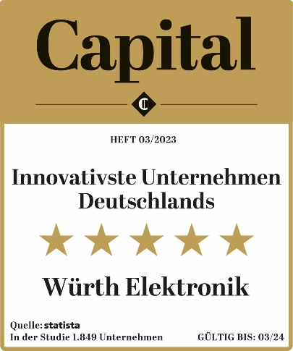Image source: Statista  In the fourth innovation rankings: Würth Elektronik Group in the top group of German companies. | 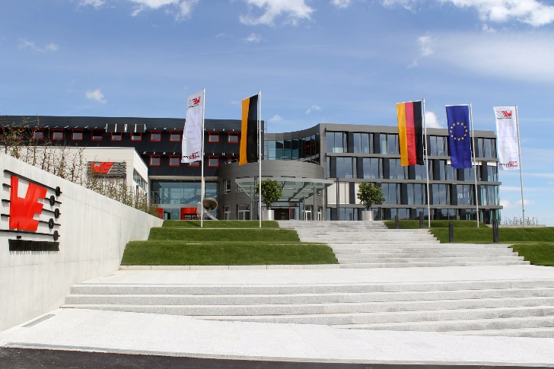  Image source: Würth Elektronik  Würth Elektronik’s headquarters in Waldenburg

About the Würth Elektronik group of companies
The Würth Elektronik group of companies, founded in Niedernhall, Baden-Wuerttemberg, Germany, has about 8,200 employees worldwide and generated global sales of 1.33 Billion Euro in 2022.
With over 23 production locations worldwide, Würth Elektronik is one of the most successful companies of the Würth Group.
Würth Elektronik operates internationally with its three company areas in various markets:

- Electronic & electromechanical components (Headquarters: Waldenburg)
Würth Elektronik eiSos (electronic and electromechanical components) is one of Europe's biggest manufacturers of electronic & electromechanical components. More than 700 sales representatives worldwide make up a direct sales network that is unique for the electronics market. The customer is offered excellent design-in support on-site from the manufacturer. The production plants in Germany, Czech Republic, Bulgaria, USA, Mexico, Taiwan and China guarantee high availability on all markets. All catalog products are available from stock and samples are free of charge.
- PCBs (Headquarters: Niedernhall)
Founded in 1971, Würth Elektronik Circuit Board Technology is today Europe's leading PCB manufacturer and, thanks to the comprehensive portfolio, a reliable partner for both individual entrepreneurs and large corporations. Whether basic or high-end technologies, customer-specific requirements are met from the initial idea for a design to the production of prototypes on the online shop and finally, manufacturing of medium and large volumes in Germany or Asia.
- Intelligent Power & Control Systems (Headquarters: Niedernhall-Waldzimmern)
As a specialist for the development and production of electronic and electromechanical system solutions, such as central electronics, Würth Elektronik ICS (Intelligent Power & Control Systems) is a longtime partner for many commercial vehicles. Professional project management accompanies business partners from the product idea through to series maturity.
Further info at www.we-online.com

More information:  Würth Elektronik eiSos GmbH & Co. KG  Sarah Hurst  Max-Eyth-Strasse 1  74638 Waldenburg  Germany  Phone: +49 7942 945-5186  E-mail: sarah.hurst@we-online.de  www.we-online.com | Press contact:  HighTech communications GmbH  Brigitte Basilio  Brunhamstrasse 21  81249 Munich  Germany  Phone: +49 89 500778-20  Telefax: +49 89 500778-77  E-mail: b.basilio@htcm.de  www.htcm.de

