PRESS RELEASE

Würth Elektronik opens High-tech Innovation Center
Innovation to Serve the Customer
Munich (Germany), April 6, 2023 – Enabling innovation and growth – these are the main objectives of Würth Elektronik's High-tech Innovation Center (HIC), officially opened in Munich-Freiham on April 3, 2023. The new high-technology site focuses on partnership with customers, research institutions, start-ups, and semiconductor manufacturers.
A successful entrepreneur for 73 years, with almost EUR 20 billion in sales at the Würth Group in 2022: Prof. Dr. h. c. mult. Reinhold Würth, Chairman of the Supervisory Board of the Würth Group's Family Trusts, could actually sit back and relax. But anyone familiar with the 87-year-old knows that he is still a visionary who is interested in the future like nothing else.
Relocation to a creative future
Because part of this future is now being driven in Munich-Freiham, the prominent Baden-Württemberg entrepreneur traveled to the Freiham-Süd Industrial Park for the inauguration of the High-tech Innovation Center. Albert Füracker, Minister of State for Finance and Home Affairs, was there as a representative of the Bavarian State Government. "We are impressed by what has been created here," praised Würth at the ceremony. “I’m looking to provide a workplace for employees that is defined by friendliness and optimism.”
Reinhold Würth always sees the customer in focus, however: “I’m a salesman with all my heart and know that customers have enabled our success,” Prof. Dr. h. c. mult. Reinhold Würth affirmed and emphasized that success was built upon the trust earned from customers. Modesty, predictability and honesty are at the core of corporate culture.
Thomas Schrott, CEO of Würth Elektronik eiSos and Business Unit Manager of the Würth Group, thanked Reinhold Würth, who had personally supported the investment at the Munich site: “We’ll show our gratitude with action,” Schrott promised.
Engineers and scientists explore high tech at the new site covering 10,770 m² of floor space: wireless connectivity, sensors, power modules, optoelectronics, power transformers and custom inductors, design and development kits, seminars and continued cooperation with the Technical University of Munich. At the heart of the HIC is a major test field with two EMC test chambers in which electromagnetic compatibility can be tested.
Growth space for ideas in Munich
“Munich is the ideal high-tech site,” Robert Friedmann, Spokesman of the Board of Directors of the Würth Group, affirms, “not least because of its proximity to universities and to important cooperation partners from the semiconductor industry.”
The new HIC accommodates 250 employees. At present, 160 experts from 29 nations search day in, day out for insights that enable innovations, for technologies that advance the industry, and for ideas that improve our planet. And the conditions are ideal: All workplaces are equipped in line with the latest New Work approaches, the space concepts promote creativity, and employees can switch between communicative togetherness and contemplative retreat. “The HIC is a growth space for ideas,” HIC site manager Oliver Opitz puts it in a nutshell. A site with potential for expansion: because the next construction phase will create another 250 jobs.
“The Champions League of modern transformation”
In his video greeting, Bavaria's Minister President Dr. Markus Söder praised Würth Elektronik as “one of the most modern companies we have. This is the Champions League of modern transformation.” Bavaria's Minister of State for Finance and Home Affairs, Füracker, stated in his address: “The Würth Group has developed from a small two-person outfit into a major global corporation with over 85,000 employees and has always remained a family business – a truly impressive story. Family businesses think in generations, not quarters. This success story is set to continue with the new Innovation Center in Freiham.”
‘WE enable to grow’, was the motto at the opening ceremony: As soon as Reinhold Würth had written the first entry in the HIC guest book, he set seeds in a raised bed using the same pen.

Available images
The following images can be downloaded from the Internet in printable quality: https://kk.htcm.de/press-releases/wuerth/
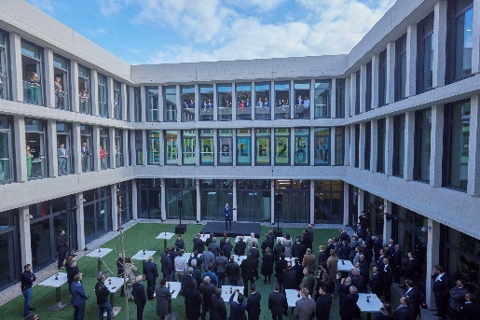Image source: FloHagena/fotolevel  During the opening event in the interior courtyard: Employees in the offices illustrated with post-its the motto of the HIC opening, ‘WE enable to grow’. Along with the sites around the world, the employees for whom no seats were available in the auditorium participated in the ceremony online. | 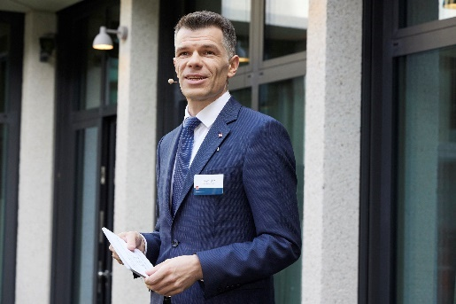Image source: FloHagena/fotolevel  Oliver Opitz, Freiham site manager of Würth Elektronik eiSos GmbH & Co. KG: “The HIC is a growth space for ideas.”

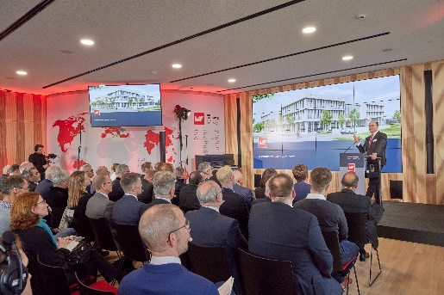  Image source: FloHagena/fotolevel  Albert Füracker, Minister of State for Finance and Home Affairs, conveyed congratulations from the Federal State of Bavaria and expressed his thanks for the investment, which serves to strengthen the region. “Family businesses think in generations, not quarters.” | 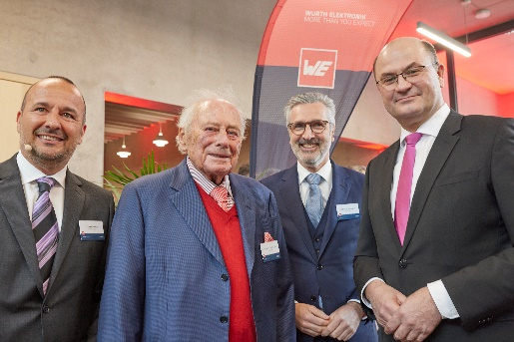  Image source: FloHagena/fotolevel  Thomas Schrott, CEO of Würth Elektronik eiSos, Prof. Dr. h. c. mult. Reinhold Würth, Chairman of the Supervisory Board of the Würth Group's Family Trusts, Robert Friedmann, Spokesman of the Board of Directors of the Würth Group, and Albert Füracker, Minister of State (from left)

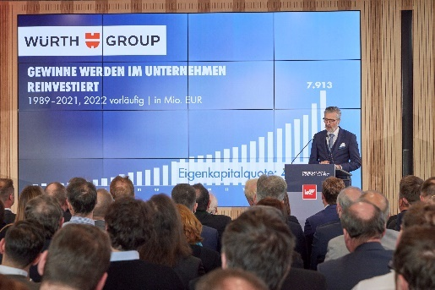  Image source: FloHagena/fotolevel  “Munich is the ideal high-tech site,” says Robert Friedmann, Spokesman of the Board of Directors of the Würth Group, while summarizing the success story. | 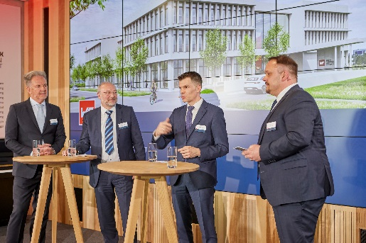  Image source: FloHagena/fotolevel  Tech-talk discussion forum:  Oliver Opitz, Freiham site manager of Würth Elektronik eiSos GmbH & Co. KG (2nd from right) explains how the company reaches out from Munich to cultivate its partnership with IC manufacturers. The customer perspective was provided by Josef Lechner, Customer Advisory Board Würth Elektronik Group (1st from left) and Dieter Müller, owner of the BMK Group (2nd from left). Dirk Knorr, Managing Director of Würth Elektronik eiSos GmbH & Co. KG (right) moderated the discussion.

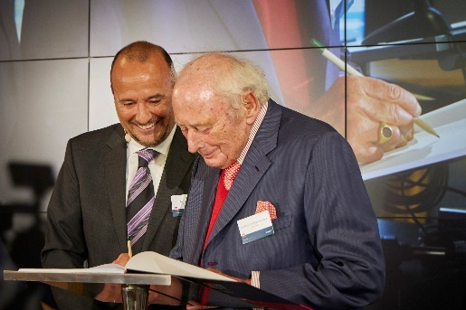  Image source: FloHagena/fotolevel  Würth Elektronik eiSos CEO Thomas Schrott witnesses how Prof. Dr. h. c. mult. Reinhold Würth, Chairman of the Supervisory Board of the Würth Group's Family Trusts, is the first to sign the High-tech Innovation Center guest book. | 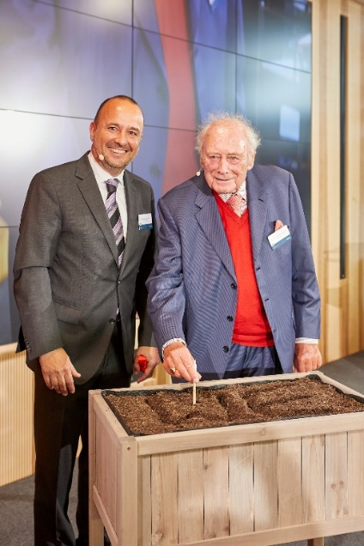Image source: FloHagena/fotolevel  Focusing on growth, also in the raised bed: Prof. Dr. h. c. mult. Reinhold Würth, Chairman of the Supervisory Board of the Würth Group's Family Trusts (right), sows seeds together with Thomas Schrott, CEO Würth Elektronik eiSos.

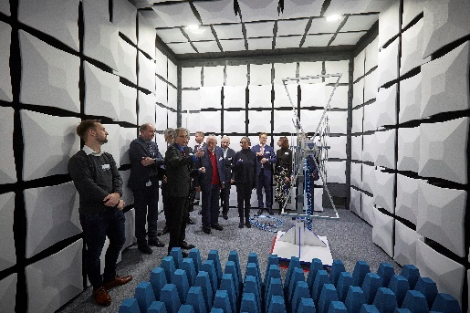Image source: FloHagena/fotolevel  One stop on the building tour: the EMC chamber | 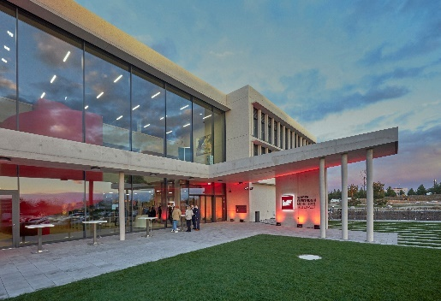Image source: FloHagena/fotolevel  Würth Elektronik High-tech Innovation Center: Workplaces designed in line with the most modern New Work approaches

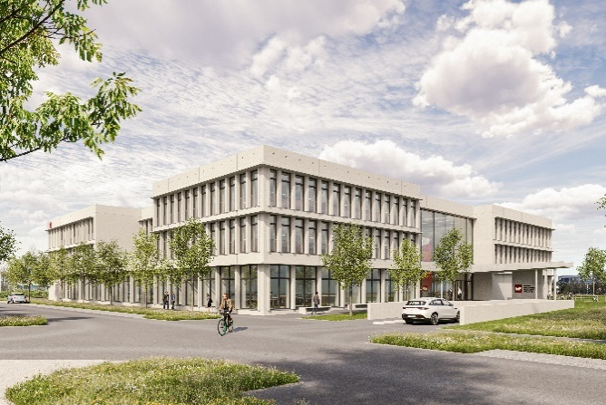  Image source: Hof 437, Alberschwende, AT  The Würth Elektronik Hightech Innovation Center was designed by the architectural firm LRO from Stuttgart. Sustainability was carefully considered in designing the building. The solar system on the roof of the building produces enough energy for its own needs. | 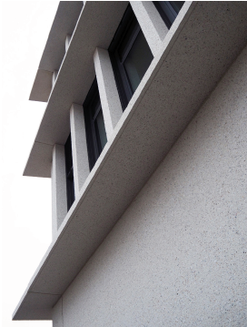  Image source: LRO, Stuttgart  Depending on the angle of view, the depth of the concrete façade presented gives rise to a sheltering spatial effect from the inside, so despite the large amount of glass, nowhere is there the impression of sitting unprotected in a transparent glass box.

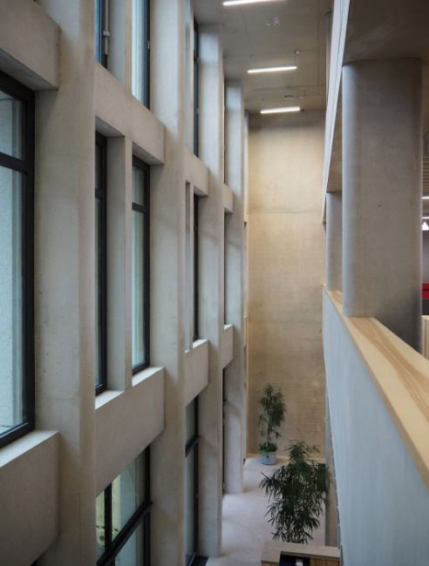  Image source: LRO, Stuttgart  The basic temperature control of the building is provided by concrete core activation in the bare concrete ceilings. | 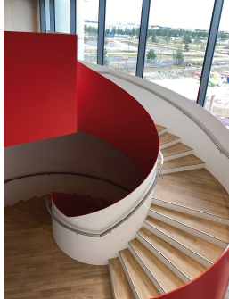  Image source: LRO, Stuttgart  The main spiral staircase painted in Würth red

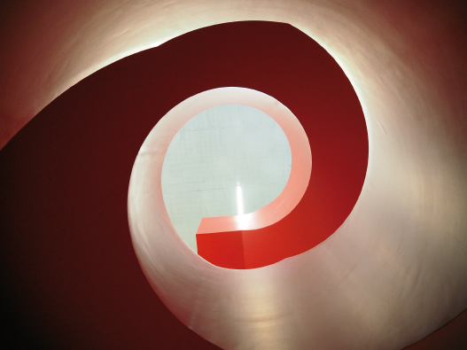
Image source: LRO, Stuttgart
The main spiral staircase painted in Würth red connects the levels and, with its closed stair stringers, forms its own space in the expansive foyer, which is entered on the first floor and is exited again on the upper floors.

About the Würth Elektronik eiSos Group
Würth Elektronik eiSos Group is a manufacturer of electronic and electromechanical components for the electronics industry and a technology company that spearheads pioneering electronic solutions. Würth Elektronik eiSos is one of the largest European manufacturers of passive components and is active in 50 countries. Production sites in Europe, Asia and North America supply a growing number of customers worldwide.
The product range includes EMC components, inductors, transformers, RF components, varistors, capacitors, resistors, quartz crystals, oscillators, power modules, Wireless Power Transfer, LEDs, sensors, connectors, power supply elements, switches, push-buttons, connection technology, fuse holders and solutions for wireless data transmission.
The unrivaled service orientation of the company is characterized by the availability of all catalog components from stock without minimum order quantity, free samples and extensive support through technical sales staff and selection tools.
Würth Elektronik is part of the Würth Group, the global market leader in the development, production, and sale of fastening and assembly materials, and employs 8,200 people. In 2022, the Würth Elektronik Group generated sales of 1.33 Billion Euro.
Würth Elektronik: more than you expect!
Further information at www.we-online.com

Further information:  Würth Elektronik eiSos GmbH & Co. KG  Sarah Hurst  Max-Eyth-Strasse 1  74638 Waldenburg  Germany  Phone: +49 7942 945-5186  E-mail: sarah.hurst@we-online.de  www.we-online.com | Press contact:  HighTech communications GmbH  Brigitte Basilio  Brunhamstrasse 21  81249 Munich  Germany  Phone: +49 89 500778-20  E-mail: b.basilio@htcm.de  www.htcm.de

