PRESS RELEASE

Würth Elektronik at embedded world 2023
14–16 March 2023
Hall 2, Stand 110
Personal Design-in Advice, Components and "more than you expect"
Waldenburg (Germany), February 23, 2023 – Würth Elektronik will be presenting itself at embedded world in Nuremberg from 14-16 March 2023 (Hall 2, Stand 110) as a manufacturer of electronic and electromechanical components and as a partner to developers. True to its motto "more than you expect!", the manufacturer will be showcasing the services it offers to help its customers bring their products to market faster. These range from online platforms such as REDEXPERT, which, for example, facilitate the selection of suitable components based on real measured values, to training courses and individual design-in support. One example of the component specialist's knowledge transfer is a workshop on the first day of the trade show. The trade fair finishes with a Student Day which is dedicated to promoting young talent.
At embedded world, Würth Elektronik will be presenting products from the fields of passive components, electromechanical components, power modules, optoelectronics, thermal management, wireless connectivity & sensors and automotive. At “theme islands”, experts from Würth Elektronik will provide advice on important decision-making parameters for component selection. They will address the requirements of industry typical applications such as in industrial electronics or automotive and present helpful and practical solutions for standard and customer-specific components. Würth Elektronik will also present and explain joint reference designs with semiconductor manufacturers at the show. The free online simulation platform REDEXPERT will also be a topic at the trade fair.
Protecting interfaces
Electromagnetic compatibility has always been a key issue for the manufacturer, as will be demonstrated once again this time. Dr. Heinz Zenkner, EMC expert at Würth Elektronik, will hold a practice-oriented workshop on "Industrial interfaces under EMC aspects." The workshop, which will take place on March 14, 2023, from 2:00 to 6:00 p.m., will revolve around how to implement robust electronic design to protect interfaces. The focus will be on EMI filter designs that attenuate emissions above 500 MHz. The workshop will look at circuit design, EMC interface filters and grounding systems. Dr. Zenkner will explain these aspects using an industrial interface card with Wi-Fi connectivity. For the workshop, which is an integral part of embedded world conference and therefore subject to a fee, prior registration is required at embedded world Conference 2023 (weka-fachmedien.de).
"We see ourselves as a partner to our customers and supply not only components - directly from stock - but an overall concept," affirms Alexander Gerfer, CTO of the Würth Elektronik eiSos Group. "The combination of exact product data, the REDEXPERT selection and design tool supported by measured value data, as well as numerous proprietary reference designs enables developers to find the perfect solution with our components quickly and easily. We are also demonstrating this with our embedded-world presence."

Available images
The following images can be downloaded from the Internet in printable quality: https://kk.htcm.de/press-releases/wuerth/
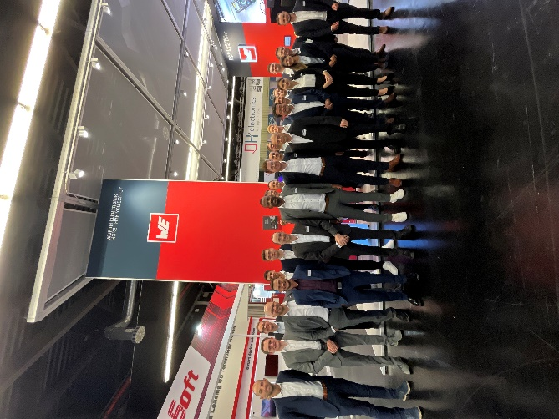  Image source: Würth Elektronik  The Würth Elektronik booth crew is looking forward to welcoming visitors to embedded world | 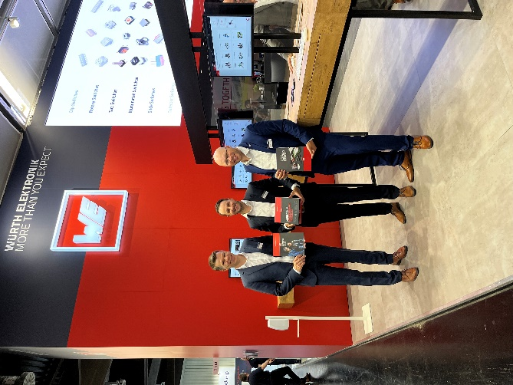  Image source: Würth Elektronik  Catalogs and evaluation kits are ready for developers to talk to Würth Elektronik. (In the picture from left to right: Oliver Opitz, Vice President Wireless Connectivity & Sensors, Tobias Mühlhäuser, Team leader BDM Wireless Connectivity & Sensors, Michael Lang, BDM Wireless Connectivity & Sensors, all Würth Elektronik eiSos).

About the Würth Elektronik eiSos Group
Würth Elektronik eiSos Group is a manufacturer of electronic and electromechanical components for the electronics industry and a technology company that spearheads pioneering electronic solutions. Würth Elektronik eiSos is one of the largest European manufacturers of passive components and is active in 50 countries. Production sites in Europe, Asia and North America supply a growing number of customers worldwide.
The product range includes EMC components, inductors, transformers, RF components, varistors, capacitors, resistors, quartz crystals, oscillators, power modules, Wireless Power Transfer, LEDs, sensors, connectors, power supply elements, switches, push-buttons, connection technology, fuse holders and solutions for wireless data transmission.
The unrivaled service orientation of the company is characterized by the availability of all catalog components from stock without minimum order quantity, free samples and extensive support through technical sales staff and selection tools.
Würth Elektronik is part of the Würth Group, the global market leader in the development, production, and sale of fastening and assembly materials, and employs 8,200 people. In 2022, the Würth Elektronik Group generated sales of 1.33 Billion Euro.
Würth Elektronik: more than you expect!
Further information at www.we-online.com

Further information:  Würth Elektronik eiSos GmbH & Co. KG  Sarah Hurst  Max-Eyth-Strasse 1  74638 Waldenburg  Germany  Phone: +49 7942 945-5186  E-mail: sarah.hurst@we-online.de  www.we-online.com | Press contact:  HighTech communications GmbH  Brigitte Basilio  Brunhamstrasse 21  81249 Munich  Germany  Phone: +49 89 500778-20  Telefax: +49 89 500778-77  E-mail: b.basilio@htcm.de  www.htcm.de

