PRESS RELEASE

Würth Elektronik offers WR-CIRCM12 M12-A circular connectors
Well-protected Connections
Waldenburg (Germany), April 20, 2023 – Würth Elektronik now offers a wide product portfolio of A-coded M12 circular connectors (DIN EN 61076-2-101). The high-quality female and male connectors with screw mating for panel mounting and cable attachment are suitable for use in harsh environments with moisture, dust and vibration. WR-CIRCM12 is available in four-, five- or eight-pole versions.
M12-A stands for data cables with the option of DC power supply – particularly suitable for fieldbus applications in industry, manufacturing engineering and automation. Sensors and actuators can be connected via the robust dustproof and waterproof connections with IP67 or IP68 ingress protection.
Packaging variants are available with metal or plastic bushings. The O-rings and seals are made of elastomers and epoxy resin and the contacts are gold-plated. All solderable products from the WR-CIRCM12 family have UL94-V0 certified packages, and the pre-attached cables and field-attachable products with screw terminals comply with UL94-HB.
The M12-A product group includes cables with male or female connectors, field-attachable connectors as well as plugs and receptacles for device installation, including prewired connectors or those to be placed on the board as THT components, for example. Free samples can now be ordered.

Available images
The following images can be downloaded from the Internet in printable quality: https://kk.htcm.de/press-releases/wuerth/

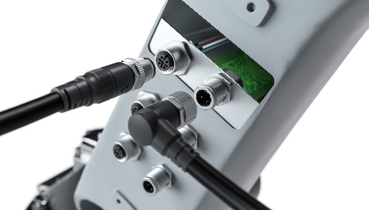Image source: Würth Elektronik
Popular in automation and mechanical engineering and now available from Würth Elektronik: M12-A circular connectors

About the Würth Elektronik eiSos Group
Würth Elektronik eiSos Group is a manufacturer of electronic and electromechanical components for the electronics industry and a technology company that spearheads pioneering electronic solutions. Würth Elektronik eiSos is one of the largest European manufacturers of passive components and is active in 50 countries. Production sites in Europe, Asia and North America supply a growing number of customers worldwide.
The product range includes EMC components, inductors, transformers, RF components, varistors, capacitors, resistors, quartz crystals, oscillators, power modules, Wireless Power Transfer, LEDs, sensors, connectors, power supply elements, switches, push-buttons, connection technology, fuse holders and solutions for wireless data transmission.
The unrivaled service orientation of the company is characterized by the availability of all catalog components from stock without minimum order quantity, free samples and extensive support through technical sales staff and selection tools.
Würth Elektronik is part of the Würth Group, the global market leader in the development, production, and sale of fastening and assembly materials, and employs 8,200 people. In 2022, the Würth Elektronik Group generated sales of 1.33 Billion Euro.
Würth Elektronik: more than you expect!
Further information at www.we-online.com

Further information:  Würth Elektronik eiSos GmbH & Co. KG  Sarah Hurst  Max-Eyth-Strasse 1  74638 Waldenburg  Germany  Phone: +49 7942 945-5186  E-mail: sarah.hurst@we-online.de  www.we-online.com | Press contact:  HighTech communications GmbH  Brigitte Basilio  Brunhamstrasse 21  81249 Munich  Germany  Phone: +49 89 500778-20  Telefax: +49 89 500778-77  E-mail: b.basilio@htcm.de  www.htcm.de

