PRESS RELEASE

Würth Elektronik introduces its toggle switch family
Switch On, Over and Off
Waldenburg (Germany), March 23, 2023 – Würth Elektronik now also produces high-quality toggle switches. Different versions of the user-friendly fast switches are now available under the name WS-TOTV. The switches are ESD compliant to IEC 61000-4-2 and have undergone operating endurance testing under full load to prove their durability (electrical life: 50,000 steps).
Toggle switches are commonly used to switch between functions on devices, which is why Würth Elektronik offers them with both ON/OFF/ON and ON/ON switching functions. They are available for SPDT (Single Pole Double Throw) and DPDT (Double Pole Double Throw) schematics as well as in horizontal and vertical versions. Their current carrying capacity is 1 A at a rated voltage of 30 V. The withstanding voltage extends to 500 V and the operating temperature from -40 up to +85°C. The frame complies with flammability class UL94 V-0.
Options include a locking ring as mechanical anti-twist protection for assembly in the 6.35 mm panel cutout, and caps in red or black. Würth Elektronik also supplies caps in any color for larger orders. Free samples for developers can now be ordered.

Available images
The following images can be downloaded from the Internet in printable quality: https://kk.htcm.de/press-releases/wuerth/
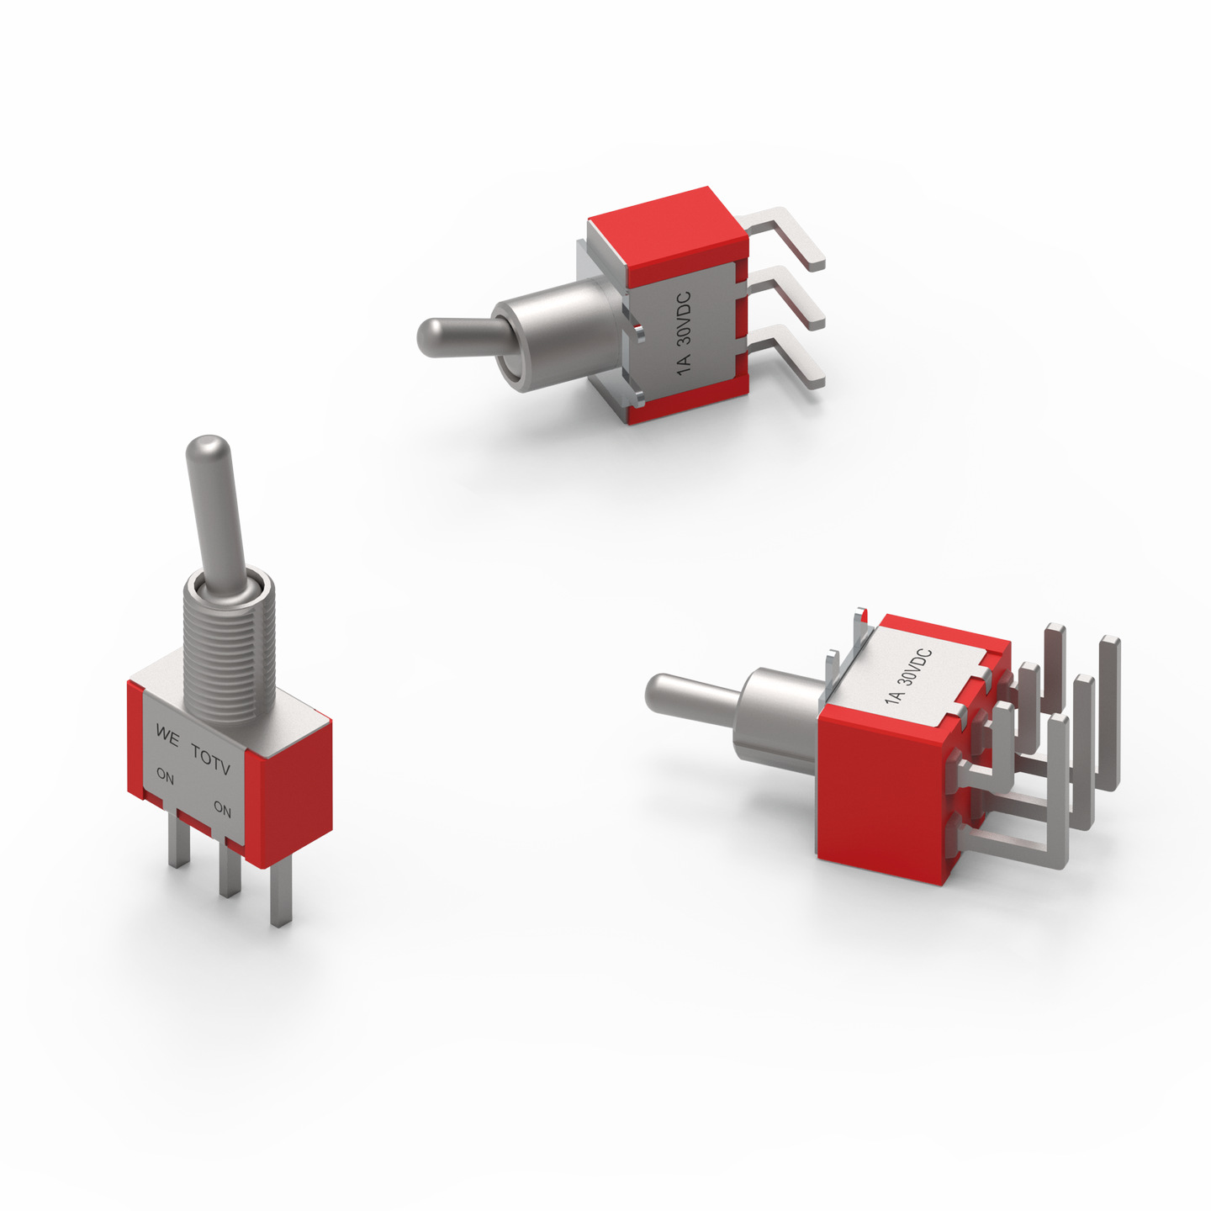
The WS-TOTV toggle switch family from Würth Elektronik is suitable for switching views on measuring devices or functions on machines, for example.

Image source: Würth Elektronik

About the Würth Elektronik eiSos Group
Würth Elektronik eiSos Group is a manufacturer of electronic and electromechanical components for the electronics industry and a technology company that spearheads pioneering electronic solutions. Würth Elektronik eiSos is one of the largest European manufacturers of passive components and is active in 50 countries. Production sites in Europe, Asia and North America supply a growing number of customers worldwide.
The product range includes EMC components, inductors, transformers, RF components, varistors, capacitors, resistors, quartz crystals, oscillators, power modules, Wireless Power Transfer, LEDs, sensors, connectors, power supply elements, switches, push-buttons, connection technology, fuse holders and solutions for wireless data transmission.
The unrivaled service orientation of the company is characterized by the availability of all catalog components from stock without minimum order quantity, free samples and extensive support through technical sales staff and selection tools.
Würth Elektronik is part of the Würth Group, the global market leader in the development, production, and sale of fastening and assembly materials, and employs 8,200 people. In 2022, the Würth Elektronik Group generated sales of 1.33 Billion Euro.
Würth Elektronik: more than you expect!
Further information at www.we-online.com

Further information:  Würth Elektronik eiSos GmbH & Co. KG  Sarah Hurst  Max-Eyth-Strasse 1  74638 Waldenburg  Germany  Phone: +49 7942 945-5186  E-mail: sarah.hurst@we-online.de  www.we-online.com | Press contact:  HighTech communications GmbH  Brigitte Basilio  Brunhamstrasse 21  81249 Munich  Germany  Phone: +49 89 500778-20  Telefax: +49 89 500778-77  E-mail: b.basilio@htcm.de  www.htcm.de

