PRESS RELEASE
A cooperation that bears fruit
Würth Elektronik Enables Organifarms’ BERRY Robot to Harvest 24/7 Throughout the Year
Munich (Germany), January 20, 2023 – Thanks to an LED board from Würth Elektronik, the BERRY harvesting robot from Organifarms – the German AgriTech startup – detects the level of ripeness of strawberries, even under the difficult lighting conditions in an indoor farm or a greenhouse. The cooperation was first presented at the Digital Life Design Conference (DLD) in Munich.
How do we feed people in the future? How can agriculture be made more sustainable and efficient? And what changes and technological developments are needed to achieve this? These are the questions that interest the agricultural industry and those looking to improve the status quo. These include Organifarms, a 2020 startup driven by the prospect of more sustainable agriculture, which has developed a harvesting robot by the name of BERRY. The first prototype for strawberry harvesting emerged just a year after founding.
A cooperation between Organifarms and Würth Elektronik was presented for the first time on January 13, 2023 to the tech-savvy audience at DLD in Munich. In a TechTalk moderated by Aman Dogra, Head of Germany at Financial Times, Hannah Brown, CCO of Organifarms together with Alexander Gerfer, CTO of Würth Elektronik eiSos, provided an insight into the collaboration.
Overcoming technological obstacles – in the agricultural sector too
Startups often face technological challenges in their daily routine. Even though these obstacles may be relatively minor, they can lead to scaling problems if no solution is found within a short time – because the competition never sleeps.
Würth Elektronik – one of Europe's largest manufacturers of passive components and pioneering technology solutions – is aware of this problem and acknowledges its responsibility in supporting companies of all sizes as a strong partner for developing innovations. By steadily expanding its optoelectronics business, the company has also promoted specific projects in the agricultural sector for several years now. Its proprietary LEDs and lighting concepts, for example, drive the seminal field of indoor and vertical farming.
Innovative LED solutions for smart agriculture
Light is also crucial for detecting ripe fruit. The violet light in the artificial light of a greenhouse has to be neutralized for BERRY to detect and harvest ripe strawberries. This is where Würth Elektronik came on the scene in June 2022. The company's support will lead to an LED board developed to enable the startup to build the innovative lighting concept for BERRY.
“BERRY will soon be able to distinguish ripe from unripe berries even under low-light conditions – that's a gigantic developmental step,” according to Hannah Brown, CCO of Organifarms. “By cooperating with Würth Elektronik, we were able to overcome another obstacle on our way to a fully autonomous harvester.”
The LED board will help reduce food waste in the future, as only ripe strawberries are picked. BERRY reduces the burden on farmers who depend on helpers for harvesting. A further benefit: The lighting concept allows the autonomous robot to also work at night. So harvesting is possible 24/7.
But that’s not all by a long shot. Organifarms and Würth Elektronik are already working on further optimizing and adding applications for the robot. BERRY could also be used specifically for pesticide management in the future, as LEDs can be used for UV-C disinfection treatment in the greenhouse. The mutual cooperation could drastically reduce the use of pesticides in the future.
“The future of agriculture is close to my heart, as I grew up on a farm. So I'm especially pleased to be actively involved in shaping projects in this sector,” says Alexander Gerfer, CTO of Würth Elektronik eiSos, commenting on the collaboration. “There are numerous innovative ideas for promoting sustainability, managing more efficiently, and reducing the burden on farmers. But, as is so often the case, the devil is in the detail, and a good idea can fail due to a single component. With the aid of our LED board, the BERRY harvesting robot from Organifarms attains the level of functionality it offers customers today. As the technology experts, it is important for us to support AgriTech startups with our knowledge and solutions and thus bring innovations to market faster for sustainable agriculture. We are also expanding our own horizons with strong and visionary partners to prepare us today for what lies ahead tomorrow.”

Available images
The following images can be downloaded from the Internet in printable quality: https://kk.htcm.de/press-releases/wuerth/

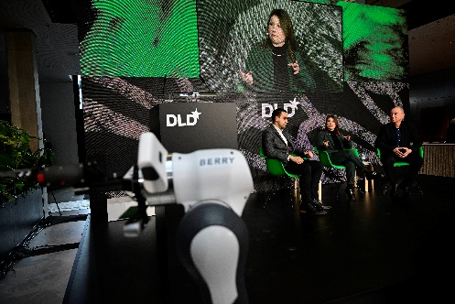  Image source: Picture Alliance for DLD / Hubert Burda Media  The BERRY robot as a harvester? Alexander Gerfer, CTO of Würth Elektronik eiSos and Hannah Brown, CCO of Organifarms, spoke with moderator Aman Dogra, Head of Germany at Financial Times, about the harvest of the future. | 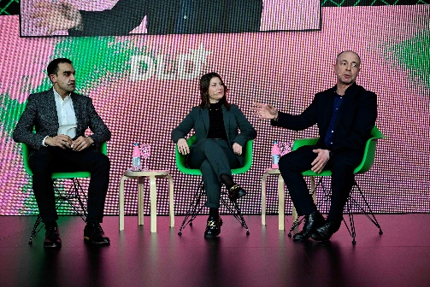Image source: Picture Alliance for DLD / Hubert Burda Media  A cooperation that bears fruit: Organifarms and Würth Elektronik presented their cooperation to a tech-savvy audience for the first time at DLD Munich 23.
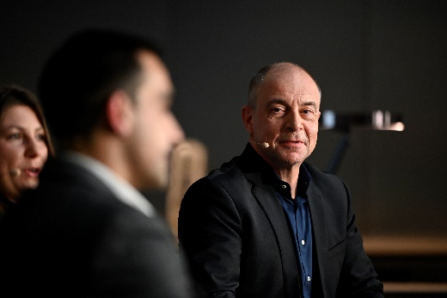 Image source: Picture Alliance for DLD / Hubert Burda Media  Alexander Gerfer, CTO of Würth Elektronik eiSos at DLD: “Our solutions help companies like Organifarms achieve their goals.” | 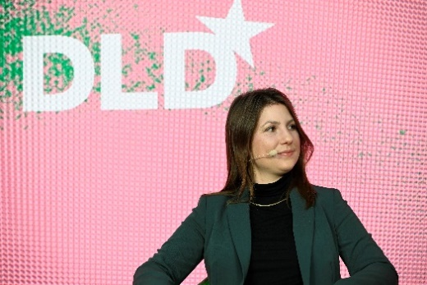Image source: Picture Alliance for DLD / Hubert Burda Media  Hannah Brown, CCO of Organifarms, briefed the audience on BERRY's range of features, its applications and benefits.
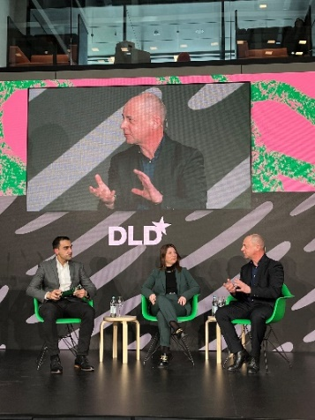
Image source: Würth Elektronik eiSos
DLD AgriTechTalk: How high-tech is driving innovation in the agricultural sector.
Available videos
You can find a video on this topic on YouTube:
https://www.youtube.com/watch?v=CwxQ9H9quvE
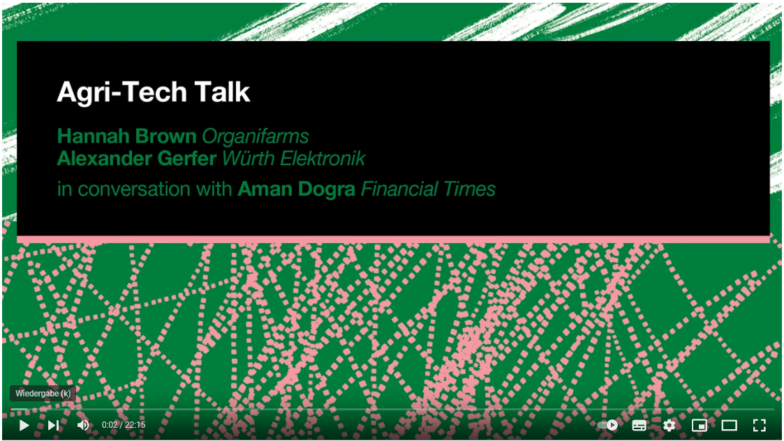
Source: DLD Conference
AgriTechTalk (DLD, January 13, 2023)

About Organifarms
Organifarms GmbH develops farm robots for automating labor-intensive tasks. The first product is a strawberry harvesting robot, which also takes care of quality control and fruit packaging. Self-learning software is at the heart of the innovation and enables the robot to produce good results even under adverse and changing conditions.
More information about Organifarms is available on the company's website: www.organifarms.de

About the Würth Elektronik eiSos Group
Würth Elektronik eiSos Group is a manufacturer of electronic and electromechanical components for the electronics industry and a technology company that spearheads pioneering electronic solutions. Würth Elektronik eiSos is one of the largest European manufacturers of passive components and is active in 50 countries. Production sites in Europe, Asia and North America supply a growing number of customers worldwide.
The product range includes EMC components, inductors, transformers, RF components, varistors, capacitors, resistors, quartz crystals, oscillators, power modules, Wireless Power Transfer, LEDs, sensors, connectors, power supply elements, switches, push-buttons, connection technology, fuse holders and solutions for wireless data transmission.
The unrivaled service orientation of the company is characterized by the availability of all catalog components from stock without minimum order quantity, free samples and extensive support through technical sales staff and selection tools.

Würth Elektronik is part of the Würth Group, the global market leader in the development, production, and sale of fastening and assembly materials, and employs 8,000 people. In 2021, the Würth Elektronik eiSos Group generated sales of 1.09 Billion Euro.
Würth Elektronik: more than you expect!
Further information at www.we-online.com

Further information:  Würth Elektronik eiSos GmbH & Co. KG  Sarah Hurst  Max-Eyth-Strasse 1  74638 Waldenburg  Germany  Phone: +49 7942 945-5186  E-mail: sarah.hurst@we-online.de  www.we-online.com | Press contact:  HighTech communications GmbH  Brigitte Basilio  Brunhamstrasse 21  81249 Munich  Germany  Phone: +49 89 500778-20  Telefax: +49 89 500778-77  E-mail: b.basilio@htcm.de  www.htcm.de

