PRESS RELEASE
Würth Elektronik partners with Crypto Quantique for IoT Security
Waldenburg (Germany), London (UK), January 13, 2023 – Würth Elektronik has signed a partnership agreement with Crypto Quantique. Collaboration with the specialist in quantum-based cyber security in the Internet of Things (IoT) enhances security for Würth Elektronik’s wireless modules.
Würth Elektronik boasts a broad portfolio of modules for wireless communication and sensors for IoT applications. The modules support connectivity via Bluetooth, Wi-Fi, Wireless M-Bus, Wirepas Mesh and proprietary radio protocols. Würth Elektronik offers components and development support for faster and more cost-effective development of market-ready IoT solutions—from simple cable replacement to radio chips with integrated GNSS modules.
Combining Crypto Quantique's QuarkLink security software platform with Würth Elektronik's wireless modules enables automatic and secure connection of thousands of sensor nodes to local or cloud-based servers. The platform allows device provisioning, onboarding, security monitoring, renewal and revocation of certificates and keys, performed with a few keystrokes on a GUI. Users thus have all functions at their disposal required to manage IoT devices in their lifecycle.
Security platform for IoT networks
“Würth Elektronik is often the first choice for radio modules, especially with industrial IoT applications. The spectrum of products offered, combined with wide-ranging support and application expertise, is outstanding,” Dr. Shahram Mossayebi, CEO of Crypto Quantique, explains the cooperation. “Expanding the offering with QuarkLink also raises the appeal of these products. This makes implementing and managing secure IoT networks faster and easier. At a time when the global threats to such networks are greater than ever, this is an important advantage.”
“We are always interested in providing our customers with the best IoT technology, reducing their development costs and workload, without compromising performance, reliability or security. QuarkLink is an important new building block here,“ says Oliver Opitz, Vice President, Wireless Connectivity and Sensors at Würth Elektronik eiSos GmbH & Co. KG.

Available images
The following images can be downloaded from the Internet in printable quality: https://kk.htcm.de/press-releases/wuerth/
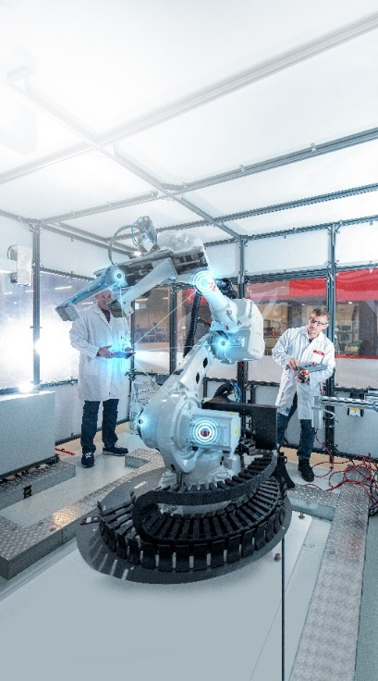
Image source: Würth Elektronik
Networking industrial robots: The QuarkLink security platform from Crypto Quantique and wireless modules from Würth Elektronik enable secure connection to the IoT.

About Crypto Quantique
Crypto Quantique has developed the world's most secure end-to-end IoT security platform. At its core is the world's first quantum-based technology—QDID—which generates multiple unique, fraud-resistant cryptographic keys for standard CMOS devices. The keys don’t have to be stored and can be used independently by several applications as required. Combined with the cryptographic APIs from the company's universal IoT security platform, QuarkLink, the solution provides a secure bridge between silicon, device, and software and solution provider.
Based in London, UK, the company was founded by Dr. Shahram Mossayebi (CEO), an expert in cryptosystems, and Dr. Patrick Camilleri (VP Research & Innovation), a semiconductor developer with extensive experience in complex parallel computing systems.
Further information at www.cryptoquantique.com

About the Würth Elektronik eiSos Group
Würth Elektronik eiSos Group is a manufacturer of electronic and electromechanical components for the electronics industry and a technology company that spearheads pioneering electronic solutions. Würth Elektronik eiSos is one of the largest European manufacturers of passive components and is active in 50 countries. Production sites in Europe, Asia and North America supply a growing number of customers worldwide.
The product range includes EMC components, inductors, transformers, RF components, varistors, capacitors, resistors, quartz crystals, oscillators, power modules, Wireless Power Transfer, LEDs, sensors, connectors, power supply elements, switches, push-buttons, connection technology, fuse holders and solutions for wireless data transmission.
The unrivaled service orientation of the company is characterized by the availability of all catalog components from stock without minimum order quantity, free samples and extensive support through technical sales staff and selection tools.
Würth Elektronik is part of the Würth Group, the global market leader in the development, production, and sale of fastening and assembly materials, and employs 8,200 people. In 2022, the Würth Elektronik Group generated sales of 1.33 Billion Euro.
Würth Elektronik: more than you expect!
Further information at www.we-online.com

Further information:  Würth Elektronik eiSos GmbH & Co. KG  Sarah Hurst  Max-Eyth-Strasse 1  74638 Waldenburg  Germany  Phone: +49 7942 945-5186  E-mail: sarah.hurst@we-online.de  www.we-online.com | Press contact:  HighTech communications GmbH  Brigitte Basilio  Brunhamstrasse 21  81249 Munich  Germany  Phone: +49 89 500778-20  Telefax: +49 89 500778-77  E-mail: b.basilio@htcm.de  www.htcm.de

