PRESS RELEASE

Würth Elektronik subsidiary established in Lithuania
Promising Market
Waldenburg (Germany), March 28, 2023 – Wurth Elektronik Lietuva, UAB, has received its official status as a registered company. Thus, the seven Lithuanian employees of Würth Elektronik form another subsidiary of the manufacturer of electronic and electromechanical components. The managing director, Zenonas Vaitonis, has successfully represented Würth Elektronik in Lithuania and Latvia since 2017.
Zenonas Vaitonis and his colleagues, who have become more and more numerous over the years, have found customers for Würth Elektronik’s complete portfolio. The region boasts a number of manufacturers in areas such as wireless technology, fleet management systems, power electronics for lasers, and building automation. Among other things, Würth Elektronik is known for its EMC expertise and products for interference suppression. As practical advice to customers is also part of the recipe for success in the young Baltic branch, Wurth Elektronik Lietuva attaches great importance to its partnership with two certified EMC laboratories and several smaller laboratories.
“We are pleased to now be able to act as our own company in the globally successful Würth Elektronik eiSos Group. There is still room for more colleagues in our beautiful office – the way our growth is developing, I am optimistic that we will soon be able to welcome others here as well,” says Zenonas Vaitonis.
The Würth Elektronik office is located in a western district of Vilnius. It is close to the main routes to Riga, Kaunas, and Panevėžys. With its large panoramic windows, the bright office reflects the vision of a great development at the local team.

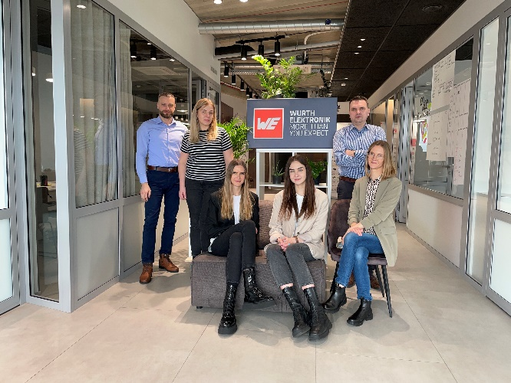Image source: Würth Elektronik
The team of the Würth Elektronik subsidiary in Lithuania

About the Würth Elektronik eiSos Group
Würth Elektronik eiSos Group is a manufacturer of electronic and electromechanical components for the electronics industry and a technology company that spearheads pioneering electronic solutions. Würth Elektronik eiSos is one of the largest European manufacturers of passive components and is active in 50 countries. Production sites in Europe, Asia and North America supply a growing number of customers worldwide.
The product range includes EMC components, inductors, transformers, RF components, varistors, capacitors, resistors, quartz crystals, oscillators, power modules, Wireless Power Transfer, LEDs, sensors, connectors, power supply elements, switches, push-buttons, connection technology, fuse holders and solutions for wireless data transmission.
The unrivaled service orientation of the company is characterized by the availability of all catalog components from stock without minimum order quantity, free samples and extensive support through technical sales staff and selection tools.
Würth Elektronik is part of the Würth Group, the global market leader in the development, production, and sale of fastening and assembly materials, and employs 8,200 people. In 2022, the Würth Elektronik Group generated sales of 1.33 Billion Euro.
Würth Elektronik: more than you expect!
Further information at www.we-online.com

Further information:  Würth Elektronik eiSos GmbH & Co. KG  Sarah Hurst  Max-Eyth-Strasse 1  74638 Waldenburg  Germany  Phone: +49 7942 945-5186  E-mail: sarah.hurst@we-online.de  www.we-online.com | Press contact:  HighTech communications GmbH  Brigitte Basilio  Brunhamstrasse 21  81249 Munich  Germany  Phone: +49 89 500778-20  Telefax: +49 89 500778-77  E-mail: b.basilio@htcm.de  www.htcm.de

