PRESS RELEASE

Electromechanics catalog 2023 from Würth Elektronik
Stay Connected
Waldenburg (Germany), January 19, 2023 – Würth Elektronik now presents its “Electromechanical Components 2023” catalog to download. The catalog contains 65 pages with innovations from the areas of connection and assembly technology as well as switches and buttons. The manufacturer dedicates a chapter to the REDCUBE high-power contacts. Thanks to press-fit technology, they are particularly robust and vibration-resistant. All products in the catalog can be ordered from stock without a minimum order quantity. Developers can receive free samples on request.
The new catalog clearly shows the various options for connecting PCBs with one another or with cables. A highlight in the 2023 catalog is the M12 circular connectors with screw locking and IP67 or IP68 protection for data lines in industrial automation equipment. The coaxial connectors also include an interesting new arrival: various N-type coaxial connectors to the MIL-STD-348 standard for particularly rugged applications. Among the switches, a new toggle switch family catches the eye—with a current carrying capacity of 1 A, rated voltage of 30 V and ESD compliance with IEC 61000-4-2.
REDFIT CRIMP is a particularly stable yet reversible connection for up to 16 A and 400 V. This PCB connector uses Würth Elektronik patented SKEDD technology. A positioning pin allows non-rotating connection to the PCB by hand and without a mating connector.
The printed version of the catalog can also be ordered at:
https://www.we-online.com/en/products/components/service/information-components

Available images
The following images can be downloaded from the Internet in printable quality: https://kk.htcm.de/press-releases/wuerth/
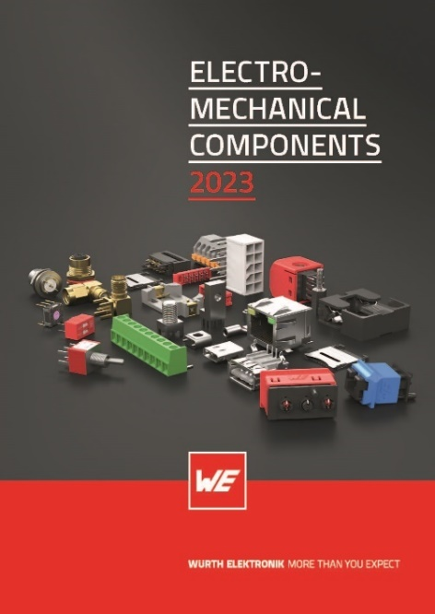Image source: Würth Elektronik
“Electromechanical Components 2023” catalog

About the Würth Elektronik eiSos Group
Würth Elektronik eiSos Group is a manufacturer of electronic and electromechanical components for the electronics industry and a technology company that spearheads pioneering electronic solutions. Würth Elektronik eiSos is one of the largest European manufacturers of passive components and is active in 50 countries. Production sites in Europe, Asia and North America supply a growing number of customers worldwide.
The product range includes EMC components, inductors, transformers, RF components, varistors, capacitors, resistors, quartz crystals, oscillators, power modules, Wireless Power Transfer, LEDs, sensors, connectors, power supply elements, switches, push-buttons, connection technology, fuse holders and solutions for wireless data transmission.

The unrivaled service orientation of the company is characterized by the availability of all catalog components from stock without minimum order quantity, free samples and extensive support through technical sales staff and selection tools.
Würth Elektronik is part of the Würth Group, the global market leader in the development, production, and sale of fastening and assembly materials, and employs 8,000 people. In 2021, the Würth Elektronik eiSos Group generated sales of 1.09 Billion Euro.
Würth Elektronik: more than you expect!
Further information at www.we-online.com

Further information:  Würth Elektronik eiSos GmbH & Co. KG  Sarah Hurst  Max-Eyth-Strasse 1  74638 Waldenburg  Germany  Phone: +49 7942 945-5186  E-mail: sarah.hurst@we-online.de  www.we-online.com | Press contact:  HighTech communications GmbH  Brigitte Basilio  Brunhamstrasse 21  81249 Munich  Germany  Phone: +49 89 500778-20  Telefax: +49 89 500778-77  E-mail: b.basilio@htcm.de  www.htcm.de

