PRESS RELEASE

Würth Elektronik introduces its WL-OCPT dual-channel optocoupler phototransistor
Space-saving Solution for Circuit Isolation
Waldenburg (Germany), February 9, 2023 – Würth Elektronik has expanded its WL-OCPT optocoupler product family with the DIP-8 design. Two-channel optocoupler phototransistors with eight pins are now available. This design contains two circuits inside a single component constructed from two input LEDs and two output phototransistors, therefore two separate circuits can be controlled with a single component. WL-OCPT features a stable current transfer ratio (CTR) over the entire operating temperature range (-55 to +110°C). The DIN-EN-60747-5-5-certified components have an insulation voltage of 5000 V, a collector-emitter voltage of 80 V, and a maximum forward current of 60 mA.
The Würth Elektronik optocouplers are suitable for optical and space-saving galvanic isolation in power supplies, chargers, computers, microprocessors, instruments, machines, ammeters or smart meters. Binning of the dual-channel WL-OCPT is in a CTR range of 130-400%, tested at an input current of 5 mA and a collector-emitter voltage of 5 V. Depending on the land pattern on the PCB, the DIP-8 optocoupler packages are available in standard, M, S and SL leadframe variants. The lead frames are made of copper thus guaranteeing the best solderability.
Like all other WL-OCPT series optocouplers, the DIP-8 variants are now available from stock without a minimum order quantity. Developers receive free samples on request.

Available images
The following images can be downloaded from the Internet in printable quality: https://kk.htcm.de/press-releases/wuerth/

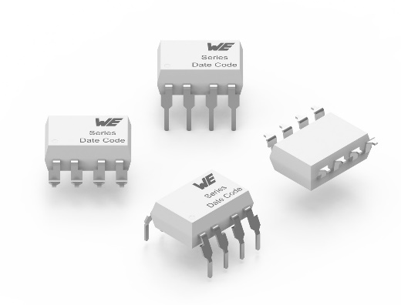Image source: Würth Elektronik
The WL-OCPT optocoupler phototransistor is now also available in a DIP-8 version

About the Würth Elektronik eiSos Group
Würth Elektronik eiSos Group is a manufacturer of electronic and electromechanical components for the electronics industry and a technology company that spearheads pioneering electronic solutions. Würth Elektronik eiSos is one of the largest European manufacturers of passive components and is active in 50 countries. Production sites in Europe, Asia and North America supply a growing number of customers worldwide.
The product range includes EMC components, inductors, transformers, RF components, varistors, capacitors, resistors, quartz crystals, oscillators, power modules, Wireless Power Transfer, LEDs, sensors, connectors, power supply elements, switches, push-buttons, connection technology, fuse holders and solutions for wireless data transmission.
The unrivaled service orientation of the company is characterized by the availability of all catalog components from stock without minimum order quantity, free samples and extensive support through technical sales staff and selection tools.
Würth Elektronik is part of the Würth Group, the global market leader in the development, production, and sale of fastening and assembly materials, and employs 8,200 people. In 2022, the Würth Elektronik eiSos Group generated sales of 1.33 billion Euro.
Würth Elektronik: more than you expect!
Further information at www.we-online.com

Further information:  Würth Elektronik eiSos GmbH & Co. KG  Sarah Hurst  Max-Eyth-Strasse 1  74638 Waldenburg  Germany  Phone: +49 7942 945-5186  E-mail: sarah.hurst@we-online.de  www.we-online.com | Press contact:  HighTech communications GmbH  Brigitte Basilio  Brunhamstrasse 21  81249 Munich  Germany  Phone: +49 89 500778-20  Telefax: +49 89 500778-77  E-mail: b.basilio@htcm.de  www.htcm.de

