PRESS RELEASE

Würth Elektronik introduces its WCAP-FTDB DC-Link capacitors
Stabilize Power Converters in Charging and Photovoltaic Systems
Waldenburg (Germany), March 30, 2023 – Würth Elektronik presents a new series of film capacitors specially designed for DC-Link applications. The WCAP-FTDB series components can be used in the voltage range from 500 to 1200 V and are characterized by high ripple current capability. This makes them particularly attractive for use in AC/DC and DC/DC converters for charging systems and power electronics in e-mobility or in renewable energy solutions. The 24-model product family offers capacitance values from 1 µF to 75 µF.
The capacitors for stabilizing DC-Link voltage are very robust. Thanks to their metallized polypropylene film design, they have self-healing properties whereby short circuits “burn out” their own cause, hence restoring an intact dielectric. Significantly more durable than other capacitor types, the WCAP-FTDB series is suitable for applications with long maintenance cycles like wind turbines. Würth Elektronik provides a boxed THT package with pitch of 27.5 mm, 37.5 mm and 52.5 mm for this component family. The operating temperature of the film capacitors extends from -40°C to 105°C, the respective maximum voltage values attained are up to 85°C.
Like all products in the Electronic Components 2022/2023 catalog, the WCAP-FTDB DC-Link capacitors are now available without a minimum order quantity. Würth Elektronik provides free samples and offers a wide range of characteristic measurement data of the capacitors in the REDEXPERT online tool. This facilitates the selection of suitable components.

Available images
The following images can be downloaded from the Internet in printable quality: https://kk.htcm.de/press-releases/wuerth/
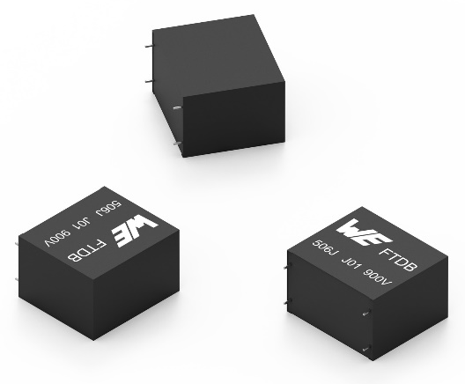Image source: Würth Elektronik
WCAP-FTDB DC-Link capacitors

Available videos
You can find video material on this topic on our YouTube channel:
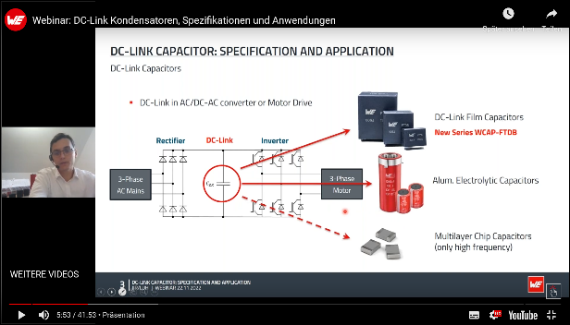
Source: Würth Elektronik
Webinar:
https://www.youtube.com/watch?v=UKJXqoDvGYs&list=PLZJdRX1BvL0z2_-tc-ZSUPC0kd7tyexYd&index=1

In a webinar, applications and properties of the new WCAP-FTDB capacitor family will be introduced – also in contrast to aluminum electrolytic capacitors.

About the Würth Elektronik eiSos Group
Würth Elektronik eiSos Group is a manufacturer of electronic and electromechanical components for the electronics industry and a technology company that spearheads pioneering electronic solutions. Würth Elektronik eiSos is one of the largest European manufacturers of passive components and is active in 50 countries. Production sites in Europe, Asia and North America supply a growing number of customers worldwide.
The product range includes EMC components, inductors, transformers, RF components, varistors, capacitors, resistors, quartz crystals, oscillators, power modules, Wireless Power Transfer, LEDs, sensors, connectors, power supply elements, switches, push-buttons, connection technology, fuse holders and solutions for wireless data transmission.
The unrivaled service orientation of the company is characterized by the availability of all catalog components from stock without minimum order quantity, free samples and extensive support through technical sales staff and selection tools.
Würth Elektronik is part of the Würth Group, the global market leader in the development, production, and sale of fastening and assembly materials, and employs 8,200 people. In 2022, the Würth Elektronik Group generated sales of 1.33 Billion Euro.
Würth Elektronik: more than you expect!
Further information at www.we-online.com

Further information:  Würth Elektronik eiSos GmbH & Co. KG  Sarah Hurst  Max-Eyth-Strasse 1  74638 Waldenburg  Germany  Phone: +49 7942 945-5186  E-mail: sarah.hurst@we-online.de  www.we-online.com | Press contact:  HighTech communications GmbH  Brigitte Basilio  Brunhamstrasse 21  81249 Munich  Germany  Phone: +49 89 500778-20  Telefax: +49 89 500778-77  E-mail: b.basilio@htcm.de  www.htcm.de

