PRESS RELEASE

Würth Elektronik introduces its WCAP-FTXH capacitor series
Interference Suppression Capacitors for Extreme Operating Conditions
Waldenburg (Germany), March 8, 2023 – With its WCAP-FTXH THB X2 series, Würth Elektronik introduces its new family of safety capacitors for interference suppression in mains filters. All articles in this series are ENEC 10, cULus, and CQC certified and belong to the X2 safety class capacitors according to IEC 60384-14. What makes the capacitors – designed for 310 V rated voltage – particularly special is their resistance to heat and moisture. They therefore pass a 1000-hour test at 85°C and 85% relative humidity with the rated voltage applied. Their operating temperature range extends from -40 to +110°C.
The WCAP-FTXH family of capacitors has self-healing properties thanks to its polypropylene dielectric: If a short circuit occurs in the component, it leads to the elimination of its own cause by vaporizing the defect, thus restoring an intact dielectric.
The film capacitors are available in 21 variants with different capacitance values (from 33 nF to 10 µF), voltage ramp-up rates, and insulation resistances. The components have different sizes depending on their values, and a pin pitch from 15 mm to 37.5 mm.
Like all products in the Electronic Components 2022/2023 catalog, the WCAP-FTXH series safety capacitors are now available from stock without a minimum order quantity.

Available images
The following images can be downloaded from the Internet in printable quality: https://kk.htcm.de/press-releases/wuerth/
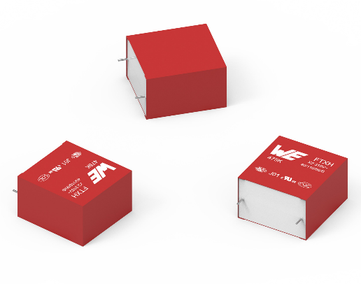Image source: Würth Elektronik
The WCAP-FTXH THB X2 safety capacitors are very well suited for harsh environments.

Available videos
You can find videos on this topic on our YouTube channel:
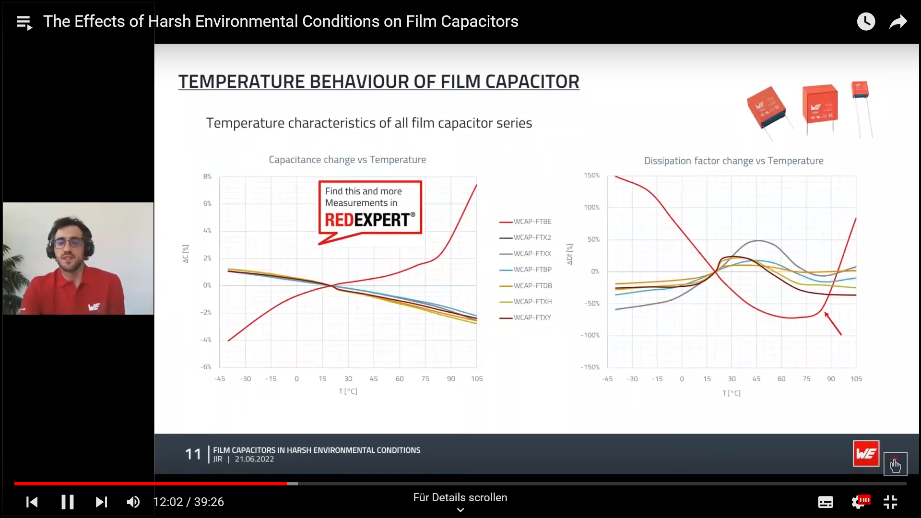
Source: Würth Elektronik
Webinar: The Effects of Harsh Environmental Conditions on Film Capacitors

https://www.youtube.com/watch?v=5DHbHOYkK2E&list=PLZJdRX1BvL0xS4z_7DwAqKYhPasl3jTNw&index=24

About the Würth Elektronik eiSos Group
Würth Elektronik eiSos Group is a manufacturer of electronic and electromechanical components for the electronics industry and a technology company that spearheads pioneering electronic solutions. Würth Elektronik eiSos is one of the largest European manufacturers of passive components and is active in 50 countries. Production sites in Europe, Asia and North America supply a growing number of customers worldwide.
The product range includes EMC components, inductors, transformers, RF components, varistors, capacitors, resistors, quartz crystals, oscillators, power modules, Wireless Power Transfer, LEDs, sensors, connectors, power supply elements, switches, push-buttons, connection technology, fuse holders and solutions for wireless data transmission.
The unrivaled service orientation of the company is characterized by the availability of all catalog components from stock without minimum order quantity, free samples and extensive support through technical sales staff and selection tools.
Würth Elektronik is part of the Würth Group, the global market leader in the development, production, and sale of fastening and assembly materials, and employs 8,200 people. In 2022, the Würth Elektronik Group generated sales of 1.33 Billion Euro.
Würth Elektronik: more than you expect!
Further information at www.we-online.com

Further information:  Würth Elektronik eiSos GmbH & Co. KG  Sarah Hurst  Max-Eyth-Strasse 1  74638 Waldenburg  Germany  Phone: +49 7942 945-5186  E-mail: sarah.hurst@we-online.de  www.we-online.com | Press contact:  HighTech communications GmbH  Brigitte Basilio  Brunhamstrasse 21  81249 Munich  Germany  Phone: +49 89 500778-20  Telefax: +49 89 500778-77  E-mail: b.basilio@htcm.de  www.htcm.de

