PRESS RELEASE

Würth Elektronik Website-Relaunch
Modern Appearance of the Würth Elektronik Group
Waldenburg (Germany), January 12, 2023—Würth Elektronik has revised and redesigned its information and communication offering. The joint web presence of the Würth Elektronik companies can be found at www.we-online.com. On a modern website, the relaunch combines various product and service offerings of Würth Elektronik eiSos, Würth Elektronik Circuit Board Technology and Würth Elektronik ICS. The store and job application systems were also aligned. In the course of the corporate design relaunch, the website was given a new, modern face, a responsive design for all end devices, and a revised content structure.
The new Würth Elektronik website reflects the company's strong service orientation. Users of www.we-online.com can quickly find help for their projects here. Numerous design tools and information sources make it easier to select suitable products and services and to connect to the right experts.
With the relaunch, the design of other stores was also adapted. The simulation platform REDEXPERT as well as the job portal are now linked to the corporate website and better accessible.
Companies from a wide range of industries require professional support in the development and integration of electrical and electronic components, electronic and electromechanical components, printed circuit boards, intelligent power and control systems. The wide range of products and services offered by Würth Elektronik reflects this need. The new website is also geared entirely towards helping customers find what they need quickly.

Available images
The following images can be downloaded from the Internet in printable quality: https://kk.htcm.de/press-releases/wuerth/

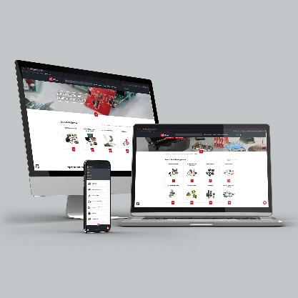Image source: Würth Elektronik
Responsive Design: Whether on a laptop, desktop PC, tablet or smartphone, the new modern website of the Würth Elektronik Group is automatically optimized for the corresponding device.

About the Würth Elektronik group of companies
The Würth Elektronik group of companies, founded in Niedernhall, Baden-Wuerttemberg, Germany, has about 8,000 employees worldwide and generated global sales of 1.09 Billion Euro in 2021.
With over 23 production locations worldwide, Würth Elektronik is one of the most successful companies of the Würth Group.
Würth Elektronik operates internationally with its three company areas in various markets:
- Electronic & electromechanical components (Headquarters: Waldenburg)
Würth Elektronik eiSos (electronic and electromechanical components) is one of Europe's biggest manufacturers of electronic & electromechanical components. More than 700 sales representatives worldwide make up a direct sales network that is unique for the electronics market. The customer is offered excellent design-in support on-site from the manufacturer. The production plants in Germany, Czech Republic, Bulgaria, USA, Mexico, Taiwan and China guarantee high availability on all markets. All catalog products are available from stock and samples are free of charge.

- PCBs (Headquarters: Niedernhall)
Founded in 1971, Würth Elektronik Circuit Board Technology is today Europe's leading PCB manufacturer and, thanks to the comprehensive portfolio, a reliable partner for both individual entrepreneurs and large corporations. Whether basic or high-end technologies, customer-specific requirements are met from the initial idea for a design to the production of prototypes on the online shop and finally, manufacturing of medium and large volumes in Germany or Asia.
- Intelligent Power & Control Systems (Headquarters: Niedernhall-Waldzimmern)
As a specialist for the development and production of electronic and electromechanical system solutions, such as central electronics, Würth Elektronik ICS (Intelligent Power & Control Systems) is a longtime partner for many commercial vehicles. Professional project management accompanies business partners from the product idea through to series maturity.

Further info at www.we-online.com

More information:  Würth Elektronik eiSos GmbH & Co. KG  Sarah Hurst  Max-Eyth-Strasse 1  74638 Waldenburg  Germany  Phone: +49 7942 945-5186  E-mail: sarah.hurst@we-online.de  www.we-online.com | Press contact:  HighTech communications GmbH  Brigitte Basilio  Brunhamstrasse 21  81249 Munich  Germany  Phone: +49 89 500778-20  Telefax: +49 89 500778-77  E-mail: b.basilio@htcm.de  www.htcm.de

