PRESS RELEASE

Würth Elektronik presents reference design for its Gigabit Ethernet front end
EMC Aspects of Gigabit Ethernet Interfaces
Waldenburg (Germany), December 2, 2022 – Würth Elektronik has published its RD016 reference design (https://www.we-online.com/RD016) and the corresponding application note ANP116 (https://www.we-online.com/ANP116). With this, the manufacturer of electronic and electromechanical components provides valuable information for the development of EMC-compliant Gigabit Ethernet applications. Developers obtain an optimized circuit design and the best possible layout for their Gigabit Ethernet front end along with all technical data.
“Gigabit Ethernet has established itself as a networking standard in office and industrial environments. Nevertheless, there is little information in the relevant technical literature about EMC aspects of Gigabit Ethernet interfaces. We are closing this gap with our reference design,” says Gerhard Stelzer, Senior Technical Editor at Würth Elektronik eiSos.
The reference design offers two interfaces, a USB Type C (USB 3.1) and a 1 Gigabit RJ45/Ethernet interface. The Gigabit-Ethernet-USB adapter was developed based on the EVB-LAN7800LC evaluation board from Microchip. The circuit board uses a 4 layer stackup and is powered via USB. The first part of the document RD016 presents the technical basics necessary for understanding the reference design. The second part details the 1 GB Ethernet interface up to the physical layer (PHY in the OSI model). EMC aspects are covered in detail in App Note ANP116. Design data is available for reconstructing the reference board (Altium Designer / Gerber data).

Available images
The following images can be downloaded from the Internet in printable quality: https://kk.htcm.de/press-releases/wuerth/

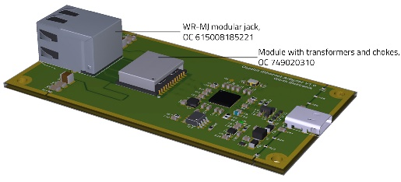  Image source: Würth Elektronik  Gigabit-Ethernet-USB adapter in the discrete V1.0 variant: The module with the transformers and common-mode chokes is placed next to the RJ45 jack. | 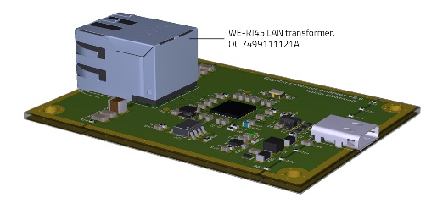  Image source: Würth Elektronik  Gigabit-Ethernet-USB adapter in the integrated V2.0 variant: The discretely placed module with transformers and chokes in the V1.0 variant is integrated in the RJ45 jack.

About the Würth Elektronik eiSos Group
Würth Elektronik eiSos Group is a manufacturer of electronic and electromechanical components for the electronics industry and a technology company that spearheads pioneering electronic solutions. Würth Elektronik eiSos is one of the largest European manufacturers of passive components and is active in 50 countries. Production sites in Europe, Asia and North America supply a growing number of customers worldwide.
The product range includes EMC components, inductors, transformers, RF components, varistors, capacitors, resistors, quartz crystals, oscillators, power modules, Wireless Power Transfer, LEDs, sensors, connectors, power supply elements, switches, push-buttons, connection technology, fuse holders and solutions for wireless data transmission.
The unrivaled service orientation of the company is characterized by the availability of all catalog components from stock without minimum order quantity, free samples and extensive support through technical sales staff and selection tools.
Würth Elektronik is part of the Würth Group, the world market leader for assembly and fastening technology. The company employs 8,000 staff and generated sales of 1.09 Billion Euro in 2021.
Würth Elektronik: more than you expect!
Further information at www.we-online.com

Further information:  Würth Elektronik eiSos GmbH & Co. KG  Sarah Hurst  Max-Eyth-Strasse 1  74638 Waldenburg  Germany  Phone: +49 7942 945-5186  E-mail: sarah.hurst@we-online.de  www.we-online.com | Press contact:  HighTech communications GmbH  Brigitte Basilio  Brunhamstrasse 21  81249 Munich  Germany  Phone: +49 89 500778-20  Telefax: +49 89 500778-77  E-mail: b.basilio@htcm.de  www.htcm.de

