PRESS RELEASE
Würth Elektronik presents its WSEN-ISDS motion sensor
Accelerometer and Gyroscope in One
Waldenburg (Germany), March 16, 2023–Würth Elektronik is expanding its range of compact MEMS-based sensors with a 3-axis accelerometer and integrated gyroscope. Its selectable measuring ranges and data rates makes WSEN-ISDS extremely versatile. To facilitate integration, the sensor outputs pre-calibrated, processed data for application-specific functionalities of free-fall, wake-up, tap, activity, motion, tilt and orientation detection. The 2.5 x 3.0 x 0.86 mm sensor in an LGA package provides digital I²C and SPI interfaces as well as a FIFO buffer for storing output data.
Countless applications await the WSEN-ISDS compact accelerometer and gyroscope: from localization and navigation solutions, to automation, industrial devices and machines, antenna and platform stabilization, through to industrial IoT devices, robots and drones. Linear and angular acceleration measurement extends from single-event registration to high frequency continuous vibration monitoring. Data rates can be selected up to 1400 Hz for the accelerometer and up to 937 Hz for the gyroscope. The output data rate extends to 6.66 kHz. The module draws 0.69 mA in high-power mode, but this goes down to 0.28 mA in low-power mode to capture single pulses.
From a light breeze to an intense tremor
The user can select different measuring ranges depending on the level of acceleration the WSEN-ISDS is to detect. Here, Würth Elektronik offers the ranges ±2 g, ±4 g, ±8 g, ±16 g for linear acceleration and ±250 dps, ±500 dps, ±1000 dps, ±2000 dps for the change of angular velocity. The sensitivity accuracy is ±3 percent.
The WSEN-ISDS sensor is always available from stock without a minimum order quantity. Würth Elektronik offers developers design-in consultation.

Available images
The following images can be downloaded from the Internet in printable quality: https://kk.htcm.de/press-releases/wuerth/

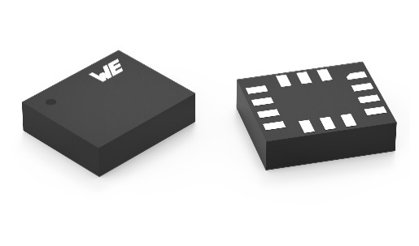
Image source: Würth Elektronik
WSEN-ISDS motion sensor

About the Würth Elektronik eiSos Group
Würth Elektronik eiSos Group is a manufacturer of electronic and electromechanical components for the electronics industry and a technology company that spearheads pioneering electronic solutions. Würth Elektronik eiSos is one of the largest European manufacturers of passive components and is active in 50 countries. Production sites in Europe, Asia and North America supply a growing number of customers worldwide.
The product range includes EMC components, inductors, transformers, RF components, varistors, capacitors, resistors, quartz crystals, oscillators, power modules, Wireless Power Transfer, LEDs, sensors, connectors, power supply elements, switches, push-buttons, connection technology, fuse holders and solutions for wireless data transmission.
The unrivaled service orientation of the company is characterized by the availability of all catalog components from stock without minimum order quantity, free samples and extensive support through technical sales staff and selection tools.
Würth Elektronik is part of the Würth Group, the global market leader in the development, production, and sale of fastening and assembly materials, and employs 8,200 people. In 2022, the Würth Elektronik Group generated sales of 1.33 Billion Euro.
Würth Elektronik: more than you expect!
Further information at www.we-online.com

Further information:  Würth Elektronik eiSos GmbH & Co. KG  Sarah Hurst  Max-Eyth-Strasse 1  74638 Waldenburg  Germany  Phone: +49 7942 945-5186  E-mail: sarah.hurst@we-online.de  www.we-online.com | Press contact:  HighTech communications GmbH  Brigitte Basilio  Brunhamstrasse 21  81249 Munich  Germany  Phone: +49 89 500778-20  Telefax: +49 89 500778-77  E-mail: b.basilio@htcm.de  www.htcm.de

