PRESS RELEASE

Würth Elektronik presents WE-XHMA SMD Power Inductor
High current inductor for automotive applications
Waldenburg (Germany), February 2, 2023 – Würth Elektronik introduces another AEC-Q200 certified SMD inductor: WE-XHMA features an extremely high current capability of up to 50.6 A saturation current and the ability to handle high current transient peaks. Its design with flat wire coil and a composite core material ensures low copper losses and stable behavior under temperature fluctuations.
WE-XHMA is particularly suitable for use in DC/DC converters for high current supply and field programmable gate arrays (FPGA), as well as filter applications. It is particularly useful when used in switching power supplies: In contrast to conventional core materials, the compact coil shows hardly any temperature-dependent fluctuations in terms of inductance and saturation current. The higher energy density and the compact design due to the use of flat wire also make WE-XHMA interesting for switched-mode power supplies. Flat wire also has the advantage that a larger cross-sectional area can be achieved with the same space requirement, thereby reducing resistance. Furthermore, it shows a lower skin effect at higher frequencies and the heat dissipation towards the circuit board is, because of the flat thermally conducting surface, also better than round wire.
The compact molded magnetically shielded coils are AEC-Q200 certified and have an operating temperature range of -40°C to +125°C. WE-XHMA is available from stock in SMT styles 6030, 6060, 8080, 1090, 1510 and with saturation currents from 9.3 to 50.6 A. Free samples for developers are provided.

Available images
The following images can be downloaded from the Internet in printable quality: https://kk.htcm.de/press-releases/wuerth/

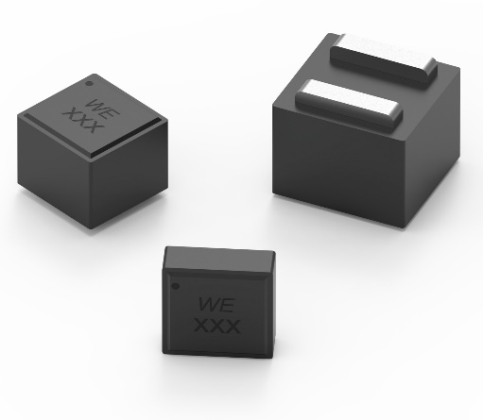Image source: Würth Elektronik
WE-XHMA: The flat wire coil with composite core material enables high saturation currents

About the Würth Elektronik eiSos Group
Würth Elektronik eiSos Group is a manufacturer of electronic and electromechanical components for the electronics industry and a technology company that spearheads pioneering electronic solutions. Würth Elektronik eiSos is one of the largest European manufacturers of passive components and is active in 50 countries. Production sites in Europe, Asia and North America supply a growing number of customers worldwide.
The product range includes EMC components, inductors, transformers, RF components, varistors, capacitors, resistors, quartz crystals, oscillators, power modules, Wireless Power Transfer, LEDs, sensors, connectors, power supply elements, switches, push-buttons, connection technology, fuse holders and solutions for wireless data transmission.
The unrivaled service orientation of the company is characterized by the availability of all catalog components from stock without minimum order quantity, free samples and extensive support through technical sales staff and selection tools.
Würth Elektronik is part of the Würth Group, the global market leader in the development, production, and sale of fastening and assembly materials, and employs 8,000 people. In 2021, the Würth Elektronik eiSos Group generated sales of 1.09 Billion Euro.
Würth Elektronik: more than you expect!
Further information at www.we-online.com

Further information:  Würth Elektronik eiSos GmbH & Co. KG  Sarah Hurst  Max-Eyth-Strasse 1  74638 Waldenburg  Germany  Phone: +49 7942 945-5186  E-mail: sarah.hurst@we-online.de  www.we-online.com | Press contact:  HighTech communications GmbH  Brigitte Basilio  Brunhamstrasse 21  81249 Munich  Germany  Phone: +49 89 500778-20  Telefax: +49 89 500778-77  E-mail: b.basilio@htcm.de  www.htcm.de

