PRESS RELEASE
Würth Elektronik expands its WE-MCA range of chip antennas
Electrically small dual-band antenna with great performance
Waldenburg (Germany), July 7, 2022—Würth Elektronik is now launching an additional multilayer chip antenna for the miniaturization of radio applications. Measuring just 40 x 6 x 5 mm, the WE-MCA antenna (7488918022) covers the 700 to 960 MHz and 1710 to 2690 MHz frequency ranges. With its hitherto unachieved form factor and slender profile, the antenna offers an excellent size-to-performance ratio.
WE-MCA is ideally suited for applications such as GSM 900, WLAN/WiFi, Bluetooth, GPS/GNSS, ZigBee, and mobile communication (4G/LTE). Together with a broad variety of radio modules and EMC products for high-frequency applications, Würth Elektronik offers a complete portfolio of products for the development of radio applications, including among others compact IoT and smart-building applications. With an operating temperature range from -40°C to +85°C, these chip antennas are also perfectly suited for robust applications.
For the perfect PCB layout
The layout of miniaturized radio applications and the selection of suitable inductors and capacitors to eliminate interferences is an art in itself. This is why Würth Elektronik also offers an Antenna Matching and Characterization Support for its WE-MCA range of multilayer chip antennas.
The WE-MCA chip antennas are supplied packaged in reels for SMT assembly, with no restrictions regarding the number of items. Free-of-charge samples are available on request.

Available images
The following images can be downloaded from the Internet in printable quality: https://kk.htcm.de/press-releases/wuerth/

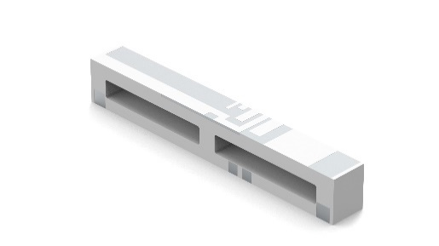
Image source: Würth Elektronik
Extremely compact antenna (for 700 to 960 MHz and 1710 to 2690 MHz): WE-MCA

About the Würth Elektronik eiSos Group
Würth Elektronik eiSos Group is a manufacturer of electronic and electromechanical components for the electronics industry and a technology company that spearheads pioneering electronic solutions. Würth Elektronik eiSos is one of the largest European manufacturers of passive components and is active in 50 countries. Production sites in Europe, Asia and North America supply a growing number of customers worldwide.
The product range includes EMC components, inductors, transformers, RF components, varistors, capacitors, resistors, quartz crystals, oscillators, power modules, Wireless Power Transfer, LEDs, sensors, connectors, power supply elements, switches, push-buttons, connection technology, fuse holders and solutions for wireless data transmission.
The unrivaled service orientation of the company is characterized by the availability of all catalog components from stock without minimum order quantity, free samples and extensive support through technical sales staff and selection tools.
Würth Elektronik is part of the Würth Group, the world market leader for assembly and fastening technology. The company employs 8,000 staff and generated sales of 1.09 Billion Euro in 2021.
Würth Elektronik: more than you expect!
Further information at www.we-online.com

Further information:  Würth Elektronik eiSos GmbH & Co. KG  Sarah Hurst  Max-Eyth-Strasse 1  74638 Waldenburg  Germany  Phone: +49 7942 945-5186  E-mail: sarah.hurst@we-online.de  www.we-online.com | Press contact:  HighTech communications GmbH  Brigitte Basilio  Brunhamstrasse 21  81249 Munich  Germany  Phone: +49 89 500778-20  Telefax: +49 89 500778-77  E-mail: b.basilio@htcm.de  www.htcm.de

