PRESS RELEASE
Würth lets plants grow into the sky with LEDs
Würth Group with innovations for more sustainability at the Greentech Festival in Berlin
Berlin/Künzelsau/Waldenburg (Germany), June 27, 2022—LEDs for accelerated plant growth, reinforcement systems for bridge renovation under ongoing traffic and solutions for efficient construction: The Würth Group has been advancing its innovative strength for more than 30 years. The Group presented these projects at the Greentech Festival in Berlin from June 22 to 24, 2022.
"Würth's business originally started with screws and nuts. Today, 77 years later, with companies from a wide range of industries, we have great diversity in the business units and thus great innovation potential. Examples include electrical wholesale, electronics or production. They sustainably drive research and development work. At the Greentech Festival, this innovative strength can be experienced - it is really great to see the future-oriented development that the Group is showing here," says Robert Friedmann, Chairman of the Central Managing Board of the Würth Group.
The right light formula for every plant
Würth Elektronik, one of nine business units of the Allied Companies within the Würth Group, develops and researches technologies for the future of agriculture. Horticulture with LEDs makes a significant contribution to producing food sustainably, healthily and locally. It should be seen as part of the solution when it comes to feeding the world's growing population in the future. "Advancing climate change, pandemics and fragile supply chains threaten our food supply," said Alexander Gerfer, Chief Technology Officer of the Würth Elektronik eiSos Group. "But there's more to it than just copying sunlight. With our own scientists, we are developing lighting formulas. These are tailor-made lighting solutions for the different needs of plants. In principle, this would make it possible to grow plants in the sky." Gerfer says.
With its own biologists and agricultural scientists, as well as cooperative ventures, for example with the Technical University of Munich, Würth Elektronik is conducting research into controlling plant growth with the aid of differently combined wavelengths.

Würth Elektronik as technology partner for start-ups Heatle and Unleash Future Boats
The Heatle company developed the world's first inductive immersion heater that can sustainably heat liquids in almost any vessel to the appropriate temperature. Unleash Future Boats presents autonomous high-tech catamarans that have electric propulsion with fuel cells - based on green hydrogen.
As technology partner, both start-ups are supported by Würth Elektronik with know-how and components. "At the Greentech Festival, the know-how of companies and innovative ideas of start-ups come together. I consider it an important responsibility of companies to approach future-oriented topics together. Our Berlin subsidiary is particularly entrusted with technology partnerships and the support of start-ups," says Gerfer.
Adolf Würth GmbH & Co KG: Partnerships for resource-conserving and efficient construction
Innovative ideas are needed for a new kind of building, such as the BetaPort from Berlin-based Studio Urban Beta. Its modular construction system makes it possible to transform existing buildings and erect deconstructable new buildings in a short time. Adolf Würth GmbH & Co. KG, a leading manufacturer of fastening technology and the largest single company of the Würth Group, is sponsoring not only the fastening technology but also the machines, tools and equipment needed for the construction. Würth and Urban Beta have agreed to jointly develop innovative fastening systems, modular building technology solutions and sustainable construction site concepts in the coming years. This combination of innovative design and Würth's core competencies promotes the further development of this pioneering concept.
"Our company thrives on innovation - in order to survive in the market and, of course, to be prepared for the future and attractive for new employees. Pushing forward great ideas on pressing sustainability issues together with startups motivates employees that they can make a difference themselves," says Norbert Heckmann, Chairman of the Management Board of Adolf Würth GmbH & Co. KG.
Würth relies on prefabricated building elements for the resource-saving and efficient implementation of construction projects in order to reduce transport routes and packaging waste. A module developed with the consulting firm Drees & Sommer for technical building equipment can be seen at the Greentech Festival. Würth supplies the corresponding fasteners for prefabricated elements in wood-concrete composite construction. This construction method is based to a large extent on wood, a renewable and therefore resource-saving raw material. Customers save long journeys and time for material procurement thanks to BAULOC® construction site logistics solutions. Würth delivers the right material in sufficient quantities directly to the construction site. The RELAST® reinforcement system, which is used to rehabilitate bridges that would otherwise have been demolished and rebuilt, is also sustainable.
There is no traffic congestion, there are no long road closures, with costs and environmental impacts reduced.

Available images
The following images can be downloaded from the Internet in printable quality: https://kk.htcm.de/press-releases/wuerth/
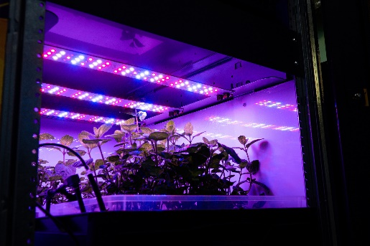Image source: Würth Elektronik  LED Horticulture: Provide the right light formula for every plant | 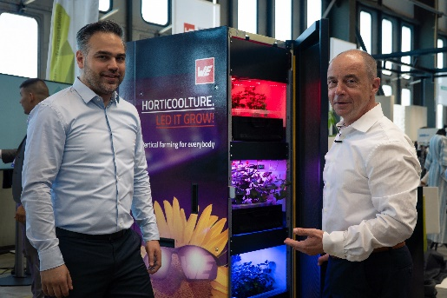Image source: Würth Elektronik  Expert discussion partners: Alexander Gerfer, Chief Technology Officer of the Würth Elektronik eiSos Group (right) and Harun Özgür, Division Manager for Optoelectronic Components, Würth Elektronik eiSos (left), at the booth.
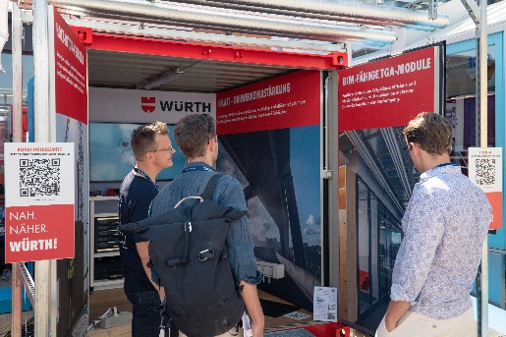Image source: Würth Elektronik  RELAST reinforcement system: rehabilitating bridges while traffic continues to flow | 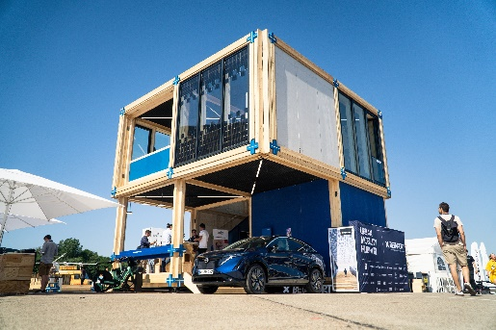  Image source: Würth Elektronik  Modular construction with BetaPort: In a short time, remodel existing buildings and erect deconstructable new buildings

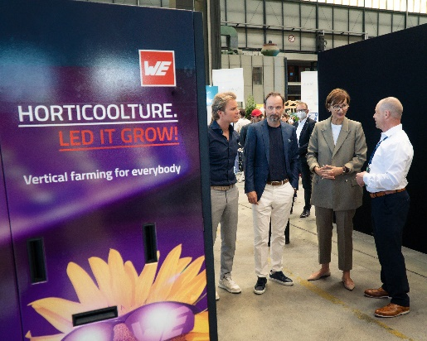Image source: Würth Elektronik
Press tour of the Würth stand

(From left:) Nico Rosberg and Marco Voigt, co-founders Greentech Festival, Bettina Stark-Watzinger, Federal Minister of Education and Research, Alexander Gerfer, Chief Technology Officer of the Würth Elektronik eiSos Group.

About the Würth Elektronik eiSos Group
Würth Elektronik eiSos Group is a manufacturer of electronic and electromechanical components for the electronics industry and a technology company that spearheads pioneering electronic solutions. Würth Elektronik eiSos is one of the largest European manufacturers of passive components and is active in 50 countries. Production sites in Europe, Asia and North America supply a growing number of customers worldwide.
The product range includes EMC components, inductors, transformers, RF components, varistors, capacitors, resistors, quartz crystals, oscillators, power modules, Wireless Power Transfer, LEDs, sensors, connectors, power supply elements, switches, push-buttons, connection technology, fuse holders and solutions for wireless data transmission.
The unrivaled service orientation of the company is characterized by the availability of all catalog components from stock without minimum order quantity, free samples and extensive support through technical sales staff and selection tools.
Würth Elektronik is part of the Würth Group, the world market leader for assembly and fastening technology. The company employs 8,000 staff and generated sales of 1.09 Billion Euro in 2021.
Würth Elektronik: more than you expect!
Further information at www.we-online.com

Über die Würth-Gruppe
Die Würth-Gruppe ist Weltmarktführer in der Entwicklung, der Herstellung und dem Vertrieb von Montage- und Befestigungsmaterial. Darüber hinaus sind Handels- und Produktionsunternehmen, die Allied Companies, in angrenzenden Geschäftsfeldern aktiv. Dazu zählen beispielsweise der Elektrogroßhandel oder der Bereich Elektronik bis hin zu Finanzdienstleistungen. In über 80 Ländern beschäftigt der Konzern weltweit mehr als 83 000 Mitarbeitende in über 400 Gesellschaften mit 2 500 Niederlassungen. Der Konzern erzielte im Geschäftsjahr 2021 gemäß testiertem Abschluss einen konsolidierten Umsatz von 17,1 Milliarden Euro und ein Betriebsergebnis vor Steuern von 1,27 Milliarden Euro.

Further information:
Würth Elektronik eiSos GmbH & Co. KG
Sarah Hurst
Max-Eyth-Strasse 1
74638 Waldenburg
Germany
Phone: +49 7942 945-5186
E-mail: sarah.hurst@we-online.de
www.we-online.com

Press contact:
Adolf Würth GmbH & Co. KG
Alexandra Schneid
Reinhold-Würth-Strasse 12-17
74650 Künzelsau
Germany
Phone: +49 7940 15-1645
Fax: +49 7940 15-4400
E-mail: presse@wuerth.com

