PRESS RELEASE
Würth Elektronik introduces its new products
Innovative into the summer
Waldenburg (Germany), May 31, 2022—Würth Elektronik has added to its product families in the areas of inductors, power transformers, RF components and signal transformers, optoelectronics, as well as MagI³C power modules. A transformer for battery management systems and a UV-A LED are just a couple of highlights. A brochure with information on the additions to the portfolio is provided by the technology enabler for free download.
The new product series include the WE-BMS transformer for battery management systems—ideal for use in energy storage systems, e-bikes or e-scooters thanks to its galvanic isolation of 4300 VDC / 1 min, high operating voltage of up to 1000 VDC and integrated filter chokes.
The additions also include new MagI³C power modules, new sizes in the WE-XHMI storage choke series, plus the WE-MCA multilayer chip antennas, for which Würth Elektronik also offers an antenna matching and characterization service.
Optoelectronics
Würth Elektronik’s Optoelectronics business unit was not idle either: A UV-A LED with a flat PLCC2 standard package is introduced—WL-SUTW—which can be used in UV curing lamps or for sensing applications. Also new—the UV-C LEDs in the WL-SUMW series for sterilization applications.
The range of seven-segment displays has also grown: Würth Elektronik now has the WL-S7DS and WL-T7DS models of the robust display modules in SMT and THT versions in its product range.
All components presented in the new product catalog are now available from stock. Würth Elektronik provides customers with samples from the entire range, free of charge for prototyping.

Available images
The following images can be downloaded from the Internet in printable quality: https://kk.htcm.de/press-releases/wuerth/

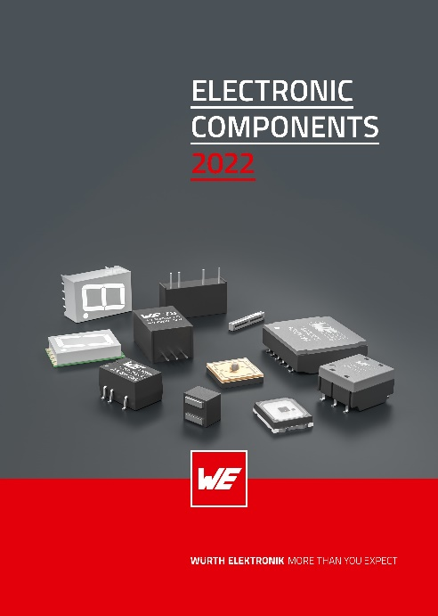Image source: Würth Elektronik
Cover of the Würth Elektronik new products catalog

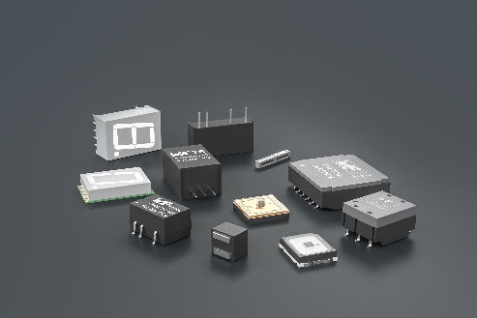  Image source: Würth Elektronik  The new product catalog provides information about the additions to the portfolio in the areas of inductors and power transformers, RF components and signal transformers, optoelectronics, as well as MagI³C power modules. | 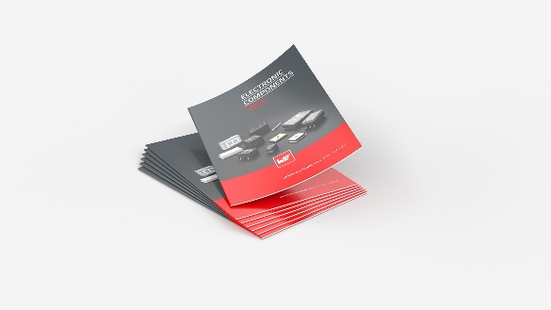Image source: Würth Elektronik  The highlights in the new product catalog include a transformer for battery management systems and a UV-A LED.

About the Würth Elektronik eiSos Group
Würth Elektronik eiSos Group is a manufacturer of electronic and electromechanical components for the electronics industry and a technology company that spearheads pioneering electronic solutions. Würth Elektronik eiSos is one of the largest European manufacturers of passive components and is active in 50 countries. Production sites in Europe, Asia and North America supply a growing number of customers worldwide.
The product range includes EMC components, inductors, transformers, RF components, varistors, capacitors, resistors, quartz crystals, oscillators, power modules, Wireless Power Transfer, LEDs, sensors, connectors, power supply elements, switches, push-buttons, connection technology, fuse holders and solutions for wireless data transmission.
The unrivaled service orientation of the company is characterized by the availability of all catalog components from stock without minimum order quantity, free samples and extensive support through technical sales staff and selection tools.
Würth Elektronik is part of the Würth Group, the world market leader for assembly and fastening technology. The company employs 8,000 staff and generated sales of 1.09 Billion Euro in 2021.
Würth Elektronik: more than you expect!
Further information at www.we-online.com

Further information:  Würth Elektronik eiSos GmbH & Co. KG  Sarah Hurst  Max-Eyth-Strasse 1  74638 Waldenburg  Germany  Phone: +49 7942 945-5186  E-mail: sarah.hurst@we-online.de  www.we-online.com | Press contact:  HighTech communications GmbH  Brigitte Basilio  Brunhamstrasse 21  81249 Munich  Germany  Phone: +49 89 500778-20  Telefax: +49 89 500778-77  E-mail: b.basilio@htcm.de  www.htcm.de

