PRESS RELEASE
IQD introduced IQCM-200
Disciplined OCXO with extended Holdover
Waldenburg (Germany), May 11, 2022—IQD, a company of the Würth Elektronik eiSos Group, has presented the IQCM-200, a disciplined OCXO, incorporating sync to a 1 PPS (pulse per second) input as well as a 1 PPS output. Its exceptional holdover stability and accuracy makes this particular product a superlative Disciplined OCXO.
The IQCM-200 is part of a series of disciplined OCXOs available from IQD. This particular model is the smallest sized OCXO capable of achieving a holdover capability of 1.5µs over 24 hours meaning you can rest assured your devices can continue to function with incredible accuracy during a holdover period.
This ‘best in class’ holdover stability of up to 1.5 μs over 24 hours across 0 – 60 °C, and 25 µs typical in 10 days at 25 ±2 °C is achieved using an adaptive algorithm. Internal parameters of the algorithm, including maintenance alarms and message functions are available to the user via a serial interface. A Frequency stability better than ±0.02 ppb is achievable.
Extensive in-house testing of the ICQM-200 has been carried out by engineers here at the IQD laboratory in the UK. In these controlled tests the holdover achieved by the IQCM-200 after 10 days was a very impressive 25.5 μs, ideal if your application requires a longer holdover than 24 hours. Tests also concluded ADEV figures as 2.2E-12 @ τ = 1 s.
Due to its exceptional holdover times, this product is ideal for applications that require an accurate time reference, Telecoms LTE and 5G timing, and PTP GM clocks with the required IEEE 1588 holdover support, and within White Rabbit applications. This particular model will be an excellent asset to power sector products which require increased holdover times due to the emerging changes and requirements within this sector. The IQCM-200 is compliant with MiFID II.
The IQCM-200 is part of a series including the IQCM-140, IQCM-310, IQCM-112, and IQCM-100. Although it is larger in size than some of our models, the IQCM-200 boasts incredible accuracy.
An IQCM Evaluation Board is also available for this series. Details on all the tests carried out including the 10 day holdover can be found in the IQCM-200 handbook. For your copy please contact sales and support teams at any time. Contact details can be found at www.iqdfrequencyproducts.com

IQD has been active in the frequency products market for nearly 50 years. The company has invested in its design and technical measurement capabilities at its head office in the UK, which also acts as the centre of excellence for frequency products within the Wurth Elektronik eiSos Group.
This ensures that customers and interested parties can be offered the best possible service that IQD and Wurth eiSos are widely known for. This service, combined with excellent quality and reliability, makes IQD the best choice for your Disciplined OCXO requirements.

Available images
The following images can be downloaded from the Internet in printable quality: https://kk.htcm.de/press-releases/wuerth/
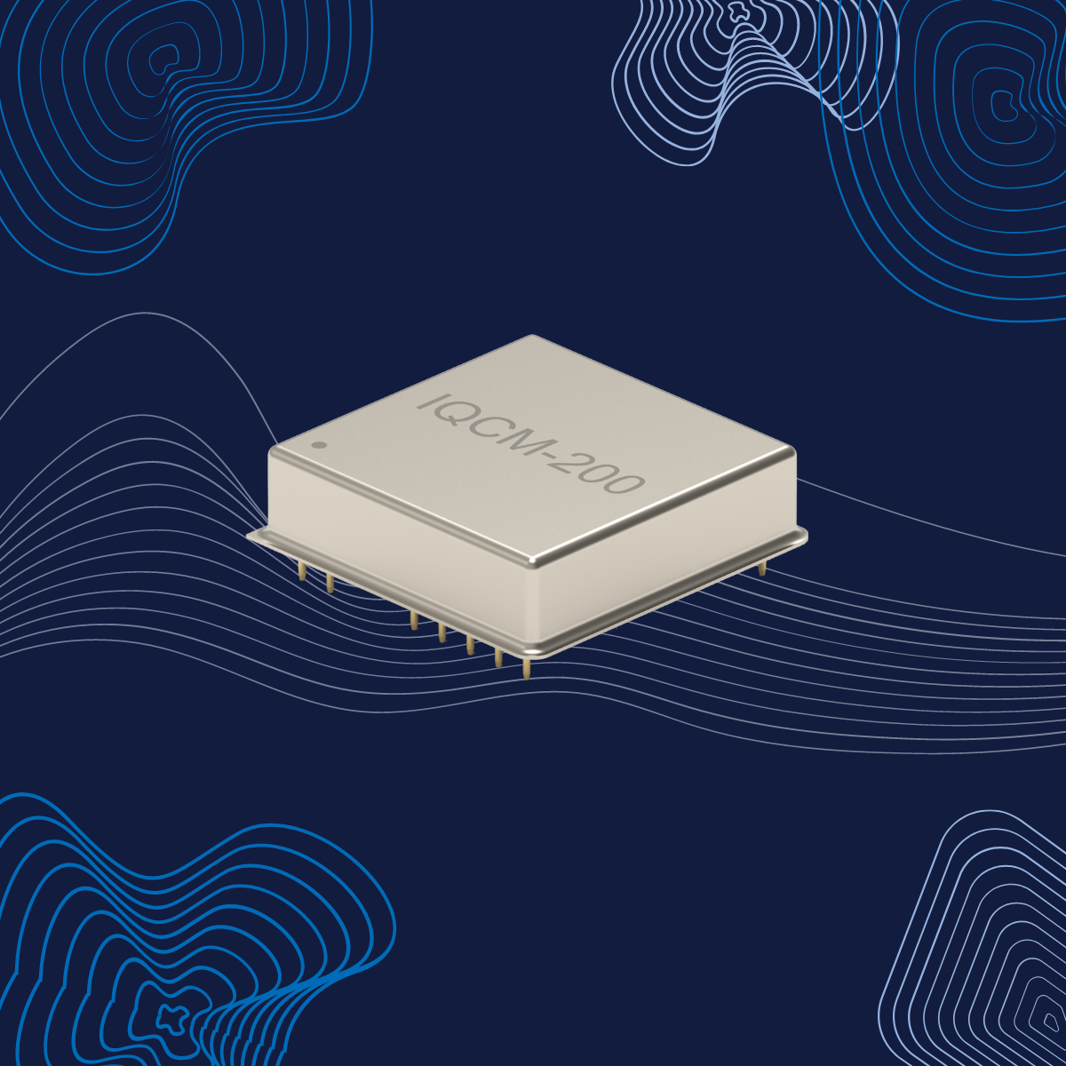
Image source: IQD
IQCM-200: Disciplined OCXO with extended Holdover

About IQD
Backed by over 40 years’ experience in the manufacture of frequency products, IQD is a recognised market leader in the frequency control market and part of the Würth Elektronik eiSos Group, one of the leading European manufacturers of passive components. With active customers in over 80 countries, IQD offers one of the most comprehensive frequency product ranges available, from low cost commercial grade product to that used in high reliability industrial and automotive applications including: Quartz Crystals, Clock Oscillators, AEC-Q200 Crystals & Oscillators, VCXOs, TCXOs, OCVCSOs & OCXOs, GPS Disciplined OCXOs, and Rubidium Oscillators.
Further info at www.iqdfrequencyproducts.com

About the Würth Elektronik eiSos Group
Würth Elektronik eiSos Group is a manufacturer of electronic and electromechanical components for the electronics industry and a technology company that spearheads pioneering electronic solutions. Würth Elektronik eiSos is one of the largest European manufacturers of passive components and is active in 50 countries. Production sites in Europe, Asia and North America supply a growing number of customers worldwide.
The product range includes EMC components, inductors, transformers, RF components, varistors, capacitors, resistors, quartz crystals, oscillators, power modules, Wireless Power Transfer, LEDs, sensors, connectors, power supply elements, switches, push-buttons, connection technology, fuse holders and solutions for wireless data transmission.
The unrivaled service orientation of the company is characterized by the availability of all catalog components from stock without minimum order quantity, free samples and extensive support through technical sales staff and selection tools.
Würth Elektronik is part of the Würth Group, the world market leader for assembly and fastening technology. The company employs 8,000 staff and generated sales of 1.09 Billion Euro in 2021.
Würth Elektronik: more than you expect!
Further information at www.we-online.com

Further information:  IQD Frequency Products Ltd  Isabelle McGovan  Station Road  Crewkerne  Somerset  TA18 8AR  United Kingdom  Phone: +44 1460 270270  E-mail: isabelle.mcgowan@iqdfrequencyproducts.com  www.we-online.com  www.iqdfrequencyproducts.com | Press contact:  HighTech communications GmbH  Brigitte Basilio  Brunhamstrasse 21  81249 Munich  Germany  Phone: +49 89 500778-20  Telefax: +49 89 500778-77  E-mail: b.basilio@htcm.de  www.htcm.de

