PRESS RELEASE
Würth Elektronik joins Oscilloscope Days 2022
How to Achieve Test Goals
Waldenburg (Germany), April 13, 2022—As a partner of Rohde & Schwarz, Würth Elektronik is involved in organizing their Oscilloscope Days on Wednesday April 27 and Thursday April 28, 2022. In the popular free online event, Rohde & Schwarz and partner companies will offer application-oriented presentations via live stream. The focus will be on challenges that electronics engineers face when using test and measurement equipment such as oscilloscopes. The webcasts will be streamed in English, French, German, Spanish, and Portuguese.
Robert Schillinger, Field Application Engineer, will represent Würth Elektronik eiSos with his presentation, "Which RF Effects Need to be Considered in the Measurement and Design of Wide-bandgap Semiconductor-Based Power Systems?". The presentation will focus on power electronics utilizing SiC and GaN transistor technology, a topic being researched for many years at Würth Elektronik. Schillinger will share with Oscilloscope Days participants the latest findings on filtering gate drivers. Other topics at the event include the selection of suitable measurement equipment, jitter analysis, signal integrity, and EMC troubleshooting.
For more information, visit:
https://www.rohde-schwarz.com/de/knowledge-center/webinars/webinar-oscilloscope-days_255400.html

Available images
The following images can be downloaded from the Internet in printable quality: https://kk.htcm.de/press-releases/wuerth/

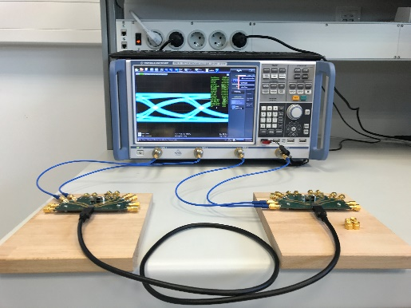Image source: Würth Elektronik
Oscilloscope with test setup

About the Würth Elektronik eiSos Group
Würth Elektronik eiSos Group is a manufacturer of electronic and electromechanical components for the electronics industry and a technology company that spearheads pioneering electronic solutions. Würth Elektronik eiSos is one of the largest European manufacturers of passive components and is active in 50 countries. Production sites in Europe, Asia and North America supply a growing number of customers worldwide.
The product range includes EMC components, inductors, transformers, RF components, varistors, capacitors, resistors, quartz crystals, oscillators, power modules, Wireless Power Transfer, LEDs, sensors, connectors, power supply elements, switches, push-buttons, connection technology, fuse holders and solutions for wireless data transmission.
The unrivaled service orientation of the company is characterized by the availability of all catalog components from stock without minimum order quantity, free samples and extensive support through technical sales staff and selection tools.
Würth Elektronik is part of the Würth Group, the world market leader for assembly and fastening technology. The company employs 8,000 staff and generated sales of 1.09 Billion Euro in 2021.
Würth Elektronik: more than you expect!
Further information at www.we-online.com

Further information:  Würth Elektronik eiSos GmbH & Co. KG  Sarah Hurst  Max-Eyth-Strasse 1  74638 Waldenburg  Germany  Phone: +49 7942 945-5186  E-mail: sarah.hurst@we-online.de  www.we-online.com | Press contact:  HighTech communications GmbH  Brigitte Basilio  Brunhamstrasse 21  81249 Munich  Germany  Phone: +49 89 500778-20  Telefax: +49 89 500778-77  E-mail: b.basilio@htcm.de  www.htcm.de

