PRESS RELEASE
"Germany's most innovative companies": Four stars for the Würth Elektronik Group
Capital Award
Waldenburg (Germany), April 26, 2022—The Würth Elektronik Group has once again received an award from the renowned trade magazine Capital: The organization received four stars in the category "Germany's Most Innovative Companies" in issue 3/2022. The award followed a survey of innovation experts.
The survey was conducted in the "Electronics & Electrical Engineering" section in collaboration with Statista. The magazine and the well-known information portal identified particularly forward-looking companies by random sampling among 3,600 innovation experts.
A total of 2,061 candidates were on the evaluation list of the monthly business magazine. They were subjected to a rigorous and objective judgment by the expert panel. Only 470 companies received four or five stars. A total of 20 sectors and companies of all sizes, all headquartered in Germany, were evaluated. The three areas of innovation were surveyed: Products and services, process innovations, and cultural and social innovations. A total of eight criteria were evaluated, for example "has launched a new and innovative product/service on the market for the first time," "has installed business processes that promote innovation," or "is taking innovative approaches to promoting employee satisfaction and motivation."
This is the third time the Würth Elektronik Group has been honored by Capital. The four-star rating is seen as both an award and an incentive. As a technology enabler, the company will continue to provide customers with the components they need for their innovations - from stock, in any quantities, without minimum order quantities.

Available images
The following images can be downloaded from the Internet in printable quality: https://kk.htcm.de/press-releases/wuerth/
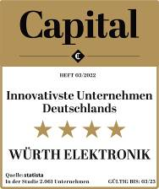Image source: Würth Elektronik  Awarded for the third time: Würth Elektronik received four-star seal in survey of "Germany's most innovative companies". | 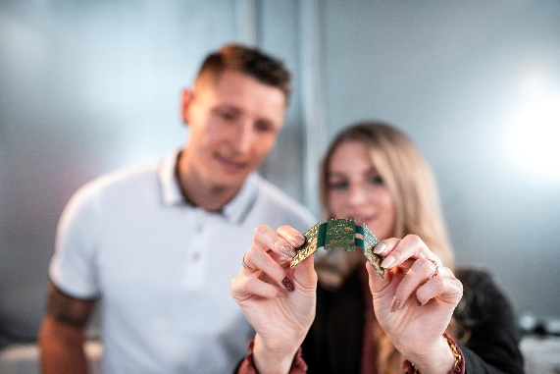  Image source:  Würth Elektronik  Würth Elektronik is known as an innovative company and at the same time valued as an "enabler": companies turn to products and services from Würth Elektronik to advance their own innovations.

About the Würth Elektronik group of companies
The Würth Elektronik group of companies, with headquarters in Niedernhall (Hohenlohe), Germany, has about 8,000 employees worldwide and generated global sales of 1.09 Billion Euro in 2021.
With over 23 production locations worldwide, Würth Elektronik is one of the most successful companies of the Würth Group.
Würth Elektronik operates internationally with its three company areas in various markets:
- Electronic & electromechanical components (Headquarters: Waldenburg)
Würth Elektronik eiSos (electronic and electromechanical components) is one of Europe's biggest manufacturers of electronic & electromechanical components. More than 700 sales representatives worldwide make up a direct sales network that is unique for the electronics market. The customer is offered excellent design-in support on-site from the manufacturer. The production plants in Germany, Czech Republic, Bulgaria, USA, Mexico, Taiwan and China guarantee high availability on all markets. All catalog products are available from stock and samples are free of charge.
- PCBs (Headquarters: Niedernhall)
As one of Germany’s leading PCB manufacturers, Würth Elektronik CBT (Circuit Board Technology) is specialized in prototypes, as well as small and medium order sizes. Electronic developers find all conventional and many innovative PCB technologies through to system solutions, all from a single source - and last but not least, specialists as dialog partners.
- Intelligent Power & Control Systems (Headquarters: Niedernhall-Waldzimmern)
As a specialist for the development and production of electronic and electromechanical system solutions, such as central electronics, Würth Elektronik ICS (Intelligent Power & Control Systems) is a longtime partner for many commercial vehicles. Professional project management accompanies business partners from the product idea through to series maturity.

Further information at www.we-online.com

Further information:  Würth Elektronik eiSos GmbH & Co. KG  Sarah Hurst  Max-Eyth-Strasse 1  74638 Waldenburg  Germany  Phone: +49 7942 945-5186  E-mail: sarah.hurst@we-online.de  www.we-online.de | Press contact:  HighTech communications GmbH  Brigitte Basilio  Brunhamstrasse 21  81249 Munich  Germany  Phone: +49 89 500778-20  Telefax: +49 89 500778-77  E-mail: b.basilio@htcm.de  www.htcm.de

