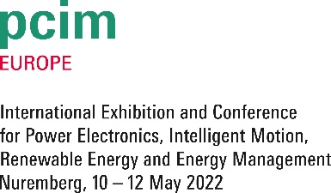
PRESS RELEASE
Würth Elektronik at PCIM 2022
Performance Meets Customer Service
Hall 6, Booth 402

Waldenburg (Germany), April 07, 2022—Würth Elektronik, manufacturer of electronic and electromechanical components, will be exhibiting at PCIM, May 10-12, 2022 (Nuremberg Convention Center, NCC, Hall 6, Booth 402). In keeping with the focus of the event, the manufacturer will be presenting its power electronics highlights. Würth Elektronik employees will also participate with two presentations at the trade show conference.
With 500 exhibitors from around 30 countries, PCIM (Power Conversion Intelligent Motion) Europe is the pioneering international trade show and conference for power electronics, intelligent drive technology, renewable energy and energy management. Participation is possible in person or online.
"For the first time since the outbreak of the pandemic, we will be represented live at a major trade fair in Germany," Alexander Gerfer, CTO at the Würth Elektronik eiSos Group is delighted to announce. "The power electronics elite gathers in Nuremberg. This exhibition is the ideal platform for us to present our product portfolio and meet our customers.”
Plenty of time to chat
Technical specialists at the booth will provide plenty of opportunities for in-depth discussions. Not only visitors stand to profit. “It’s also important for us to keep our ears open and pick up ideas from our customers' practical experience," Gerfer stresses. "We see ourselves as technology enablers." Which is why Würth Elektronik's products are available from stock in any quantities and without minimum order quantities. There are also free samples for most products, which are delivered in 1-2 days.
Interesting contributions
Würth Elektronik supports PCIM with its Silver Partnership. Another highlight: Product experts will participate at the trade show conference with the following presentations (May 11, 2022, 3.00 to 5.00 pm):
• Antonio Alccaria: Study of Combined Solutions for Thermal Management and Electromagnetic Shielding: Shielding Cabinets, EMI Absorbers and Thermal Gap Fillers
• Christian Merz: Mathematical Model of the Temperature Rise of a Wireless Power Transfer Coil in DC Operation

Available images
The following images can be downloaded from the Internet in printable quality: https://kk.htcm.de/press-releases/wuerth/
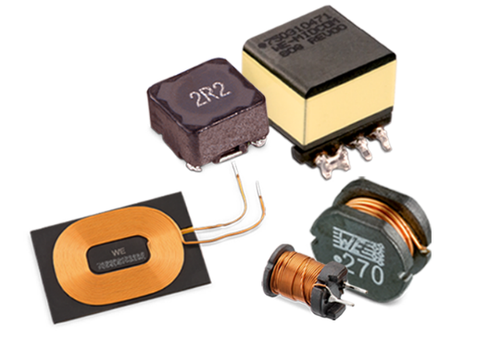  Image source: Würth Elektronik  The Power Magnetics product group ranges from inductors, chokes and transformers to coils for wireless energy transmission. | 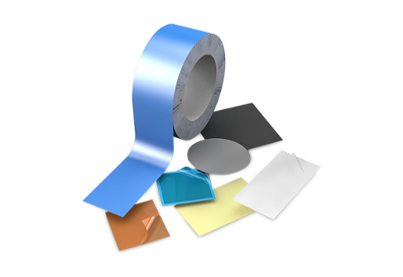  Image source: Würth Elektronik  Würth Elektronik offers a wide range of solutions for heat dissipation.

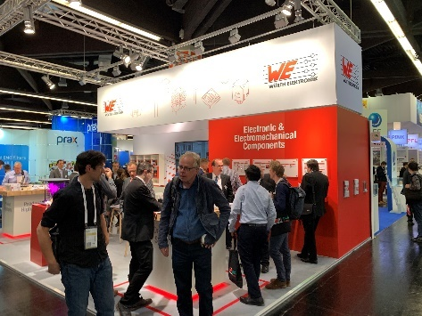  Image source: Würth Elektronik  A place for interesting technical discussions: the Würth Elektronik trade fair booth | 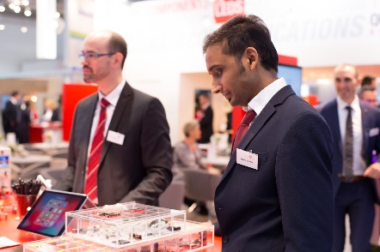  Image source: Würth Elektronik  Würth Elektronik will be presenting highlights from its product portfolio at the trade fair stand.

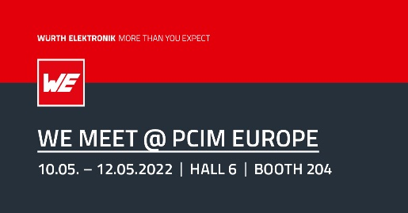Image source: Würth Elektronik
Würth Elektronik will be represented at PCIM in Nuremberg, 10-12 May 2022.

About the Würth Elektronik eiSos Group
Würth Elektronik eiSos Group is a manufacturer of electronic and electromechanical components for the electronics industry and a technology company that spearheads pioneering electronic solutions. Würth Elektronik eiSos is one of the largest European manufacturers of passive components and is active in 50 countries. Production sites in Europe, Asia and North America supply a growing number of customers worldwide.
The product range includes EMC components, inductors, transformers, RF components, varistors, capacitors, resistors, quartz crystals, oscillators, power modules, Wireless Power Transfer, LEDs, sensors, connectors, power supply elements, switches, push-buttons, connection technology, fuse holders and solutions for wireless data transmission.
The unrivaled service orientation of the company is characterized by the availability of all catalog components from stock without minimum order quantity, free samples and extensive support through technical sales staff and selection tools.
Würth Elektronik is part of the Würth Group, the world market leader for assembly and fastening technology. The company employs 8,000 staff and generated sales of 1.09 Billion Euro in 2021.
Würth Elektronik: more than you expect!
Further information at www.we-online.com

Further information:  Würth Elektronik eiSos GmbH & Co. KG  Sarah Hurst  Max-Eyth-Strasse 1  74638 Waldenburg  Germany  Phone: +49 7942 945-5186  E-mail: sarah.hurst@we-online.de  www.we-online.com | Press contact:  HighTech communications GmbH  Brigitte Basilio  Brunhamstrasse 21  81249 Munich  Germany  Phone: +49 89 500778-20  Telefax: +49 89 500778-77  E-mail: b.basilio@htcm.de  www.htcm.de

