PRESS RELEASE
Würth Elektronik extends its MagI³C-FDSM family with 74.5 V versions
MagI³C Power Module Suitable for 48 V Industrial Voltage Network
Waldenburg, Germany, April 28, 2022—Würth Elektronik extends its MagI³C-FDSM power module product range: The fixed step-down regulator modules now cover all bus voltages from 12 V up to 48 V. The modules facilitate development for applications with direct connection to bus voltages of 12 V, 24 V or 48 V. The wide input voltage range up to 74.5 V makes the FDSM module robust against voltage transients on the 48 V bus. The new power modules are implemented in a cost-effective SIP-3 package and provide fixed output voltages of 3.3 V, 5.0 V as well as 12 V, with an output current up to 0.5 A.
The MagI³C-FDSM series are fully integrated DC/DC voltage converters with fixed output voltage. Besides the power stage, the modules consist of a regulator, inductor as well as input and output capacitors. The power modules are protected against short circuit and thermal overload. MagI³C-FDSM reduces the workload involved in circuit design to a minimum, as no external components are required for operation—this reduces development costs and time. For simple assembly, the MagI³C-FDSM family has been realized in a standard THT housing.
Pre-compliance testing of our evaluation board has shown the conducted and radiated EMI is below limits established by relevant standards. For more details please see our datasheet. All MagI³C-FDSM power module versions are available from stock. Free samples can be requested.

Available images
The following images can be downloaded from the Internet in printable quality: https://kk.htcm.de/press-releases/wuerth/

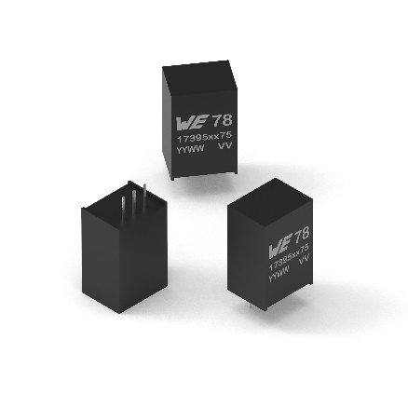
Image source: Würth Elektronik
MagI³C-FDSM family with 74.5 V versions

About the Würth Elektronik eiSos Group
Würth Elektronik eiSos Group is a manufacturer of electronic and electromechanical components for the electronics industry and a technology company that spearheads pioneering electronic solutions. Würth Elektronik eiSos is one of the largest European manufacturers of passive components and is active in 50 countries. Production sites in Europe, Asia and North America supply a growing number of customers worldwide.
The product range includes EMC components, inductors, transformers, RF components, varistors, capacitors, resistors, quartz crystals, oscillators, power modules, Wireless Power Transfer, LEDs, sensors, connectors, power supply elements, switches, push-buttons, connection technology, fuse holders and solutions for wireless data transmission.
The unrivaled service orientation of the company is characterized by the availability of all catalog components from stock without minimum order quantity, free samples and extensive support through technical sales staff and selection tools.
Würth Elektronik is part of the Würth Group, the world market leader for assembly and fastening technology. The company employs 8,000 staff and generated sales of 1.09 Billion Euro in 2021.
Würth Elektronik: more than you expect!
Further information at www.we-online.com

Further information:  Würth Elektronik eiSos GmbH & Co. KG  Sarah Hurst  Max-Eyth-Strasse 1  74638 Waldenburg  Germany  Phone: +49 7942 945-5186  E-mail: sarah.hurst@we-online.de  www.we-online.com | Press contact:  HighTech communications GmbH  Brigitte Basilio  Brunhamstrasse 21  81249 Munich  Germany  Phone: +49 89 500778-20  Telefax: +49 89 500778-77  E-mail: b.basilio@htcm.de  www.htcm.de

