PRESS RELEASE
Würth Elektronik is a partner of UnternehmerTUM MakerSpace GmbH
Supporter of the largest start-up and innovation center in Europe
Waldenburg, Munich (Germany), February 11, 2022—Würth Elektronik has joined the circle of organizations supporting the new MakerSpace of Susanne Klatten's non-profit, UnternehmerTUM GmbH. The high-tech prototype workshop MakerSpace offers ambitious start-ups, innovation teams from companies, and do-it-yourselfers a place to produce ideas and innovations in the form of prototypes and small series. Würth Elektronik contributes with Expert Talks on EMC and electronics, support in designing and setting up a Tech Library, and expert consultation hours. In addition, MakerSpace users will receive technical support in the form of prototypes by Field Application Engineers, as well as a quota of EMC pre-compliance tests.
"We are pleased to participate in the MakerSpace. It aligns with our self-image as a technology enabler. We enable students, startups and employees, as well as private makers, to bring their ideas to life. We shorten time-to-market, increase scalability and improve manufacturability," explains Alexander Gerfer, CTO of the Würth Elektronik eiSos Group.
Cooperation for innovation
In the circle of cooperative partners of the start-up center for smart city solutions Munich Urban Colab in Munich, where MakerSpace is located, joint project ideas are generated; for example for IoT solutions of the future. The focus of the joint projects is the collaboration of new and established companies in pre-competitive research and development. Recognized industry standards that lead to order and interoperability of existing and new IoT architectures will be applied and further developed.
The MakerSpace, opening in Munich Urban Colab at the end of 2021 in which Würth Elektronik is now participating, is impressive; with 1,200 square meters on two floors, 43 high-tech machines, special software, and courses. Together with the existing facility in Garching, MakerSpace now offers 2,700 square meters of publicly accessible high-tech workshops.
"We are proud and grateful to have Würth Elektronik eiSos as a competent partner at our side who shares our entrepreneurial values. Together, we are fostering the next generation of inventors at the MakerSpace in Munich so that visions can be turned into real products. Thanks to the strong partnership with Würth Elektronik eiSos, start-ups can be professionally accompanied from the first product idea to the product series," says Florian Küster, Managing Director at UnternehmerTUM MakerSpace. Küster directly addresses the users of the MakerSpace, "We accelerate your prototyping by offering pre-sorted design kits. These design kits contain electronic and electromechanical components, as well as elements for assembling printed circuit boards to make your project a success. Start-ups are also supported directly in finding solutions by Würth Elektronik experts and MakerSpace employees who mediate between the worlds. Together, we put ourselves at the service of your start-up so that your project becomes successful."

Available images
The following images can be downloaded from the Internet in printable quality: https://kk.htcm.de/press-releases/wuerth/
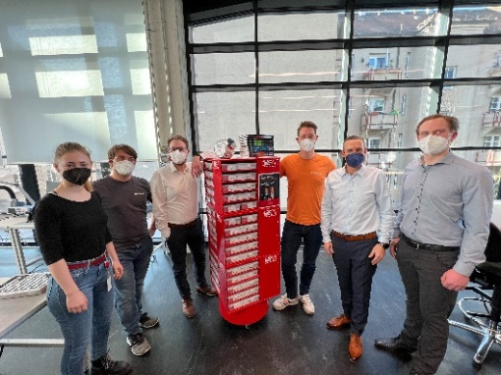  Image source: Würth Elektronik  From the UnternehmerTUM MakerSpace, Anna Mühlbauer, Engineering Master's student (1st from left), Johannes Walcher, Junior Expert Electronics & IoT (2nd from left) and Florian Küster, Managing Director (3rd from right) are delighted with the design kits from Würth Elektronik.  Also in the picture from Würth Elektronik eiSos: Matthias Wagner, Technical Field Service - Electromechanical Division (3rd from left), Norbert Schmid, Sales Management Electromechanical Components (2nd from right), Benedikt Haeckl, Technical Sales (1st from right). | 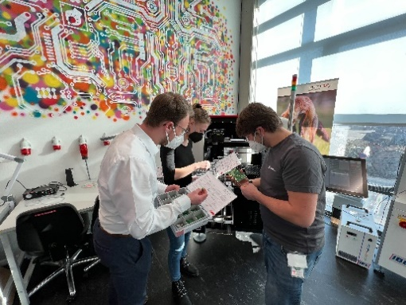  Image source: Würth Elektronik  With the design kits from Würth Elektronik, developers in the MakerSpace have all versions of components at their fingertips.

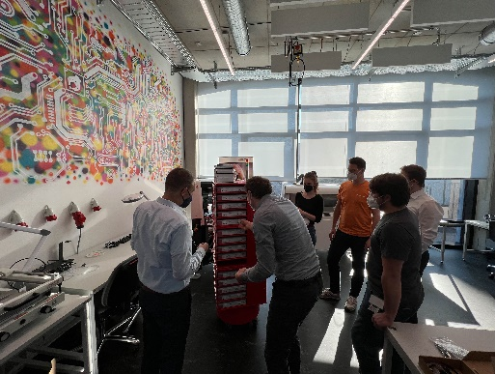Image source: Würth Elektronik  A whole tower full of design kits - components such as coils or capacitors from Würth Elektronik always at hand for prototyping. | 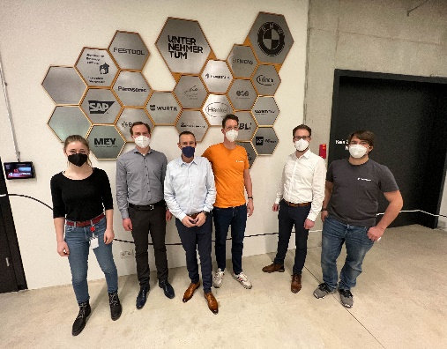  Image source: Würth Elektronik  Würth Elektronik now also has a plaque on the wall of MakerSpace partners. (From left:) Anna Mühlbauer, Master Student Engineering, UnternehmerTUM MakerSpace, Benedikt Haeckl, Technical Sales at Würth Elektronik eiSos, Norbert Schmid, Sales Manager Electromechanical Components at Würth Elektronik eiSos, Florian Küster, Managing Director at UnternehmerTUM MakerSpace, Matthias Wagner, Technical Field Service - Electromechanical Division at Würth Elektronik eiSos, Johannes Walcher, Junior Expert Electronics & IoT at UnternehmerTUM MakerSpace.

MakerSpace - A Paradise for Inventors and Creatives
MakerSpace is a publicly accessible high-tech workshop that gives ambitious start-ups, Do-It-Yourselfers and creative people access to machines, tools and software as well as a creative community.
The workshop opened in 2015 as a subsidiary of UnternehmerTUM, Europe's largest center for innovation and start-ups, and offers a place where ideas and innovations can be realized in the form of prototypes and small series. Different work areas are available, such as machine, metal and wood workshops, as well as textile and electrical processing. 3D printers, laser cutters and waterjet cutting machines can be used to create new shapes and process all materials. For support and networking, MakerSpace offers training and consulting services as well as events for members.
MakerSpace is located at two sites: with 1,500 m² at the Garching research campus and, since 2021, with 1,200 m² at the Munich Urban Colab startup center, centrally located in the creative quarter in Munich.
Further information at https://maker-space.de/

About the Würth Elektronik eiSos Group
Würth Elektronik eiSos Group is a manufacturer of electronic and electromechanical components for the electronics industry and a technology company that spearheads pioneering electronic solutions. Würth Elektronik eiSos is one of the largest European manufacturers of passive components and is active in 50 countries. Production sites in Europe, Asia and North America supply a growing number of customers worldwide.
The product range includes EMC components, inductors, transformers, RF components, varistors, capacitors, resistors, quartz crystals, oscillators, power modules, Wireless Power Transfer, LEDs, sensors, connectors, power supply elements, switches, push-buttons, connection technology, fuse holders and solutions for wireless data transmission.
The unrivaled service orientation of the company is characterized by the availability of all catalog components from stock without minimum order quantity, free samples and extensive support through technical sales staff and selection tools.
Würth Elektronik is part of the Würth Group, the world market leader for assembly and fastening technology. The company employs 8,000 staff and generated sales of 1.09 Billion Euro in 2021.
Würth Elektronik: more than you expect!
Further information at www.we-online.com

Further information:  Würth Elektronik eiSos GmbH & Co. KG  Sarah Hurst  Max-Eyth-Strasse 1  74638 Waldenburg  Germany  Phone: +49 7942 945-5186  E-mail: sarah.hurst@we-online.de  www.we-online.com | Press contact:  HighTech communications GmbH  Brigitte Basilio  Brunhamstrasse 21  81249 Munich  Germany  Phone: +49 89 500778-20  Telefax: +49 89 500778-77  E-mail: b.basilio@htcm.de  www.htcm.de

