PRESS RELEASE
Würth Elektronik establishes subsidiary in Bulgaria
Successful sales force becomes subsidiary
Waldenburg (Deutschland) / Sofia (Bulgaria), April 12, 2022—Würth Elektronik, manufacturer of electronic and electromechanical components, has founded a new subsidiary in Sofia. Würth Elektronik Bulgaria EOOD starts with four female employees and three male employees. The move into the new business premises in the Business Park Sofia is a milestone in the success story: In 2013, the current Managing Director Dimitar Vasilev started with 14 active customers. In 2018, a second sales representative was added, followed by a third in 2021. Among the 170 customers are well-known companies such as Festo Production, KATEK electronic Bulgaria, VEAS Bulgaria, Sanmina Bulgaria, Integrated Micro-Electronics and Sensata Technologies Bulgaria.
As you would expect from Würth Elektronik, success in Bulgaria is also based on competent individual customer support. The newly founded subsidiary has the best prerequisites for this: With three engineers in the field and one female engineer in the office, the small team has a combined 60 years of professional experience in electronics.
"The preparations for the establishment of Würth Elektronik Bulgaria were not entirely easy. The expansion of our team coincided with the Corona-related contact restrictions. We are all the more pleased that we can now get off to a flying start. A big thank you goes to my strong team and the colleagues in Germany who gave us excellent support," says Dimitar Vasilev, Managing Director Würth Elektronik Bulgaria EOOD.
The headquarters of the new Würth Elektronik subsidiary is located in a business park with an excellent infrastructure and parkland with a lake in the southeastern part of Sofia. The Bulgarian Würth Elektronik team benefits from optimal metro and road connections and also has one of the most popular recreational areas in the capital region, the Vitosha Mountains, in its immediate vicinity.

Available images
The following images can be downloaded from the Internet in printable quality: https://kk.htcm.de/press-releases/wuerth/
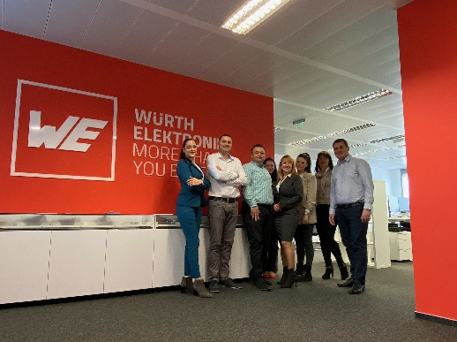Image source: Würth Elektronik
The employees of the Würth Elektronik subsidiary in Sofia (Bulgaria).

About the Würth Elektronik eiSos Group
Würth Elektronik eiSos Group is a manufacturer of electronic and electromechanical components for the electronics industry and a technology company that spearheads pioneering electronic solutions. Würth Elektronik eiSos is one of the largest European manufacturers of passive components and is active in 50 countries. Production sites in Europe, Asia and North America supply a growing number of customers worldwide.
The product range includes EMC components, inductors, transformers, RF components, varistors, capacitors, resistors, quartz crystals, oscillators, power modules, Wireless Power Transfer, LEDs, sensors, connectors, power supply elements, switches, push-buttons, connection technology, fuse holders and solutions for wireless data transmission.
The unrivaled service orientation of the company is characterized by the availability of all catalog components from stock without minimum order quantity, free samples and extensive support through technical sales staff and selection tools.
Würth Elektronik is part of the Würth Group, the world market leader for assembly and fastening technology. The company employs 8,000 staff and generated sales of 1.09 Billion Euro in 2021.
Würth Elektronik: more than you expect!
Further information at www.we-online.com

Further information:  Würth Elektronik eiSos GmbH & Co. KG  Sarah Hurst  Max-Eyth-Strasse 1  74638 Waldenburg  Germany  Phone: +49 7942 945-5186  E-mail: sarah.hurst@we-online.de  www.we-online.com | Press contact:  HighTech communications GmbH  Brigitte Basilio  Brunhamstrasse 21  81249 Munich  Germany  Phone: +49 89 500778-20  Telefax: +49 89 500778-77  E-mail: b.basilio@htcm.de  www.htcm.de

